UNITED STATES
SECURITIES AND EXCHANGE COMMISSION
Washington, D.C. 20549
Form 10-Q
(Mark One)
☒ |  |  | QUARTERLY REPORT PURSUANT TO SECTION 13 OR 15(d) OF THE SECURITIES EXCHANGE ACT OF 1934
For the quarterly period ended July 31, 2026
or
☐ |  |  | TRANSITION REPORT PURSUANT TO SECTION 13 OR 15(d) OF THE SECURITIES EXCHANGE ACT OF 1934
For the transition period from ______ to ______

Commission File Number |  |  |  |  |  |  |  |  |  |  |  |  |  |  |  |  |  |  |  |  |  |  |  |  |  |  |  |  |  |  |  |  | 001-35832
Science Applications International Corporation
(Exact name of registrant as specified in its charter)
Delaware |  |  |  |  |  |  |  |  |  |  |  |  |  |  |  |  |  |  |  |  |  |  |  |  |  |  |  |  |  |  |  |  | 46-1932921
(State or other jurisdiction of incorporation or organization) |  |  |  |  |  |  |  |  |  |  |  |  |  |  |  |  |  |  |  |  |  |  |  |  |  |  |  |  |  |  |  |  | (I.R.S. Employer Identification No.)
12010 Sunset Hills Road, |  |  |  |  |  |  |  |  |  |  |  |  |  |  |  |  |  | Reston, |  |  |  |  |  | Virginia |  |  |  |  |  |  |  |  | 20190
(Address of principal executive offices) |  |  |  |  |  |  |  |  |  |  |  |  |  |  |  |  |  |  |  |  |  |  |  |  |  |  |  |  |  |  |  |  | (Zip Code)
(703) |  |  |  |  |  |  |  |  |  |  |  |  |  |  |  |  |  |  |  |  |  |  |  |  |  |  |  |  |  | 676-4300
(Registrant's telephone number, including area code)

Securities registered pursuant to Section 12(b) of the Act:
Title of each class |  |  | Trading Symbol(s) |  |  | Name of each exchange on which registered
Common Stock, par value $.0001 per share |  |  | SAIC |  |  | The Nasdaq Stock Market LLC
Indicate by check mark whether the registrant (1) has filed all reports required to be filed by Section 13 or 15(d) of the Securities Exchange Act of 1934 during the preceding 12 months (or for such shorter period that the registrant was required to file such reports), and (2) has been subject to such filing requirements for the past 90 days. Yes ☒ No ☐
Indicate by check mark whether the registrant has submitted electronically every Interactive Data File required to be submitted pursuant to Rule 405 of Regulation S-T (§232.405 of this chapter) during the preceding 12 months (or for such shorter period that the registrant was required to submit such files). Yes ☒ No ☐
Indicate by check mark whether the registrant is a large accelerated filer, an accelerated filer, a non-accelerated filer, a smaller reporting company or an emerging growth company. See the definitions of “large accelerated filer,” “accelerated filer,” “smaller reporting company” and “emerging growth company” in Rule 12b-2 of the Exchange Act.
Large accelerated filer |  |  | ☒ |  |  | Accelerated filer |  |  | ☐ |  |  | Non-accelerated filer |  |  | ☐ |  |  | Smaller reporting company |  |  | ☐
 |  |  |  |  |  |  |  |  |  |  |  |  |  |  |  |  |  | Emerging growth company |  |  | ☐
If an emerging growth company, indicate by check mark if the registrant has elected not to use the extended transition period for complying with any new or revised financial accounting standards provided pursuant to Section 13(a) of the Exchange Act. ☐
Indicate by check mark whether the registrant is a shell company (as defined in Rule 12b-2 of the Exchange Act). Yes ☐ No ☒
The number of shares issued and outstanding of the registrant’s common stock as of August 21, 2026 was as follows:
41,897,635 shares of common stock ($.0001 par value per share)

SCIENCE APPLICATIONS INTERNATIONAL CORPORATION
FORM 10-Q
TABLE OF CONTENTS

 |  |  |  |  |  |  |  |  | Page
Part I |  |  |  |  |  | Financial Information
Item 1 |  |  |  |  |  | Financial Statements |  |  | 1
 |  |  |  |  |  | Condensed Consolidated Statements of Income |  |  | 1
 |  |  |  |  |  | Condensed Consolidated Statements of Comprehensive Income |  |  | 2
 |  |  |  |  |  | Condensed Consolidated Balance Sheets |  |  | 3
 |  |  |  |  |  | Condensed Consolidated Statements of Equity |  |  | 4
 |  |  |  |  |  | Condensed Consolidated Statements of Cash Flows |  |  | 5
 |  |  |  |  |  | Notes to Condensed Consolidated Financial Statements |  |  | 6
 |  |  |  |  |  | Note 1—Business Overview and Summary of Significant Accounting Policies |  |  | 6
 |  |  |  |  |  | Note 2—Earnings Per Share, Share Repurchases and Dividends |  |  | 8
 |  |  |  |  |  | Note 3—Revenues |  |  | 9
 |  |  |  |  |  | Note 4—Acquisitions |  |  | 12
 |  |  |  |  |  | Note 5—Goodwill and Intangible Assets |  |  | 12
 |  |  |  |  |  | Note 6—Income Taxes |  |  | 13
 |  |  |  |  |  | Note 7—Debt Obligations |  |  | 14
 |  |  |  |  |  | Note 8—Changes in Accumulated Other Comprehensive Income (Loss) by Component |  |  | 15
 |  |  |  |  |  | Note 9—Sales of Receivables |  |  | 16
 |  |  |  |  |  | Note 10—Business Segments Information |  |  | 16
 |  |  |  |  |  | Note 11—Legal Proceedings and Other Commitments and Contingencies |  |  | 18
 |  |  |  |  |  | Note 12—Subsequent Events |  |  | 19
Item 2 |  |  |  |  |  | Management’s Discussion and Analysis of Financial Condition and Results of Operations |  |  | 20
Item 3 |  |  |  |  |  | Quantitative and Qualitative Disclosures About Market Risk |  |  | 30
Item 4 |  |  |  |  |  | Controls and Procedures |  |  | 30
Part II |  |  |  |  |  | Other Information |  |  | 31
Item 1 |  |  |  |  |  | Legal Proceedings |  |  | 31
Item 1A |  |  |  |  |  | Risk Factors |  |  | 31
Item 2 |  |  |  |  |  | Unregistered Sales of Equity Securities and Use of Proceeds |  |  | 31
Item 3 |  |  |  |  |  | Defaults Upon Senior Securities |  |  | 31
Item 4 |  |  |  |  |  | Mine Safety Disclosures |  |  | 31
Item 5 |  |  |  |  |  | Other Information |  |  | 32
Item 6 |  |  |  |  |  | Exhibits |  |  | 33
 |  |  |  |  |  | Signatures |  |  | 34

-i-

Table of Contents
PART I—FINANCIAL INFORMATION

Item 1. Financial Statements

SCIENCE APPLICATIONS INTERNATIONAL CORPORATION
CONDENSED CONSOLIDATED STATEMENTS OF INCOME
(UNAUDITED)
 |  |  | Three Months Ended |  |  |  |  |  |  |  |  |  |  |  | Six Months Ended
 |  |  | July 31,  2026 |  |  |  |  |  | August 1,  2025 |  |  |  |  |  | July 31,  2026 |  |  |  |  |  | August 1,  2025
 |  |  | (in millions, except per share amounts)
Revenues |  |  | $ | 1,880 |  |  |  |  | $ | 1,769 |  |  |  |  | $ | 3,786 |  |  |  |  | $ | 3,646
Cost of revenues |  |  | 1,641 |  |  |  |  |  | 1,554 |  |  |  |  |  | 3,298 |  |  |  |  |  | 3,222
Selling, general and administrative expenses |  |  | 87 |  |  |  |  |  | 75 |  |  |  |  |  | 170 |  |  |  |  |  | 164
Other operating (income) expense |  |  | — |  |  |  |  |  | 1 |  |  |  |  |  | (13) |  |  |  |  |  | —
Operating income |  |  | 152 |  |  |  |  |  | 139 |  |  |  |  |  | 331 |  |  |  |  |  | 260
Interest expense, net |  |  | 33 |  |  |  |  |  | 31 |  |  |  |  |  | 66 |  |  |  |  |  | 61
Other (income) expense, net |  |  | — |  |  |  |  |  | — |  |  |  |  |  | 1 |  |  |  |  |  | 5
Income before income taxes |  |  | 119 |  |  |  |  |  | 108 |  |  |  |  |  | 264 |  |  |  |  |  | 194
Income tax (expense) benefit |  |  | (17) |  |  |  |  |  | 19 |  |  |  |  |  | (47) |  |  |  |  |  | 1
Net income |  |  | $ | 102 |  |  |  |  | $ | 127 |  |  |  |  | $ | 217 |  |  |  |  | $ | 195
Earnings per share:
Basic |  |  | $ | 2.41 |  |  |  |  | $ | 2.72 |  |  |  |  | $ | 5.03 |  |  |  |  | $ | 4.14
Diluted |  |  | $ | 2.38 |  |  |  |  | $ | 2.71 |  |  |  |  | $ | 5.00 |  |  |  |  | $ | 4.12

See accompanying notes to condensed consolidated financial statements.

-1-

Table of Contents
SCIENCE APPLICATIONS INTERNATIONAL CORPORATION
CONDENSED CONSOLIDATED STATEMENTS OF COMPREHENSIVE INCOME
(UNAUDITED)
 |  |  | Three Months Ended |  |  |  |  |  |  |  |  |  |  |  | Six Months Ended
 |  |  | July 31,  2026 |  |  |  |  |  | August 1,  2025 |  |  |  |  |  | July 31,  2026 |  |  |  |  |  | August 1,  2025
 |  |  | (in millions)
Net income |  |  | $ | 102 |  |  |  |  | $ | 127 |  |  |  |  | $ | 217 |  |  |  |  | $ | 195
Other comprehensive (loss) income, net of tax:
Defined benefit obligation adjustment |  |  | — |  |  |  |  |  | — |  |  |  |  |  | (1) |  |  |  |  |  | —
Net unrealized (loss) gain on derivative instruments |  |  | — |  |  |  |  |  | (2) |  |  |  |  |  | — |  |  |  |  |  | (3)
Total other comprehensive (loss) income, net of tax |  |  | — |  |  |  |  |  | (2) |  |  |  |  |  | (1) |  |  |  |  |  | (3)
Comprehensive income |  |  | $ | 102 |  |  |  |  | $ | 125 |  |  |  |  | $ | 216 |  |  |  |  | $ | 192

See accompanying notes to condensed consolidated financial statements.

-2-

Table of Contents
SCIENCE APPLICATIONS INTERNATIONAL CORPORATION
CONDENSED CONSOLIDATED BALANCE SHEETS
(UNAUDITED)
 |  |  | July 31,  2026 |  |  |  |  |  | January 30,  2026
 |  |  | (in millions)
ASSETS
Current assets:
Cash and cash equivalents |  |  | $ | 126 |  |  |  |  | $ | 182
Receivables, net |  |  | 996 |  |  |  |  |  | 853
Prepaid expenses |  |  | 129 |  |  |  |  |  | 122
Other current assets |  |  | 28 |  |  |  |  |  | 22
Total current assets |  |  | 1,279 |  |  |  |  |  | 1,179
Goodwill |  |  | 2,943 |  |  |  |  |  | 2,944
Intangible assets, net |  |  | 697 |  |  |  |  |  | 761
Property, plant, and equipment (net of accumulated depreciation of $220 million and $215 million at July 31, 2026 and January 30, 2026, respectively) |  |  | 122 |  |  |  |  |  | 110
Operating lease right of use assets |  |  | 210 |  |  |  |  |  | 193
Other assets |  |  | 172 |  |  |  |  |  | 167
Total assets |  |  | $ | 5,423 |  |  |  |  | $ | 5,354
LIABILITIES AND EQUITY
Current liabilities:
Accounts payable |  |  | $ | 597 |  |  |  |  | $ | 500
Accrued payroll and employee benefits |  |  | 334 |  |  |  |  |  | 316
Other accrued liabilities |  |  | 98 |  |  |  |  |  | 147
Debt, current portion |  |  | 33 |  |  |  |  |  | 19
Total current liabilities |  |  | 1,062 |  |  |  |  |  | 982
Debt, net of current portion |  |  | 2,452 |  |  |  |  |  | 2,468
Operating lease liabilities |  |  | 220 |  |  |  |  |  | 198
Deferred income taxes |  |  | 147 |  |  |  |  |  | 104
Other long-term liabilities |  |  | 106 |  |  |  |  |  | 102
Commitments and contingencies (Note 11)
Equity:
Common stock, $0.0001 par value, 1 billion shares authorized, 42 million and 44 million shares issued and outstanding as of July 31, 2026 and January 30, 2026, respectively |  |  | — |  |  |  |  |  | —
Additional paid-in capital |  |  | — |  |  |  |  |  | —
Retained earnings |  |  | 1,429 |  |  |  |  |  | 1,492
Accumulated other comprehensive income |  |  | 7 |  |  |  |  |  | 8
Total stockholders' equity |  |  | 1,436 |  |  |  |  |  | 1,500
Total liabilities and stockholders' equity |  |  | $ | 5,423 |  |  |  |  | $ | 5,354

See accompanying notes to condensed consolidated financial statements.

-3-

Table of Contents
SCIENCE APPLICATIONS INTERNATIONAL CORPORATION
CONDENSED CONSOLIDATED STATEMENTS OF EQUITY
(UNAUDITED)
 |  |  | Shares of  common  stock |  |  |  |  |  | Additional  paid-in  capital |  |  |  |  |  | Retained  earnings |  |  |  |  |  | Accumulated  other  comprehensive  income (loss) |  |  |  |  |  |  |  | Total
 |  |  | (in millions)
Balance at May 1, 2026 |  |  | 43 |  |  |  |  |  | $ | — |  |  |  |  | $ | 1,416 |  |  |  |  | $ | 7 |  |  |  |  |  |  | $ | 1,423
Net income |  |  | — |  |  |  |  |  | — |  |  |  |  |  | 102 |  |  |  |  |  | — |  |  |  |  |  |  |  | 102
Issuances of stock |  |  | — |  |  |  |  |  | 5 |  |  |  |  |  | — |  |  |  |  |  | — |  |  |  |  |  |  |  | 5
Other comprehensive loss, net of tax |  |  | — |  |  |  |  |  | — |  |  |  |  |  | — |  |  |  |  |  | — |  |  |  |  |  |  |  | —
Cash dividends of $0.37 per share |  |  | — |  |  |  |  |  | — |  |  |  |  |  | (16) |  |  |  |  |  | — |  |  |  |  |  |  |  | (16)
Stock-based compensation, net of shares withheld for taxes(1) |  |  | — |  |  |  |  |  | 13 |  |  |  |  |  | — |  |  |  |  |  | — |  |  |  |  |  |  |  | 13
Repurchases of stock |  |  | (1) |  |  |  |  |  | (18) |  |  |  |  |  | (73) |  |  |  |  |  | — |  |  |  |  |  |  |  | (91)
Balance at July 31, 2026 |  |  | 42 |  |  |  |  |  | $ | — |  |  |  |  | $ | 1,429 |  |  |  |  | $ | 7 |  |  |  |  |  |  | $ | 1,436
Balance at May 2, 2025 |  |  | 47 |  |  |  |  |  | $ | — |  |  |  |  | $ | 1,494 |  |  |  |  | $ | 11 |  |  |  |  |  |  | $ | 1,505
Net income |  |  | — |  |  |  |  |  | — |  |  |  |  |  | 127 |  |  |  |  |  | — |  |  |  |  |  |  |  | 127
Issuances of stock |  |  | — |  |  |  |  |  | 6 |  |  |  |  |  | — |  |  |  |  |  | — |  |  |  |  |  |  |  | 6
Other comprehensive loss, net of tax |  |  | — |  |  |  |  |  | — |  |  |  |  |  | — |  |  |  |  |  | (2) |  |  |  |  |  |  |  | (2)
Cash dividends of $0.37 per share |  |  | — |  |  |  |  |  | — |  |  |  |  |  | (18) |  |  |  |  |  | — |  |  |  |  |  |  |  | (18)
Stock-based compensation, net of shares withheld for taxes(1) |  |  | — |  |  |  |  |  | 8 |  |  |  |  |  | — |  |  |  |  |  | — |  |  |  |  |  |  |  | 8
Repurchases of stock |  |  | (1) |  |  |  |  |  | (14) |  |  |  |  |  | (95) |  |  |  |  |  | — |  |  |  |  |  |  |  | (109)
Balance at August 1, 2025 |  |  | 46 |  |  |  |  |  | $ | — |  |  |  |  | $ | 1,508 |  |  |  |  | $ | 9 |  |  |  |  |  |  | $ | 1,517
Balance at January 30, 2026 |  |  | 44 |  |  |  |  |  | $ | — |  |  |  |  | $ | 1,492 |  |  |  |  | $ | 8 |  |  |  |  |  |  | $ | 1,500
Net income |  |  | — |  |  |  |  |  | — |  |  |  |  |  | 217 |  |  |  |  |  | — |  |  |  |  |  |  |  | 217
Issuances of stock |  |  | 1 |  |  |  |  |  | 10 |  |  |  |  |  | — |  |  |  |  |  | — |  |  |  |  |  |  |  | 10
Other comprehensive loss, net of tax |  |  | — |  |  |  |  |  | — |  |  |  |  |  | — |  |  |  |  |  | (1) |  |  |  |  |  |  |  | (1)
Cash dividends of $0.74 per share |  |  | — |  |  |  |  |  | — |  |  |  |  |  | (32) |  |  |  |  |  | — |  |  |  |  |  |  |  | (32)
Stock-based compensation, net of shares withheld for taxes(1) |  |  | — |  |  |  |  |  | 9 |  |  |  |  |  | — |  |  |  |  |  | — |  |  |  |  |  |  |  | 9
Repurchases of stock |  |  | (3) |  |  |  |  |  | (19) |  |  |  |  |  | (248) |  |  |  |  |  | — |  |  |  |  |  |  |  | (267)
Balance at July 31, 2026 |  |  | 42 |  |  |  |  |  | $ | — |  |  |  |  | $ | 1,429 |  |  |  |  | $ | 7 |  |  |  |  |  |  | $ | 1,436
Balance at January 31, 2025 |  |  | 48 |  |  |  |  |  | $ | — |  |  |  |  | $ | 1,565 |  |  |  |  | $ | 12 |  |  |  |  |  |  | $ | 1,577
Net income |  |  | — |  |  |  |  |  | — |  |  |  |  |  | 195 |  |  |  |  |  | — |  |  |  |  |  |  |  | 195
Issuances of stock |  |  | — |  |  |  |  |  | 12 |  |  |  |  |  | — |  |  |  |  |  | — |  |  |  |  |  |  |  | 12
Other comprehensive loss, net of tax |  |  | — |  |  |  |  |  | — |  |  |  |  |  | — |  |  |  |  |  | (3) |  |  |  |  |  |  |  | (3)
Cash dividends of $0.74 per share |  |  | — |  |  |  |  |  | — |  |  |  |  |  | (36) |  |  |  |  |  | — |  |  |  |  |  |  |  | (36)
Stock-based compensation, net of shares withheld for taxes(1) |  |  | — |  |  |  |  |  | 6 |  |  |  |  |  | — |  |  |  |  |  | — |  |  |  |  |  |  |  | 6
Repurchases of stock |  |  | (2) |  |  |  |  |  | (18) |  |  |  |  |  | (216) |  |  |  |  |  | — |  |  |  |  |  |  |  | (234)
Balance at August 1, 2025 |  |  | 46 |  |  |  |  |  | $ | — |  |  |  |  | $ | 1,508 |  |  |  |  | $ | 9 |  |  |  |  |  |  | $ | 1,517
(1) During the three months ended July 31, 2026 and August 1, 2025, shares withheld for taxes related to stock-based compensation arrangements amounted to $2 million. During the six months ended July 31, 2026 and August 1, 2025, shares withheld for taxes related to stock-based compensation arrangements amounted to $19 million.

See accompanying notes to condensed consolidated financial statements.

-4-

Table of Contents
SCIENCE APPLICATIONS INTERNATIONAL CORPORATION
CONDENSED CONSOLIDATED STATEMENTS OF CASH FLOWS
(UNAUDITED)
 |  |  | Six Months Ended
 |  |  | July 31,  2026 |  |  |  |  |  | August 1,  2025
 |  |  | (in millions)
Cash flows from operating activities:
Net income |  |  | $ | 217 |  |  |  |  | $ | 195
Adjustments to reconcile net income to net cash provided by operating activities:
Depreciation and amortization |  |  | 79 |  |  |  |  |  | 71
Stock-based compensation expense |  |  | 28 |  |  |  |  |  | 25
Deferred income taxes |  |  | 43 |  |  |  |  |  | 109
Gain on sales of investments |  |  | (12) |  |  |  |  |  | —
Other |  |  | (4) |  |  |  |  |  | —
Increase (decrease) resulting from changes in operating assets and liabilities:
Receivables |  |  | (143) |  |  |  |  |  | 49
Prepaid expenses and other current assets |  |  | (14) |  |  |  |  |  | (107)
Accounts payable and other accrued liabilities |  |  | 60 |  |  |  |  |  | (84)
Accrued payroll and employee benefits |  |  | 18 |  |  |  |  |  | (3)
Operating lease assets and liabilities, net |  |  | (2) |  |  |  |  |  | (4)
Other assets and other long-term liabilities, net |  |  | 3 |  |  |  |  |  | (29)
Net cash provided by operating activities |  |  | 273 |  |  |  |  |  | 222
Cash flows from investing activities:
Expenditures for property, plant, and equipment |  |  | (24) |  |  |  |  |  | (15)
Contributions to investments |  |  | (9) |  |  |  |  |  | (7)
Purchases of marketable securities |  |  | (9) |  |  |  |  |  | (4)
Sales of marketable securities |  |  | 11 |  |  |  |  |  | 4
Proceeds from sales of investments |  |  | 15 |  |  |  |  |  | —
Other |  |  | 2 |  |  |  |  |  | —
Net cash used in investing activities |  |  | (14) |  |  |  |  |  | (22)
Cash flows from financing activities:
Stock repurchased and retired or withheld for taxes on equity awards |  |  | (286) |  |  |  |  |  | (252)
Dividend payments to stockholders |  |  | (33) |  |  |  |  |  | (36)
Principal payments on borrowings |  |  | (2) |  |  |  |  |  | (1,235)
Proceeds from borrowings |  |  | — |  |  |  |  |  | 1,307
Issuances of stock |  |  | 10 |  |  |  |  |  | 12
Other |  |  | (4) |  |  |  |  |  | (4)
Net cash used in financing activities |  |  | (315) |  |  |  |  |  | (208)
Net decrease in cash, cash equivalents and restricted cash |  |  | (56) |  |  |  |  |  | (8)
Cash, cash equivalents and restricted cash at beginning of period |  |  | 190 |  |  |  |  |  | 64
Cash, cash equivalents and restricted cash at end of period |  |  | $ | 134 |  |  |  |  | $ | 56

See accompanying notes to condensed consolidated financial statements.

-5-
Table of Contents
SCIENCE APPLICATIONS INTERNATIONAL CORPORATION
NOTES TO CONDENSED CONSOLIDATED FINANCIAL STATEMENTS
(UNAUDITED)

Note 1—Business Overview and Summary of Significant Accounting Policies:
Overview
Science Applications International Corporation (collectively, with its consolidated subsidiaries, the “Company") is a leading provider of technical, engineering, and information technology ("IT") services primarily to the U.S. government. The Company integrates emerging technology securely and in real-time into mission critical operations that modernize and enable national imperatives. The Company provides these services for large, complex projects with a targeted emphasis on higher-end, differentiated technology services and solutions that accelerate and transform secure and resilient digital environments through system development, modernization, integration, and sustainment to drive enterprise and mission outcomes.
Effective January 31, 2026, the first day of fiscal 2027, the Company completed a business reorganization that consolidated its five previous business groups into three. The reorganization was designed to simplify the Company's organization structure and optimize operations and customer focus for growth. The consolidated business groups are led by three Executive Vice Presidents. The three business groups report directly to the Company’s Chief Executive Officer (“CEO”), the chief operating decision maker (“CODM”). The reorganization did not have an impact on the Company's reportable segments.
The Company has three customer facing business groups which are also its operating segments. They are aggregated into two reportable segments for financial reporting purposes given the similarity in economic and qualitative characteristics, and based on the nature of the customers they serve. The Company’s two reportable segments are the Defense and Intelligence segment and the Civilian segment.
The Defense and Intelligence segment provides a diverse portfolio of national security solutions to the Department of War ("DoW", formerly referred to as the Department of Defense) and the Intelligence Community of the United States Government, supporting a variety of missions across land, sea, air, and space.
The Civilian segment provides solutions to the civilian markets, encompassing federal, state, and local governments. This includes integrating solutions into a spectrum of public service missions that impact travel, security, trade, health and the economy.
The offerings of both reportable segments entail the integration of emerging technologies into mission critical operations that modernize and enable national imperatives. These services include end-to-end solutions spanning the design, development, integration, deployment, management, operation, sustainment, and security of customer hardware and software platforms.
The Company's Solutions and Technology Group ("STG") supports the operating segments by developing enterprise-class solutions to meet complex customer needs and accelerate digital transformation. These capabilities are delivered to the Company's customers as stand-alone solutions, or integrated with the Company's product offerings through the operations of the business. The STG includes teams focused on artificial intelligence, application development, network services, platforms and cloud, engineering, and cybersecurity. It uses a highly automated, cloud-hosted tool set to rapidly build, test, deploy, and continuously enhance solutions.
Costs associated with corporate functions that are not allocable to the reportable segments are presented as Corporate activities. See Note 10—Business Segments Information for additional information.
Principles of Consolidation and Basis of Presentation
References to “financial statements” refer to the condensed consolidated financial statements of the Company, which include the statements of income and comprehensive income, balance sheets, statements of equity and statements of cash flows. These financial statements were prepared in accordance with U.S. generally accepted accounting principles ("GAAP"). All intercompany transactions and account balances within the Company have been eliminated.
-6-
Table of Contents
SCIENCE APPLICATIONS INTERNATIONAL CORPORATION
NOTES TO CONDENSED CONSOLIDATED FINANCIAL STATEMENTS
(UNAUDITED)

The results reported in these financial statements are not necessarily indicative of results that may be expected for the entire year and should be read in conjunction with the information contained in the Company’s Annual Report on Form 10-K for the year ended January 30, 2026.
Use of Estimates
The preparation of the financial statements in conformity with GAAP requires management to make estimates and assumptions that affect the reported amounts of assets and liabilities and the disclosure of contingencies at the date of the financial statements, as well as the reported amounts of revenues and expenses during the reporting periods. Significant estimates inherent in the preparation of the financial statements may include, but are not limited to, estimated profitability of long-term contracts, income taxes, fair value measurements, fair value of goodwill and other intangible assets, pension and defined benefit plan obligations, and contingencies. Estimates have been prepared by management on the basis of the most current and best available information at the time of estimation and actual results could differ from those estimates.
Reporting Periods
The Company utilizes a 52/53 week fiscal year ending on the Friday closest to January 31, with fiscal quarters typically consisting of 13 weeks. Fiscal 2027 began on January 31, 2026 and ends on January 29, 2027, while fiscal 2026 began on February 1, 2025 and ended on January 30, 2026.
Operating Cycle
The Company’s operating cycle may be greater than one year and is measured by the average time intervening between the inception and the completion of contracts.
Investments in Equity Securities
The Company invests in certain companies that advance or develop new technologies applicable to its business. Each investment is evaluated for consolidation under the variable interest entities model and/or the voting interest model. As of July 31, 2026, none of the Company's investments in equity securities were consolidated.
During the first quarter of fiscal 2027, on April 20, 2026, the Company sold all of its equity in one of its investments, which resulted in a gain of $12 million recognized within "Other operating (income) expense" on the condensed consolidated statements of income and $15 million in cash proceeds, recognized within "Proceeds from sales of investments" on the condensed consolidated statements of cash flows.
Cash, Cash Equivalents and Restricted Cash
The following table provides a reconciliation of cash, cash equivalents and restricted cash to amounts reported on the condensed consolidated balance sheets for the periods presented:
 |  |  | July 31,  2026 |  |  |  |  |  | January 30,  2026
 |  |  | (in millions)
Cash and cash equivalents |  |  | $ | 126 |  |  |  |  | $ | 182
Restricted cash included in other current assets |  |  | 3 |  |  |  |  |  | 3
Restricted cash included in other assets |  |  | 5 |  |  |  |  |  | 5
Cash, cash equivalents and restricted cash |  |  | $ | 134 |  |  |  |  | $ | 190
Accounting Standards Updates
Accounting Standards Updates Recently Issued But Not Yet Adopted
In November 2024, the FASB issued ASU No. 2024-03, Income Statement – Reporting Comprehensive Income – Expense Disaggregation Disclosures (Subtopic 220-40): Disaggregation of Income Statement Expenses. The standard includes new disclosure requirements relating to specified categories of expenses (purchases of inventory,
-7-
Table of Contents
SCIENCE APPLICATIONS INTERNATIONAL CORPORATION
NOTES TO CONDENSED CONSOLIDATED FINANCIAL STATEMENTS
(UNAUDITED)

employee compensation, depreciation, and amortization) that are included in certain expense captions presented on the face of the income statement. Early adoption is permitted. The amendments can be applied on a prospective or retrospective basis. In January 2025, the FASB clarified the effective date of the standard by issuing ASU No. 2025-01, Income Statement—Reporting Comprehensive Income—Expense Disaggregation Disclosures (Subtopic 220-40): Clarifying the Effective Date. The standard is effective for fiscal years beginning after December 15, 2026, and interim periods within annual reporting periods beginning after December 15, 2027. The Company is currently evaluating the impact of adoption of this standard on its financial statement disclosures.
In September 2025, the FASB issued ASU No. 2025-06, Intangibles – Goodwill and Other – Internal-Use Software (Subtopic 350-40): Targeted Improvements to the Accounting for Internal-Use Software. The standard modernizes the accounting for internal-use software costs by removing all references to project stages and defining a probable-to-complete threshold to begin capitalizing costs. The standard also clarifies the disclosure requirements for capitalized internal-use software costs. The standard is effective for annual reporting periods, including interim reporting periods within those annual reporting periods, beginning after December 15, 2027. The amendment can be applied prospectively, retrospectively, or on a modified transition approach. Early adoption is permitted. The Company is currently evaluating the impact of adoption of this standard on its consolidated financial statements and related disclosures.

Note 2—Earnings Per Share, Share Repurchases and Dividends:

Earnings Per Share ("EPS")
Basic EPS is computed by dividing net income by the basic weighted-average number of shares outstanding. Diluted EPS is computed similarly to basic EPS, except the weighted-average number of shares outstanding is increased to include the dilutive effect of outstanding stock-based awards. The dilutive effect of outstanding stock-based awards is computed using the treasury stock method.
The following table provides a reconciliation of the weighted-average number of shares outstanding used to compute basic and diluted EPS for the periods presented:
 |  |  | Three Months Ended |  |  |  |  |  |  |  |  |  |  |  | Six Months Ended
 |  |  | July 31,  2026 |  |  |  |  |  | August 1,  2025 |  |  |  |  |  | July 31,  2026 |  |  |  |  |  | August 1,  2025
 |  |  | (in millions)
Basic weighted-average number of shares outstanding |  |  | 42.4 |  |  |  |  |  | 46.7 |  |  |  |  |  | 43.1 |  |  |  |  |  | 47.1
Dilutive common share equivalents - stock options and other stock-based awards |  |  | 0.4 |  |  |  |  |  | 0.1 |  |  |  |  |  | 0.3 |  |  |  |  |  | 0.2
Diluted weighted-average number of shares outstanding |  |  | 42.8 |  |  |  |  |  | 46.8 |  |  |  |  |  | 43.4 |  |  |  |  |  | 47.3
Antidilutive stock awards excluded from the weighted-average number of shares outstanding used to compute diluted EPS for the three and six months ended July 31, 2026 and August 1, 2025 were immaterial.

Share Repurchases
The Company may repurchase shares in accordance with established repurchase plans. The Company retires its common stock upon repurchase with the excess over par value allocated to additional paid-in capital. When repurchases for the period exceed total additional paid-in capital, the excess repurchases are recorded as a reduction to retained earnings. The Company has not made any material purchases of common stock other than in connection with its established share repurchase plans.
During the six months ended July 31, 2026, the Company repurchased approximately 2.7 million shares of its common stock from the open market under its existing share repurchase plan for approximately $265 million. In December 2024, the Company's Board of Directors authorized the repurchase of up to $1.2 billion of the Company's outstanding common stock under its existing share repurchase plan. As of July 31, 2026, the Company has repurchased approximately 31.2 million shares of its common stock under the plan for approximately $2.8 billion, which included amounts previously authorized under the plan prior to December 2024.

-8-
Table of Contents
SCIENCE APPLICATIONS INTERNATIONAL CORPORATION
NOTES TO CONDENSED CONSOLIDATED FINANCIAL STATEMENTS
(UNAUDITED)

Dividends
The Company declared and paid a quarterly dividend of $0.37 per share of its common stock during the three months ended July 31, 2026.

Note 3—Revenues:

Changes in Estimates on Contracts
Changes in estimates of revenues, cost of revenues or profits related to performance obligations satisfied over time are recognized in operating income in the period in which such changes are made for the inception-to-date effect of the changes. Changes in these estimates can occur routinely over the performance period for a variety of reasons, which include: changes in scope; changes in cost estimates due to unanticipated cost growth or reassessments of risks impacting costs; changes in the estimated transaction price, such as variable amounts for incentive or award fees; and performance being better or worse than previously estimated.
A significant portion of the Company's contracts recognize revenue on performance obligations using a cost input measure (cost-to-cost), which requires estimates of total costs at completion. In cases when total expected costs exceed total estimated revenues for a performance obligation, the Company recognizes the total estimated loss in the quarter identified. Total estimated losses are inclusive of any unexercised options that are probable of award, only if they increase the amount of the loss.
Aggregate net changes in estimates on contracts accounted for using the cost-to-cost method of accounting were recognized in operating income as follows:
 |  |  | Three Months Ended |  |  |  |  |  |  |  |  |  |  |  | Six Months Ended
 |  |  | July 31,  2026 |  |  |  |  |  | August 1,  2025 |  |  |  |  |  | July 31,  2026 |  |  |  |  |  | August 1,  2025
 |  |  | (in millions, except per share amounts)
Net favorable (unfavorable) adjustments |  |  | $ | 6 |  |  |  |  | $ | 5 |  |  |  |  | $ | 14 |  |  |  |  | $ | 3
Net favorable (unfavorable) adjustments, after tax |  |  | 5 |  |  |  |  |  | 6 |  |  |  |  |  | 11 |  |  |  |  |  | 3
Basic EPS impact |  |  | $ | 0.12 |  |  |  |  | $ | 0.13 |  |  |  |  | $ | 0.26 |  |  |  |  | $ | 0.06
Diluted EPS impact |  |  | $ | 0.12 |  |  |  |  | $ | 0.13 |  |  |  |  | $ | 0.25 |  |  |  |  | $ | 0.06
Revenues were $6 million and $9 million higher for the three and six months ended July 31, 2026, respectively, and were $7 million higher for the three and six months ended August 1, 2025, due to net revenue recognized from performance obligations satisfied in prior periods.

-9-
Table of Contents
SCIENCE APPLICATIONS INTERNATIONAL CORPORATION
NOTES TO CONDENSED CONSOLIDATED FINANCIAL STATEMENTS
(UNAUDITED)

Disaggregation of Revenues
The Company's revenues are generated primarily from long-term contracts with the U.S. government including subcontracts with other contractors engaged in work for the U.S. government. The Company disaggregates revenues by customer, contract type and prime versus subcontractor to the federal government for each of its reportable segments.
Disaggregated revenues by customer were as follows:
 |  |  | Three Months Ended
 |  |  | July 31, 2026 |  |  |  |  |  |  |  |  |  |  |  | August 1, 2025
 |  |  | Defense and Intelligence |  |  | Civilian |  |  | Total SAIC |  |  |  |  |  | Defense and Intelligence |  |  | Civilian |  |  | Total SAIC
 |  |  | (in millions)
Department of War |  |  | $ | 986 |  | $ | 1 |  | $ | 987 |  |  |  |  | $ | 920 |  | $ | 2 |  | $ | 922
Intelligence and other federal government agencies |  |  | 453 |  |  | 387 |  |  | 840 |  |  |  |  |  | 444 |  |  | 360 |  |  | 804
Commercial, state and local governments and international |  |  | 10 |  |  | 43 |  |  | 53 |  |  |  |  |  | 10 |  |  | 33 |  |  | 43
Total |  |  | $ | 1,449 |  | $ | 431 |  | $ | 1,880 |  |  |  |  | $ | 1,374 |  | $ | 395 |  | $ | 1,769
 |  |  | Six Months Ended
 |  |  | July 31, 2026 |  |  |  |  |  |  |  |  |  |  |  | August 1, 2025
 |  |  | Defense and Intelligence |  |  | Civilian |  |  | Total SAIC |  |  |  |  |  | Defense and Intelligence |  |  | Civilian |  |  | Total SAIC
 |  |  | (in millions)
Department of War |  |  | $ | 1,967 |  | $ | 2 |  | $ | 1,969 |  |  |  |  | $ | 1,902 |  | $ | 5 |  | $ | 1,907
Intelligence and other federal government agencies |  |  | 932 |  |  | 783 |  |  | 1,715 |  |  |  |  |  | 889 |  |  | 768 |  |  | 1,657
Commercial, state and local governments and international |  |  | 16 |  |  | 86 |  |  | 102 |  |  |  |  |  | 16 |  |  | 66 |  |  | 82
Total |  |  | $ | 2,915 |  | $ | 871 |  | $ | 3,786 |  |  |  |  | $ | 2,807 |  | $ | 839 |  | $ | 3,646
Disaggregated revenues by contract type were as follows:
 |  |  | Three Months Ended
 |  |  | July 31, 2026 |  |  |  |  |  |  |  |  |  |  |  | August 1, 2025
 |  |  | Defense and Intelligence |  |  | Civilian |  |  | Total SAIC |  |  |  |  |  | Defense and Intelligence |  |  | Civilian |  |  | Total SAIC
 |  |  | (in millions)
Cost reimbursement |  |  | $ | 1,123 |  | $ | 11 |  | $ | 1,134 |  |  |  |  | $ | 1,093 |  | $ | 13 |  | $ | 1,106
Time and materials ("T&M") |  |  | 145 |  |  | 283 |  |  | 428 |  |  |  |  |  | 117 |  |  | 276 |  |  | 393
Firm-fixed price ("FFP") |  |  | 181 |  |  | 137 |  |  | 318 |  |  |  |  |  | 164 |  |  | 106 |  |  | 270
Total |  |  | $ | 1,449 |  | $ | 431 |  | $ | 1,880 |  |  |  |  | $ | 1,374 |  | $ | 395 |  | $ | 1,769
 |  |  | Six Months Ended
 |  |  | July 31, 2026 |  |  |  |  |  |  |  |  |  |  |  | August 1, 2025
 |  |  | Defense and Intelligence |  |  | Civilian |  |  | Total SAIC |  |  |  |  |  | Defense and Intelligence |  |  | Civilian |  |  | Total SAIC
 |  |  | (in millions)
Cost reimbursement |  |  | $ | 2,287 |  | $ | 19 |  | $ | 2,306 |  |  |  |  | $ | 2,227 |  | $ | 33 |  | $ | 2,260
Time and materials ("T&M") |  |  | 283 |  |  | 589 |  |  | 872 |  |  |  |  |  | 258 |  |  | 568 |  |  | 826
Firm-fixed price ("FFP") |  |  | 345 |  |  | 263 |  |  | 608 |  |  |  |  |  | 322 |  |  | 238 |  |  | 560
Total |  |  | $ | 2,915 |  | $ | 871 |  | $ | 3,786 |  |  |  |  | $ | 2,807 |  | $ | 839 |  | $ | 3,646
-10-
Table of Contents
SCIENCE APPLICATIONS INTERNATIONAL CORPORATION
NOTES TO CONDENSED CONSOLIDATED FINANCIAL STATEMENTS
(UNAUDITED)

Disaggregated revenues by prime versus subcontractor were as follows:
 |  |  | Three Months Ended
 |  |  | July 31, 2026 |  |  |  |  |  |  |  |  |  |  |  | August 1, 2025
 |  |  | Defense and Intelligence |  |  | Civilian |  |  | Total SAIC |  |  |  |  |  | Defense and Intelligence |  |  | Civilian |  |  | Total SAIC
 |  |  | (in millions)
Prime contractor to federal government |  |  | $ | 1,286 |  | $ | 358 |  | $ | 1,644 |  |  |  |  | $ | 1,239 |  | $ | 329 |  | $ | 1,568
Subcontractor to federal government |  |  | 153 |  |  | 30 |  |  | 183 |  |  |  |  |  | 125 |  |  | 33 |  |  | 158
Other |  |  | 10 |  |  | 43 |  |  | 53 |  |  |  |  |  | 10 |  |  | 33 |  |  | 43
Total |  |  | $ | 1,449 |  | $ | 431 |  | $ | 1,880 |  |  |  |  | $ | 1,374 |  | $ | 395 |  | $ | 1,769
 |  |  | Six Months Ended
 |  |  | July 31, 2026 |  |  |  |  |  |  |  |  |  |  |  | August 1, 2025
 |  |  | Defense and Intelligence |  |  | Civilian |  |  | Total SAIC |  |  |  |  |  | Defense and Intelligence |  |  | Civilian |  |  | Total SAIC
 |  |  | (in millions)
Prime contractor to federal government |  |  | $ | 2,625 |  | $ | 729 |  | $ | 3,354 |  |  |  |  | $ | 2,538 |  | $ | 701 |  | $ | 3,239
Subcontractor to federal government |  |  | 274 |  |  | 56 |  |  | 330 |  |  |  |  |  | 253 |  |  | 72 |  |  | 325
Other |  |  | 16 |  |  | 86 |  |  | 102 |  |  |  |  |  | 16 |  |  | 66 |  |  | 82
Total |  |  | $ | 2,915 |  | $ | 871 |  | $ | 3,786 |  |  |  |  | $ | 2,807 |  | $ | 839 |  | $ | 3,646

Contract Balances
Contract balances for the periods presented were as follows:
 |  |  | Balance Sheet line item |  |  | July 31,  2026 |  |  |  |  |  | January 30,  2026
 |  |  |  |  |  | (in millions)
Billed and billable receivables, net(1) |  |  | Receivables, net |  |  | $ | 574 |  |  |  |  | $ | 490
Contract assets - unbillable receivables |  |  | Receivables, net |  |  | 422 |  |  |  |  |  | 363
Contract assets - unbillable receivables |  |  | Other assets |  |  | 22 |  |  |  |  |  | 23
Contract assets - contract retentions |  |  | Other assets |  |  | 18 |  |  |  |  |  | 18
Contract liabilities - current |  |  | Other accrued liabilities |  |  | 33 |  |  |  |  |  | 41
Contract liabilities - non-current |  |  | Other long-term liabilities |  |  | $ | 2 |  |  |  |  | $ | 2
(1) Net of allowance of $2 million as of July 31, 2026 and January 30, 2026.
During the three and six months ended July 31, 2026, the Company recognized revenues of $11 million and $29 million, respectively, relating to amounts that were included in the opening balance of contract liabilities as of January 30, 2026. During the three and six months ended August 1, 2025, the Company recognized revenues of $8 million and $25 million, respectively, relating to amounts that were included in the opening balance of contract liabilities as of January 31, 2025.

Remaining Performance Obligations
Remaining performance obligations ("RPO") represent the transaction price of exercised contracts (both funded and unfunded) less inception to date revenue recognized. RPO does not include unexercised option periods and future task orders expected to be awarded under IDIQ contracts. As of July 31, 2026, the Company had approximately $6.4 billion of RPO. The Company expects to recognize revenue on approximately 75% of the RPO over the next 12 months and approximately 90% over the next 24 months, with the remaining recognized thereafter.

-11-
Table of Contents
SCIENCE APPLICATIONS INTERNATIONAL CORPORATION
NOTES TO CONDENSED CONSOLIDATED FINANCIAL STATEMENTS
(UNAUDITED)

Note 4—Acquisitions:
Acquisition of SilverEdge Government Solutions (“SilverEdge”)
On October 15, 2025, the Company acquired SilverEdge, an innovative provider of mission-driven technology solutions and products, for a purchase price of $202 million, net of $6 million cash acquired. The acquisition advances the Company's strategy to provide mission focused, IP-based solutions and commercial products to its customers. The Company funded the transaction from increased borrowings and cash on hand.
As of July 31, 2026, the Company has substantially completed the purchase price allocation, primarily subject to the final measurement of deferred income taxes. The Company has preliminarily recorded goodwill and amortizable intangible assets of $93 million and $101 million, respectively. Substantially all of the goodwill recorded is tax deductible. The goodwill is primarily associated with intellectual capital and an acquired assembled workforce. The intangible assets consist of customer relationships of $90 million, developed technology of $9 million, and backlog of $2 million that will be amortized over a period of ten years, eight years, and one year, respectively.
During the three and six months ended July 31, 2026, revenues of $20 million and $39 million, respectively, related to SilverEdge were recorded to the Defense and Intelligence reportable segment.

Note 5—Goodwill and Intangible Assets:
Goodwill
The following table presents the carrying value of goodwill by reportable segment:
 |  |  | July 31,  2026 |  |  |  |  |  | January 30,  2026
 |  |  | (in millions)
Defense and Intelligence |  |  | $ | 2,093 |  |  |  |  | $ | 2,094
Civilian |  |  | 850 |  |  |  |  |  | 850
Total |  |  | $ | 2,943 |  |  |  |  | $ | 2,944
Goodwill is not amortized, but rather tested for potential impairment annually or whenever events or changes in circumstances indicate that the carrying value may not be recoverable. The goodwill impairment test is performed at the reporting unit level. As a result of the internal reorganization on January 31, 2026, the Company reallocated its goodwill to its three new goodwill reporting units.
The Company performed a goodwill impairment test immediately before and after the reorganization, both of which resulted in no impairment. For the goodwill impairment test immediately after the reorganization, the Company performed a quantitative assessment of its goodwill as of January 31, 2026 for its three new goodwill reporting units. The Company estimated the fair value of each reporting unit using a 50:50 weighting of fair values derived from an income approach and market approach.
Under the income approach, the Company estimated the fair value of its reporting units using a multi-year discounted cash flow model involving assumptions about projected future revenue growth, operating margins, income tax rates, capital expenditures, discount rate, and terminal value. Under the market approach, the Company estimated the fair value of its reporting units based on multiples of earnings derived from observable market data of comparable public companies.
-12-
Table of Contents
SCIENCE APPLICATIONS INTERNATIONAL CORPORATION
NOTES TO CONDENSED CONSOLIDATED FINANCIAL STATEMENTS
(UNAUDITED)

Intangible Assets
Intangible assets, all of which were finite-lived, consisted of the following:
 |  |  | July 31, 2026 |  |  |  |  |  |  |  |  |  |  |  |  |  |  |  |  |  | January 30, 2026
 |  |  | Gross carrying value |  |  |  |  |  | Accumulated amortization |  |  |  |  |  | Net carrying value |  |  |  |  |  | Gross carrying value |  |  |  |  |  | Accumulated amortization |  |  |  |  |  | Net carrying value
 |  |  | (in millions)
Customer relationships |  |  | $ | 1,550 |  |  |  |  | $ | (865) |  |  |  |  | $ | 685 |  |  |  |  | $ | 1,551 |  |  |  |  | $ | (804) |  |  |  |  | $ | 747
Developed technology |  |  | 19 |  |  |  |  |  | (7) |  |  |  |  |  | 12 |  |  |  |  |  | 19 |  |  |  |  |  | (6) |  |  |  |  |  | 13
Backlog |  |  | 2 |  |  |  |  |  | (2) |  |  |  |  |  | — |  |  |  |  |  | 2 |  |  |  |  |  | (1) |  |  |  |  |  | 1
Total intangible assets |  |  | $ | 1,571 |  |  |  |  | $ | (874) |  |  |  |  | $ | 697 |  |  |  |  | $ | 1,572 |  |  |  |  | $ | (811) |  |  |  |  | $ | 761
Amortization expense related to intangible assets was $32 million and $64 million for the three and six months ended July 31, 2026, respectively, and was $29 million and $58 million for the three and six months ended August 1, 2025, respectively. There were no intangible asset impairment losses during the periods presented.
As of July 31, 2026, the estimated future annual amortization expense related to intangible assets is as follows:
Fiscal Year |  |  | Total
 |  |  | (in millions)
Remainder of 2027 |  |  | $ | 62
2028 |  |  | 108
2029 |  |  | 108
2030 |  |  | 105
2031 |  |  | 98
Thereafter |  |  | 216
 |  |  | $ | 697
Actual amortization expense in future periods could differ from these estimates as a result of future acquisitions, divestitures, impairments, and other factors.

Note 6—Income Taxes:
The Company's effective income tax rate was 14.2% and 17.9% for the three and six months ended July 31, 2026, respectively, and was (17.2)% and (0.4)% for the three and six months ended August 1, 2025, respectively. The effective tax rates for the prior year periods reflected a $47 million tax benefit related to the settlement of an IRS audit covering fiscal years 2016 through 2019.
For the three and six months ended July 31, 2026, the Company's effective tax rates were lower than the combined federal and state statutory tax rates, primarily due to research and development tax credits and the tax deduction for foreign-derived deduction eligible income.

-13-
Table of Contents
SCIENCE APPLICATIONS INTERNATIONAL CORPORATION
NOTES TO CONDENSED CONSOLIDATED FINANCIAL STATEMENTS
(UNAUDITED)

Note 7—Debt Obligations:
The Company’s debt as of the dates presented was as follows:
 |  |  | July 31, 2026 |  |  |  |  |  |  |  |  |  |  |  |  |  |  |  |  |  |  |  |  |  |  |  |  |  |  |  |  |  | January 30, 2026
 |  |  | Stated  interest  rate |  |  |  |  |  | Effective  interest  rate |  |  |  |  |  | Principal |  |  |  |  |  | Unamortized  debt  issuance  costs |  |  |  |  |  | Net |  |  |  |  |  | Principal |  |  |  |  |  | Unamortized  debt  issuance  costs |  |  |  |  |  | Net
 |  |  | (dollars in millions)
Term Loan A Facility due September 2030 |  |  | 4.98 |  | % |  |  |  | 5.06 |  | % |  |  |  | $ | 1,100 |  |  |  |  | $ | (3) |  |  |  |  | $ | 1,097 |  |  |  |  | $ | 1,100 |  |  |  |  | $ | (3) |  |  |  |  | $ | 1,097
Term Loan B3 Facility due February 2031 |  |  | 5.48 |  | % |  |  |  | 5.62 |  | % |  |  |  | 499 |  |  |  |  |  | (3) |  |  |  |  |  | 496 |  |  |  |  |  | 501 |  |  |  |  |  | (3) |  |  |  |  |  | 498
Senior Notes due April 2028 |  |  | 4.88 |  | % |  |  |  | 5.11 |  | % |  |  |  | 400 |  |  |  |  |  | (2) |  |  |  |  |  | 398 |  |  |  |  |  | 400 |  |  |  |  |  | (2) |  |  |  |  |  | 398
Senior Notes due November 2033 |  |  | 5.88 |  | % |  |  |  | 6.09 |  | % |  |  |  | 500 |  |  |  |  |  | (6) |  |  |  |  |  | 494 |  |  |  |  |  | 500 |  |  |  |  |  | (6) |  |  |  |  |  | 494
Total debt |  |  |  |  |  |  |  |  |  |  |  |  |  |  | $ | 2,499 |  |  |  |  | $ | (14) |  |  |  |  | $ | 2,485 |  |  |  |  | $ | 2,501 |  |  |  |  | $ | (14) |  |  |  |  | $ | 2,487
Less current portion |  |  |  |  |  |  |  |  |  |  |  |  |  |  | 33 |  |  |  |  |  | — |  |  |  |  |  | 33 |  |  |  |  |  | 19 |  |  |  |  |  | — |  |  |  |  |  | 19
Total debt, net of current portion |  |  |  |  |  |  |  |  |  |  |  |  |  |  | $ | 2,466 |  |  |  |  | $ | (14) |  |  |  |  | $ | 2,452 |  |  |  |  | $ | 2,482 |  |  |  |  | $ | (14) |  |  |  |  | $ | 2,468
As of July 31, 2026, the Company had a $2.6 billion secured credit facility (the "Credit Facility") consisting of a Term Loan A Facility due September 2030, a Term Loan B3 Facility due February 2031 (together, the "Term Loan Facilities"), and a $1.0 billion Revolving Credit Facility due September 2030 (the "Revolving Credit Facility").
During the three and six months ended July 31, 2026, the Company made scheduled principal payments of $1 million and $2 million, respectively, on the Term Loan B3 Facility due February 2031.
During the three and six months ended July 31, 2026, the Company made no borrowings or repayments under the Revolving Credit Facility, and as of July 31, 2026 and January 30, 2026, there were no borrowings outstanding.
As of July 31, 2026, the Company was in compliance with the covenants under its Credit Facility.
As of July 31, 2026 and January 30, 2026, the carrying value of the Company’s outstanding debt obligations approximated its fair value. The fair value of debt is calculated using Level 2 inputs, based on interest rates available for debt with terms and maturities similar to the Company’s Term Loan Facilities and Senior Notes.
Maturities of debt as of July 31, 2026 are:
Fiscal Year |  |  | Total
 |  |  | (in millions)
Remainder of 2027 |  |  | $ | 17
2028 |  |  | 31
2029 |  |  | 489
2030 |  |  | 88
2031 |  |  | 899
Thereafter |  |  | 975
 |  |  | $ | 2,499

-14-
Table of Contents
SCIENCE APPLICATIONS INTERNATIONAL CORPORATION
NOTES TO CONDENSED CONSOLIDATED FINANCIAL STATEMENTS
(UNAUDITED)

Note 8—Changes in Accumulated Other Comprehensive Income (Loss) by Component:
The following table presents the changes in accumulated other comprehensive income (loss) attributable to the Company’s fixed interest rate swap cash flow hedges and the Company's defined benefit plans.
 |  |  | Defined Benefit  Obligation  Adjustment(1) |  |  |  |  |  | Unrealized Gains  (Losses) on Fixed  Interest Rate  Swap Cash Flow  Hedges(2) |  |  |  |  |  | Total
 |  |  | (in millions)
Three months ended July 31, 2026
Balance at May 1, 2026 |  |  | $ | 7 |  |  |  |  | $ | — |  |  |  |  | $ | 7
Other comprehensive income before reclassifications |  |  | — |  |  |  |  |  | — |  |  |  |  |  | —
Amounts reclassified from accumulated other comprehensive income |  |  | — |  |  |  |  |  | — |  |  |  |  |  | —
Income tax impact |  |  | — |  |  |  |  |  | — |  |  |  |  |  | —
Net other comprehensive loss |  |  | — |  |  |  |  |  | — |  |  |  |  |  | —
Balance at July 31, 2026 |  |  | $ | 7 |  |  |  |  | $ | — |  |  |  |  | $ | 7
Three months ended August 1, 2025
Balance at May 2, 2025 |  |  | $ | 8 |  |  |  |  | $ | 3 |  |  |  |  | $ | 11
Other comprehensive income before reclassifications |  |  | — |  |  |  |  |  | 1 |  |  |  |  |  | 1
Amounts reclassified from accumulated other comprehensive income |  |  | — |  |  |  |  |  | (3) |  |  |  |  |  | (3)
Income tax impact |  |  | — |  |  |  |  |  | — |  |  |  |  |  | —
Net other comprehensive loss |  |  | — |  |  |  |  |  | (2) |  |  |  |  |  | (2)
Balance at August 1, 2025 |  |  | $ | 8 |  |  |  |  | $ | 1 |  |  |  |  | $ | 9
Six months ended July 31, 2026
Balance at January 30, 2026 |  |  | $ | 8 |  |  |  |  | $ | — |  |  |  |  | $ | 8
Other comprehensive income before reclassifications |  |  | — |  |  |  |  |  | — |  |  |  |  |  | —
Amounts reclassified from accumulated other comprehensive income |  |  | (1) |  |  |  |  |  | — |  |  |  |  |  | (1)
Income tax impact |  |  | — |  |  |  |  |  | — |  |  |  |  |  | —
Net other comprehensive loss |  |  | (1) |  |  |  |  |  | — |  |  |  |  |  | (1)
Balance at July 31, 2026 |  |  | $ | 7 |  |  |  |  | $ | — |  |  |  |  | $ | 7
Six months ended August 1, 2025
Balance at January 31, 2025 |  |  | $ | 8 |  |  |  |  | $ | 4 |  |  |  |  | $ | 12
Other comprehensive income before reclassifications |  |  | — |  |  |  |  |  | 1 |  |  |  |  |  | 1
Amounts reclassified from accumulated other comprehensive income |  |  | — |  |  |  |  |  | (5) |  |  |  |  |  | (5)
Income tax impact |  |  | — |  |  |  |  |  | 1 |  |  |  |  |  | 1
Net other comprehensive loss |  |  | — |  |  |  |  |  | (3) |  |  |  |  |  | (3)
Balance at August 1, 2025 |  |  | $ | 8 |  |  |  |  | $ | 1 |  |  |  |  | $ | 9
(1)The amount reclassified from accumulated other comprehensive income (loss) is included in "Other (income) expense, net."
(2)The amount reclassified from accumulated other comprehensive income (loss) is included in "Interest expense, net."

-15-
Table of Contents
SCIENCE APPLICATIONS INTERNATIONAL CORPORATION
NOTES TO CONDENSED CONSOLIDATED FINANCIAL STATEMENTS
(UNAUDITED)

Note 9—Sales of Receivables:
The Company has a Master Accounts Receivable Purchase Agreement ("MARPA") Facility for the sale of up to a maximum amount of $300 million of certain designated eligible receivables with the U.S. government.
MARPA Facility activity consisted of the following:
 |  |  | Six Months Ended
 |  |  | July 31,  2026 |  |  |  |  |  | August 1,  2025
 |  |  | (in millions)
Beginning balance |  |  | $ | 164 |  |  |  |  | $ | 164
Sale of receivables |  |  | 1,581 |  |  |  |  |  | 2,443
Cash collections |  |  | (1,581) |  |  |  |  |  | (2,342)
Outstanding balance sold(1) |  |  | 164 |  |  |  |  |  | 265
Cash collected, not remitted(2) |  |  | (44) |  |  |  |  |  | (25)
Remaining sold receivables(3) |  |  | $ | 120 |  |  |  |  | $ | 240
(1) For the six months ended July 31, 2026, there was no net impact to cash flows from operating activities from sold receivables. For the six months ended August 1, 2025, the Company recorded a net increase of $101 million to cash flows from operating activities from sold receivables.
(2) The cash collected, not remitted balance is included in "Accounts payable" on the condensed consolidated balance sheets.
(3) The remaining sold receivables balance is included in "Receivables, net" on the condensed consolidated balance sheets.

Note 10—Business Segments Information:
Effective January 31, 2026, the first day of fiscal 2027, the Company completed a business reorganization that consolidated its five previous business groups into three. The reorganization was designed to simplify the Company's organization structure and optimize operations and customer focus for growth. The consolidated business groups are led by three Executive Vice Presidents. The three business groups report directly to the Company’s CEO, the CODM. The reorganization did not have an impact on the Company's reportable segments.
The Company has three customer facing business groups which are also its operating segments. They are aggregated into two reportable segments for financial reporting purposes given the similarity in economic and qualitative characteristics, and based on the nature of the customers they serve. The Company’s two reportable segments are the Defense and Intelligence segment and the Civilian segment. The Company defines its operating segments based on the way the CODM manages the operations for the purpose of allocating resources and assessing performance.
The Defense and Intelligence segment provides a diverse portfolio of national security solutions to the DoW and the Intelligence Community of the United States Government, supporting a variety of missions across land, sea, air, and space.
The Civilian segment provides solutions to the civilian markets, encompassing federal, state, and local governments. This includes integrating solutions into a spectrum of public service missions that impact travel, security, trade, health and the economy.
The offerings of both reportable segments entail the integration of emerging technologies into mission critical operations that modernize and enable national imperatives. These services include end-to-end solutions spanning the design, development, integration, deployment, management, operation, sustainment, and security of customer hardware and software platforms.
Costs associated with corporate functions that are not allocable to the reportable segments are presented as Corporate.
-16-
Table of Contents
SCIENCE APPLICATIONS INTERNATIONAL CORPORATION
NOTES TO CONDENSED CONSOLIDATED FINANCIAL STATEMENTS
(UNAUDITED)

The CODM reviews and evaluates segment operating performance using segment "Revenues" and "Adjusted operating income (loss)". Adjusted operating income is a performance measure that primarily excludes the impact of non-recurring transactions and activities that the Company does not consider to be indicative of its ongoing operating performance. Adjusted operating income is calculated by taking operating income and excluding amortization of intangible assets, depreciation of property, plant, and equipment, acquisition, integration, restructuring, and impairment costs, and any other material non-recurring costs. The CODM uses revenues and adjusted operating income to assess the financial performance of each operating segment against pre-established performance targets and to allocate resources for strategic business decisions, including investments in certain products or services, potential acquisitions or divestitures, and capital deployment. Labor base is the significant expense that is regularly provided to the CODM, and primarily includes direct labor on customer contracts.
The segment information for the periods presented was as follows:
 |  |  | Three Months Ended July 31, 2026
 |  |  | Defense and Intelligence |  |  |  |  |  | Civilian |  |  |  |  |  | Corporate |  |  |  |  |  | Total SAIC
 |  |  | (in millions)
Revenues |  |  | $ | 1,449 |  |  |  |  | $ | 431 |  |  |  |  | $ | — |  |  |  |  | $ | 1,880
Labor base |  |  | 404 |  |  |  |  |  | 126 |  |  |  |  |  | — |  |  |  |  |  | 530
Other operating expenses (income)(1) |  |  | 907 |  |  |  |  |  | 249 |  |  |  |  |  | 3 |  |  |  |  |  | 1,159
Adjusted operating income (loss) |  |  | $ | 138 |  |  |  |  | $ | 56 |  |  |  |  | $ | (3) |  |  |  |  | $ | 191
 |  |  | Three Months Ended August 1, 2025
 |  |  | Defense and Intelligence |  |  |  |  |  | Civilian |  |  |  |  |  | Corporate |  |  |  |  |  | Total SAIC
 |  |  | (in millions)
Revenues |  |  | $ | 1,374 |  |  |  |  | $ | 395 |  |  |  |  | $ | — |  |  |  |  | $ | 1,769
Labor base |  |  | 410 |  |  |  |  |  | 124 |  |  |  |  |  | — |  |  |  |  |  | 534
Other operating expenses (income)(1) |  |  | 840 |  |  |  |  |  | 217 |  |  |  |  |  | (4) |  |  |  |  |  | 1,053
Adjusted operating income (loss) |  |  | $ | 124 |  |  |  |  | $ | 54 |  |  |  |  | $ | 4 |  |  |  |  | $ | 182
 |  |  | Six Months Ended July 31, 2026
 |  |  | Defense and Intelligence |  |  |  |  |  | Civilian |  |  |  |  |  | Corporate |  |  |  |  |  | Total SAIC
 |  |  | (in millions)
Revenues |  |  | $ | 2,915 |  |  |  |  | $ | 871 |  |  |  |  | $ | — |  |  |  |  | $ | 3,786
Labor base |  |  | 840 |  |  |  |  |  | 254 |  |  |  |  |  | — |  |  |  |  |  | 1,094
Other operating expenses (income)(1) |  |  | 1,791 |  |  |  |  |  | 493 |  |  |  |  |  | (4) |  |  |  |  |  | 2,280
Adjusted operating income (loss) |  |  | $ | 284 |  |  |  |  | $ | 124 |  |  |  |  | $ | 4 |  |  |  |  | $ | 412
 |  |  | Six Months Ended August 1, 2025
 |  |  | Defense and Intelligence |  |  |  |  |  | Civilian |  |  |  |  |  | Corporate |  |  |  |  |  | Total SAIC
 |  |  | (in millions)
Revenues |  |  | $ | 2,807 |  |  |  |  | $ | 839 |  |  |  |  | $ | — |  |  |  |  | $ | 3,646
Labor base |  |  | 841 |  |  |  |  |  | 257 |  |  |  |  |  | — |  |  |  |  |  | 1,098
Other operating expenses (income)(1) |  |  | 1,727 |  |  |  |  |  | 476 |  |  |  |  |  | 5 |  |  |  |  |  | 2,208
Adjusted operating income (loss) |  |  | $ | 239 |  |  |  |  | $ | 106 |  |  |  |  | $ | (5) |  |  |  |  | $ | 340
(1) "Other operating expenses (income)" includes cost of revenues, selling, general and administrative expenses, and other operating income or expenses which are not regularly provided to the CODM. This excludes labor base which is presented separately.
-17-
Table of Contents
SCIENCE APPLICATIONS INTERNATIONAL CORPORATION
NOTES TO CONDENSED CONSOLIDATED FINANCIAL STATEMENTS
(UNAUDITED)

The table below includes a reconciliation of total "Adjusted operating income" to "Income before income taxes" for the three and six months ended July 31, 2026 and August 1, 2025.
 |  |  | Three Months Ended |  |  |  |  |  |  |  |  |  |  |  | Six Months Ended
 |  |  | July 31,  2026 |  |  |  |  |  | August 1,  2025 |  |  |  |  |  | July 31,  2026 |  |  |  |  |  | August 1,  2025
 |  |  | (in millions)
Adjusted operating income |  |  | $ | 191 |  |  |  |  | $ | 182 |  |  |  |  | $ | 412 |  |  |  |  | $ | 340
Depreciation of property, plant, and equipment |  |  | 7 |  |  |  |  |  | 6 |  |  |  |  |  | 15 |  |  |  |  |  | 13
Amortization of intangible assets |  |  | 32 |  |  |  |  |  | 29 |  |  |  |  |  | 64 |  |  |  |  |  | 58
Acquisition, integration, restructuring and impairment costs |  |  | 2 |  |  |  |  |  | 1 |  |  |  |  |  | 4 |  |  |  |  |  | 4
Recovery of acquisition, integration, restructuring and impairment costs |  |  | (1) |  |  |  |  |  | — |  |  |  |  |  | (2) |  |  |  |  |  | (2)
Costs related to the settlement of federal tax audits |  |  | — |  |  |  |  |  | 7 |  |  |  |  |  | 1 |  |  |  |  |  | 7
Gain on divestitures, net of transaction costs |  |  | (1) |  |  |  |  |  | — |  |  |  |  |  | (1) |  |  |  |  |  | —
Interest expense, net |  |  | 33 |  |  |  |  |  | 31 |  |  |  |  |  | 66 |  |  |  |  |  | 61
Other (income) expense, net |  |  | — |  |  |  |  |  | — |  |  |  |  |  | 1 |  |  |  |  |  | 5
Income before income taxes |  |  | $ | 119 |  |  |  |  | $ | 108 |  |  |  |  | $ | 264 |  |  |  |  | $ | 194
Asset information by segment is not a key measure of performance used by the CODM.

Note 11—Legal Proceedings and Other Commitments and Contingencies:
Legal Proceedings
The Company is involved in various claims and lawsuits arising in the normal conduct of its business, none of which the Company’s management believes, based on current information, is expected to have a material adverse effect on the Company’s financial position, results of operations or cash flows.
In April 2022 and October 2023, the Company received Federal Grand Jury Subpoenas in connection with a criminal investigation being conducted by the U.S. Department of Justice, Antitrust Division ("DOJ"). As required by the subpoenas, the Company has provided the DOJ with a broad range of documents related to the investigation, and the Company’s collection and production process remains ongoing. The Company is fully cooperating with the investigation. At this time, it is not possible to determine whether the Company will incur, or to reasonably estimate the amount of, any fines, penalties or further liabilities in connection with the investigation pursuant to which the subpoenas were issued.
Government Investigations, Audits and Reviews
The Company is routinely subject to investigations and reviews relating to compliance with various laws and regulations with respect, in particular, to its role as a contractor to federal, state and local government customers and in connection with performing services in countries outside of the United States. U.S. government agencies, including the Defense Contract Audit Agency ("DCAA"), the Defense Contract Management Agency and others, routinely audit and review a contractor’s performance on government contracts, indirect rates and pricing practices, and compliance with applicable contracting and procurement laws, regulations and standards. They also review the adequacy of the contractor’s compliance with government standards for its business systems. Adverse findings in these investigations, audits, or reviews can lead to criminal, civil or administrative proceedings, and the Company could face disallowance of previously billed costs, penalties, fines, compensatory damages and suspension or debarment from doing business with governmental agencies. Due to the Company’s reliance on government contracts, adverse findings could also have a material impact on the Company’s business, including its financial position, results of operations and cash flows.
-18-
Table of Contents
SCIENCE APPLICATIONS INTERNATIONAL CORPORATION
NOTES TO CONDENSED CONSOLIDATED FINANCIAL STATEMENTS
(UNAUDITED)

The indirect cost audits by the DCAA of the Company’s business remain open for certain prior years and the current year. Although the Company has recorded contract revenues based on an estimate of costs that the Company believes will be approved on final audit, the Company does not know the outcome of any ongoing or future audits. If future completed audit adjustments exceed the Company’s reserves for potential adjustments, the Company’s profitability could be materially adversely affected.
As of July 31, 2026, the Company believes it has adequately reserved for estimated net amounts to be refunded to customers for potential adjustments for indirect cost audits and compliance with U.S. government Cost Accounting Standards.
Letters of Credit and Surety Bonds
The Company has outstanding obligations relating to letters of credit of $8 million as of July 31, 2026, principally related to guarantees on insurance policies. The Company also has outstanding obligations relating to surety bonds of $19 million, principally related to performance and payment bonds on the Company’s contracts.

Note 12—Subsequent Events:
Accounts Receivable Facility
On August 14, 2026, the Company amended the MARPA to increase the aggregate facility limit from $300 million to $400 million.
Quarterly Dividend Declared
On August 27, 2026, the Company's Board of Directors declared a quarterly dividend of $0.37 per share of the Company's common stock payable on October 23, 2026 to stockholders of record on October 9, 2026.

-19-
Table of Contents
SCIENCE APPLICATIONS INTERNATIONAL CORPORATION
Item 2. Management’s Discussion and Analysis of Financial Condition and Results of Operations
The following discussion and analysis of our financial condition and results of operations and quantitative and qualitative disclosures about market risk should be read in conjunction with our unaudited condensed consolidated financial statements and the related notes. It contains forward-looking statements (which may be identified by words such as those described in “Risk Factors—Forward-Looking Statement Risks” in Part I of the most recently filed Annual Report on Form 10-K), including statements regarding our intent, belief, or current expectations with respect to, among other things, trends affecting our financial condition or results of operations (including our financial targets discussed below under “Management of Operating Performance and Reporting” and “Liquidity and Capital Resources”); backlog; our industry; government budgets and spending; market opportunities; the impact of competition; and the impact of acquisitions and divestitures. Such statements are not guarantees of future performance and involve risks and uncertainties, and actual results may differ materially from those in the forward-looking statements as a result of various factors. Risks, uncertainties and assumptions that could cause or contribute to these differences include those discussed below, in “Risk Factors” in Part II of this report and in Part I of the most recently filed Annual Report on Form 10-K. Due to such risks, uncertainties and assumptions, you are cautioned not to place undue reliance on such forward-looking statements, which speak only as of the date hereof. We do not undertake any obligation to update these factors or to publicly announce the results of any changes to our forward-looking statements due to future results or developments.
We use the terms "SAIC," the “Company,” “we,” “us” and “our” to refer to Science Applications International Corporation and its consolidated subsidiaries.
We utilize a 52/53 week fiscal year, ending on the Friday closest to January 31, with fiscal quarters typically consisting of 13 weeks. Fiscal 2027 began on January 31, 2026 and ends on January 29, 2027, while fiscal 2026 began on February 1, 2025 and ended on January 30, 2026.

Business Overview
We are a leading technology integrator providing full life cycle services and solutions in the technical, engineering, and information technology ("IT") markets. We have developed our brand for over 50 years by addressing our customers’ mission critical needs and solving their most complex problems. As one of the largest pure-play technology service providers to the U.S. government, we serve markets of significant scale and opportunity. Our primary customers are the departments and agencies of the U.S. government. We serve them through approximately 1,700 active contracts and task orders, employing approximately 23,000 individuals led by an experienced executive team of proven industry leaders. Our long history of serving the U.S. government has afforded us the ability to develop strong and longstanding relationships with some of the largest customers in the markets we serve. Substantially all of our revenues and tangible long-lived assets are generated and located in the United States.
Effective January 31, 2026, the first day of fiscal 2027, we completed a business reorganization that consolidated our five previous business groups into three. The reorganization was designed to simplify our organization structure and optimize operations and customer focus for growth. The consolidated business groups are led by three Executive Vice Presidents. The three business groups report directly to our Chief Executive Officer (“CEO”), the chief operating decision maker (“CODM”). The reorganization did not have an impact on our reportable segments.
We have three customer facing business groups which are also our operating segments. They are aggregated into two reportable segments for financial reporting purposes given the similarity in economic and qualitative characteristics, and based on the nature of the customers they serve. Our two reportable segments are the Defense and Intelligence segment and the Civilian segment.
The Defense and Intelligence segment provides a diverse portfolio of national security solutions to the Department of War ("DoW", formerly referred to as the Department of Defense) and the Intelligence Community of the United States Government, supporting a variety of missions across land, sea, air, and space.
The Civilian segment provides solutions to the civilian markets, encompassing federal, state, and local governments. This includes integrating solutions into a spectrum of public service missions that impact travel, security, trade, health and the economy.
-20-
Table of Contents
SCIENCE APPLICATIONS INTERNATIONAL CORPORATION
The offerings of both reportable segments entail the integration of emerging technologies into mission critical operations that modernize and enable national imperatives. These services include end-to-end solutions spanning the design, development, integration, deployment, management, operation, sustainment, and security of customer hardware and software platforms.
Our Solutions and Technology Group ("STG") supports the operating segments by developing enterprise-class solutions to meet complex customer needs and accelerate digital transformation. These capabilities are delivered to our customers as stand-alone solutions, or integrated with our product offerings through the operations of the business. The STG includes designated teams focused on artificial intelligence, application development, network services, platforms and cloud, engineering, and cybersecurity. It uses a highly automated, cloud-hosted tool set to rapidly build, test, deploy and continuously enhance solutions.
Costs associated with corporate functions that are not allocable to the reportable segments are presented as Corporate. See Note 10—Business Segments Information to the condensed consolidated financial statements contained within this report for additional information.

Economic Opportunities, Challenges, and Risks
During the three and six months ended July 31, 2026, we generated 97% of our revenues from contracts with the U.S. government, including subcontracts on which we perform. Our business performance is affected by the overall level of U.S. government spending and the alignment of our offerings and capabilities with the budget priorities of the U.S. government.
In February 2026, the President signed an appropriations package that finalized full-year funding for all government agencies with the exception of the Department of Homeland Security ("DHS"). As a result, the DHS was shut down from February 2026 through April 2026. In April 2026, the President signed a bill to fund substantially all the DHS, ending the shutdown. The bill provides full-year funding for all DHS functions except Immigration and Customs Enforcement and Customs and Border Protection. All agencies and functions funded by those bills will now be covered in full through September 30, 2026, the close of government fiscal year 2026.
The U.S. government administration has put in place a number of executive orders and actions which could affect our business. In addition, the U.S. government performs an ongoing evaluation of the structure and priorities of Federal agencies. Agencies are conducting comprehensive reviews of existing and new contracting activity to identify potential efficiencies or nonalignment with new Administration priorities. Our contracts have been, and will continue to be, subject to these reviews. We have not experienced a material financial statement impact from recent executive orders or program cancellations across the government. However, ongoing reductions in personnel, changes in agency alignment, required reviews of new contracting activity, decreases or delays in new or existing contract awards and in government spending on the types of programs that we support, and terminations or stop-work-orders and delay in funding on government contracts on which we are currently performing could adversely affect our future revenues, cash flows, and profitability.
Adverse changes in fiscal and economic conditions could materially impact our business. Some changes that could have an adverse impact on our business include the implementation of future spending reductions (including sequestration), delayed passage of appropriations bills resulting in temporary or full-year continuing resolutions, inflationary increases adversely impacting fixed price contracts, and potential government shutdowns.
Spending packages, including the infrastructure bill, Inflation Reduction Act, and CHIPS and Science Act, as well as future potential spending packages, may provide additional opportunity in areas of our focus such as digital modernization, cyber, microelectronics support, and climate resiliency.
The U.S. government has increasingly relied on contracts that are subject to a competitive bidding process (including indefinite delivery, indefinite quantity ("IDIQ"), U.S. General Services Administration ("GSA") schedules, and other multi-award contracts), which has resulted in greater competition and increased pricing pressure. Additionally, the U.S. government has put renewed emphasis on increasing the number of small business prime set-aside contracts that further reduce the addressable market in some areas.
Despite the budget and competitive pressures affecting the industry, we believe we are well-positioned to protect and expand existing customer relationships and benefit from opportunities that we have not previously pursued. Our scale, size, and prime contractor leadership position are expected to help differentiate us from our competitors, especially on large contract opportunities. We believe our long-term, trusted customer relationships and deep
-21-
Table of Contents
SCIENCE APPLICATIONS INTERNATIONAL CORPORATION
technical expertise provide us with the sophistication to handle highly complex, mission-critical contracts. Our value proposition is found in the proven ability to serve as a trusted adviser to our customers. In doing so, we leverage our expertise and scale to help them execute their mission.
We succeed as a business based on the solutions we deliver, our past performance, and our ability to compete on price. Our solutions are inspired through innovation based on adoption of best practices and technology integration of the best capabilities available. Our STG develops superior enterprise-class solutions which are delivered to our customers as stand-alone solutions or integrated with and aligned to our product offerings to meet complex customer needs and accelerate digital transformation. Our past performance was achieved by employees dedicated to supporting our customers' most challenging missions. Our current cost structure and ongoing efforts to reduce costs by strategic sourcing and developing repeatable offerings sold "as a service" and as managed services in a more commercial business model are expected to allow us to compete effectively on price in an evolving environment. Our ability to be competitive in the future will continue to be driven by our reputation for successful program execution, competitive cost structure, development of new pricing and business models, and efficiencies in assigning the right people, at the right time, in support of our contracts.

Management of Operating Performance and Reporting
Our business and program management process is directed by professionals focused on serving our customers by providing high quality services in achieving program requirements. These professionals carefully monitor contract margin performance by constantly evaluating contract risks and opportunities. Throughout each contract's life cycle, program managers review performance and update contract performance estimates to reflect their understanding of the best information available.
The primary financial measures used to evaluate our consolidated results of operations include revenues, operating income, adjusted operating income(1), adjusted EBITDA(1), and operating cash flows. Given that revenues fluctuate on our contract portfolio over time due to contract awards and completions, changes in customer requirements, and increases or decreases in ordering volume of materials, we evaluate significant trends and fluctuations resulting from these factors. Whether performed by our employees or by our subcontractors, we primarily provide services and, as a result, our cost of revenues are predominantly variable. We also analyze our cost mix (labor, subcontractor and materials) in order to understand operating margin because programs with a higher proportion of SAIC labor are generally more profitable. Changes in cost of revenues as a percentage of revenues other than from revenue volume or cost mix are normally driven by fluctuations in shared or corporate costs, or cumulative revenue adjustments due to changes in estimates.
Changes in operating cash flows are described with regard to changes in cash generated through the provision of services, significant drivers of fluctuations in assets or liabilities and the impacts of changes in timing of cash receipts or disbursements.
(1) Non-GAAP measure, see "Non-GAAP Measures" section below for additional information about this measure.

-22-
Table of Contents
SCIENCE APPLICATIONS INTERNATIONAL CORPORATION
Condensed Consolidated Results of Operations
The following table summarizes our condensed consolidated results of operations:
 |  |  | Three Months Ended |  |  |  |  |  |  |  |  |  |  |  |  |  |  |  |  |  | Six Months Ended
 |  |  | July 31,  2026 |  |  |  |  |  | Percent  change |  |  |  |  |  | August 1,  2025 |  |  |  |  |  | July 31,  2026 |  |  |  |  |  | Percent  change |  |  |  |  |  | August 1,  2025
 |  |  | (dollars in millions)
Revenues |  |  | $ | 1,880 |  |  |  |  | 6 |  | % |  |  |  | $ | 1,769 |  |  |  |  | $ | 3,786 |  |  |  |  | 4 |  | % |  |  |  | $ | 3,646
Cost of revenues |  |  | 1,641 |  |  |  |  |  | 6 |  | % |  |  |  | 1,554 |  |  |  |  |  | 3,298 |  |  |  |  |  | 2 |  | % |  |  |  | 3,222
As a percentage of revenues |  |  | 87.3 |  | % |  |  |  |  |  |  |  |  |  | 87.8 |  | % |  |  |  | 87.1 |  | % |  |  |  |  |  |  |  |  |  | 88.4 |  | %
Selling, general and administrative expenses |  |  | 87 |  |  |  |  |  | 16 |  | % |  |  |  | 75 |  |  |  |  |  | 170 |  |  |  |  |  | 4 |  | % |  |  |  | 164
Other operating (income) expense |  |  | — |  |  |  |  |  | 100 |  | % |  |  |  | 1 |  |  |  |  |  | (13) |  |  |  |  |  | 100 |  | % |  |  |  | —
Operating income |  |  | 152 |  |  |  |  |  | 9 |  | % |  |  |  | 139 |  |  |  |  |  | 331 |  |  |  |  |  | 27 |  | % |  |  |  | 260
As a percentage of revenues |  |  | 8.1 |  | % |  |  |  |  |  |  |  |  |  | 7.9 |  | % |  |  |  | 8.7 |  | % |  |  |  |  |  |  |  |  |  | 7.1 |  | %
Income tax (expense) benefit |  |  | (17) |  |  |  |  |  | 189 |  | % |  |  |  | 19 |  |  |  |  |  | (47) |  |  |  |  |  | 4,800 |  | % |  |  |  | 1
Net income |  |  | $ | 102 |  |  |  |  | (20 |  | %) |  |  |  | $ | 127 |  |  |  |  | $ | 217 |  |  |  |  | 11 |  | % |  |  |  | $ | 195
Revenues. Revenues increased $111 million for the three months ended July 31, 2026 as compared to the same period in the prior year primarily due to ramp up in volume on existing and new contracts and from the acquisition of SilverEdge Government Solutions ("SilverEdge") of $20 million, partially offset by contract completions. Adjusting for the impact of acquisitions, revenues grew by approximately 5.3%.
Revenues increased $140 million for the six months ended July 31, 2026 as compared to the same period in the prior year primarily due to ramp up in volume on existing and new contracts and from the acquisition of SilverEdge of $39 million, partially offset by contract completions. Adjusting for the impact of acquisitions, revenues grew by approximately 2.9%.
Operating Income. Operating income as a percentage of revenues for the three months ended July 31, 2026 increased from the comparable prior year period primarily due to improved profitability across our contract portfolio and costs related to the settlement of federal tax audits in the prior year, partially offset by higher selling, general and administrative expenses, including recovery of costs from the settlement of a patent infringement matter in the prior year.
Operating income as a percentage of revenues for the six months ended July 31, 2026 increased from the comparable prior year period primarily due to improved profitability across our contract portfolio and a $12 million gain from the sale of an investment in the current year, partially offset by recovery of costs from the settlement of a patent infringement matter in the prior year.

Income Taxes. Our effective income tax rate was 14.2% and 17.9% for the three and six months ended July 31, 2026, respectively, and was (17.2)% and (0.4)% for the three and six months ended August 1, 2025, respectively. The effective tax rates for the prior year periods reflected a $47 million tax benefit related to the settlement of an IRS audit covering fiscal years 2016 through 2019.
For the three and six months ended July 31, 2026, our effective tax rates were lower than the combined federal and state statutory tax rates, primarily due to research and development tax credits and the tax deduction for foreign-derived deduction eligible income.
On July 4, 2025, the One Big Beautiful Bill Act (“the Act”) was enacted, introducing several significant changes to U.S. corporate income tax law. One key provision of the Act is the permanent reinstatement of the immediate expensing of U.S. research and development expenditures. These changes are reflected in our current period effective tax rate. We are continuing to evaluate the full impact of the Act, including the treatment of previously capitalized costs, and are awaiting interpretive guidance from the IRS. Accordingly, the estimated impacts of the Act are subject to change as we complete our analysis.

-23-
Table of Contents
SCIENCE APPLICATIONS INTERNATIONAL CORPORATION
Segment and Corporate Results
The primary financial performance measures we use to manage our reportable segments and monitor results of operations are revenues and adjusted operating income. Adjusted operating income is calculated by taking operating income and excluding amortization of intangible assets, depreciation of property, plant, and equipment, acquisition, integration, restructuring, and impairment costs, and any other material non-recurring costs.
The following tables summarize our results of operations by reportable segment:
Defense and Intelligence |  |  | Three Months Ended |  |  |  |  |  |  |  |  |  |  |  |  |  |  |  |  |  | Six Months Ended
 |  |  | July 31,  2026 |  |  |  |  |  | Percent  change |  |  |  |  |  | August 1,  2025 |  |  |  |  |  | July 31,  2026 |  |  |  |  |  | Percent  change |  |  |  |  |  | August 1,  2025
 |  |  | (dollars in millions)
Revenues |  |  | $ | 1,449 |  |  |  |  | 5 |  | % |  |  |  | $ | 1,374 |  |  |  |  | $ | 2,915 |  |  |  |  | 4 |  | % |  |  |  | $ | 2,807
Adjusted operating income |  |  | $ | 138 |  |  |  |  | 11 |  | % |  |  |  | $ | 124 |  |  |  |  | $ | 284 |  |  |  |  | 19 |  | % |  |  |  | $ | 239
As a percentage of revenues |  |  | 9.5 |  | % |  |  |  |  |  |  |  |  |  | 9.0 |  | % |  |  |  | 9.7 |  | % |  |  |  |  |  |  |  |  |  | 8.5 |  | %
Revenues. Revenues increased $75 million for the three months ended July 31, 2026 as compared to the same period in the prior year primarily due to ramp up in volume on existing and new contracts and from the acquisition of SilverEdge of $20 million, partially offset by contract completions.
Revenues increased $108 million for the six months ended July 31, 2026 as compared to the same period in the prior year primarily due to ramp up in volume on existing and new contracts and from the acquisition of SilverEdge of $39 million, partially offset by contract completions.
Adjusted operating income. Adjusted operating income as a percentage of revenues for the three and six months ended July 31, 2026 increased compared to the same periods in the prior year primarily due to improved profitability across our contract portfolio.
Civilian |  |  | Three Months Ended |  |  |  |  |  |  |  |  |  |  |  |  |  |  |  |  |  | Six Months Ended
 |  |  | July 31,  2026 |  |  |  |  |  | Percent  change |  |  |  |  |  | August 1,  2025 |  |  |  |  |  | July 31,  2026 |  |  |  |  |  | Percent  change |  |  |  |  |  | August 1,  2025
 |  |  | (dollars in millions)
Revenues |  |  | $ | 431 |  |  |  |  | 9 |  | % |  |  |  | $ | 395 |  |  |  |  | $ | 871 |  |  |  |  | 4 |  | % |  |  |  | $ | 839
Adjusted operating income |  |  | $ | 56 |  |  |  |  | 4 |  | % |  |  |  | $ | 54 |  |  |  |  | $ | 124 |  |  |  |  | 17 |  | % |  |  |  | $ | 106
As a percentage of revenues |  |  | 13.0 |  | % |  |  |  |  |  |  |  |  |  | 13.7 |  | % |  |  |  | 14.2 |  | % |  |  |  |  |  |  |  |  |  | 12.6 |  | %
Revenues. Revenues increased $36 million and $32 million for the three and six months ended July 31, 2026, respectively, as compared to the same periods in the prior year primarily due to ramp up in volume on existing and new contracts, partially offset by contract completions.
Adjusted operating income. Adjusted operating income as a percentage of revenues for the three months ended July 31, 2026 decreased from the same period in the prior year primarily due to timing and volume mix in our contract portfolio.
Adjusted operating income as a percentage of revenues for the six months ended July 31, 2026 increased from the comparable prior year period primarily due to improved profitability across our contract portfolio.
Corporate |  |  | Three Months Ended |  |  |  |  |  |  |  |  |  |  |  |  |  |  |  |  |  | Six Months Ended
 |  |  | July 31,  2026 |  |  |  |  |  | Percent  change |  |  |  |  |  | August 1,  2025 |  |  |  |  |  | July 31,  2026 |  |  |  |  |  | Percent  change |  |  |  |  |  | August 1,  2025
 |  |  | (dollars in millions)
Adjusted operating income (loss) |  |  | $ | (3) |  |  |  |  | (175 |  | %) |  |  |  | $ | 4 |  |  |  |  | $ | 4 |  |  |  |  | 180 |  | % |  |  |  | $ | (5)
-24-
Table of Contents
SCIENCE APPLICATIONS INTERNATIONAL CORPORATION
Adjusted operating income (loss). Adjusted operating loss was $3 million for the three months ended July 31, 2026, compared to an adjusted operating income of $4 million during the same period in the prior year primarily due to higher selling, general and administrative expenses, including recovery of costs from the settlement of a patent infringement matter in the prior year.
Adjusted operating income was $4 million for the six months ended July 31, 2026, compared to an adjusted operating loss of $5 million during the same period in the prior year primarily due to a $12 million gain from the sale of an investment in the current year, partially offset by higher selling, general and administrative expenses, including recovery of costs from the settlement of a patent infringement matter in the prior year.

Non-GAAP Measures
Consolidated adjusted operating income, earnings before interest, taxes, depreciation and amortization ("EBITDA"), and adjusted EBITDA are non-GAAP financial measures. While we believe that these non-GAAP financial measures are also useful for management and investors in evaluating our financial information, they should be considered as supplemental in nature and not as a substitute for financial information prepared in accordance with GAAP. Reconciliations, definitions, and how we believe these measures are useful to management and investors are provided below. Other companies may define similar measures differently.
Adjusted operating income. Adjusted operating income is a performance measure that primarily excludes the impact of non-recurring transactions and activities that we do not consider to be indicative of our ongoing operating performance. Adjusted operating income is calculated by taking operating income and excluding amortization of intangible assets, depreciation of property, plant, and equipment, acquisition, integration, restructuring, and impairment costs, and any other material non-recurring costs. Adjusted operating income excludes amortization of intangible assets because we do not have a history of significant acquisition activity, we do not acquire businesses on a predictable cycle, and the amount of an acquisition's purchase price allocated to intangible assets and the related amortization term are unique to each acquisition.
EBITDA and Adjusted EBITDA. EBITDA is a performance measure that is calculated by taking net income and excluding interest and loss on sale of receivables, provision for income taxes, and depreciation and amortization. Adjusted EBITDA is a performance measure that excludes the impact of non-recurring transactions and activities that we do not consider to be indicative of our ongoing operating performance. Adjusted EBITDA is calculated by taking EBITDA and excluding acquisition, integration, restructuring and impairment costs, and any other material non-recurring costs.
Acquisition, integration, restructuring and impairment costs. Acquisition and integration costs represent costs incurred related to our acquisitions and subsequent integration with acquired businesses. Restructuring and impairment costs represent costs incurred related to internal reorganizations and initiatives (e.g., Project Orbit), facilities optimization efforts, and impairments of long-lived assets, along with associated depreciation.
Recovery of acquisition, integration, restructuring and impairment costs. Recovery of acquisition, integration, restructuring and impairment costs represents costs recovered through our indirect rates in accordance with Cost Accounting Standards.
Costs related to the settlement of federal tax audits. Costs related to the settlement of federal tax audits represent costs related to the IRS audit settlement for fiscal years 2016 through 2019.
Gain on divestitures, net of transaction costs. The gain on divestitures includes gains recognized related to divestitures, net of transaction costs.
We believe that these performance measures provide management and investors with useful information in assessing trends in our ongoing operating performance and may provide greater visibility in understanding our long-term financial performance.
-25-
Table of Contents
SCIENCE APPLICATIONS INTERNATIONAL CORPORATION
Adjusted operating income for the periods presented were calculated as follows:
 |  |  | Three Months Ended |  |  |  |  |  |  |  |  |  |  |  | Six Months Ended
 |  |  | July 31,  2026 |  |  |  |  |  | August 1,  2025 |  |  |  |  |  | July 31,  2026 |  |  |  |  |  | August 1,  2025
 |  |  | (dollars in millions)
Revenues |  |  | $ | 1,880 |  |  |  |  | $ | 1,769 |  |  |  |  | $ | 3,786 |  |  |  |  | $ | 3,646
Operating income |  |  | $ | 152 |  |  |  |  | $ | 139 |  |  |  |  | $ | 331 |  |  |  |  | $ | 260
Operating income as a percentage of revenues |  |  | 8.1 |  | % |  |  |  | 7.9 |  | % |  |  |  | 8.7 |  | % |  |  |  | 7.1 |  | %
Depreciation of property, plant and equipment |  |  | 7 |  |  |  |  |  | 6 |  |  |  |  |  | 15 |  |  |  |  |  | 13
Amortization of intangible assets |  |  | 32 |  |  |  |  |  | 29 |  |  |  |  |  | 64 |  |  |  |  |  | 58
Acquisition, integration, restructuring and impairment costs |  |  | 2 |  |  |  |  |  | 1 |  |  |  |  |  | 4 |  |  |  |  |  | 4
Recovery of acquisition, integration, restructuring and impairment costs |  |  | (1) |  |  |  |  |  | — |  |  |  |  |  | (2) |  |  |  |  |  | (2)
Costs related to the settlement of federal tax audits |  |  | — |  |  |  |  |  | 7 |  |  |  |  |  | 1 |  |  |  |  |  | 7
Gain on divestitures, net of transaction costs |  |  | (1) |  |  |  |  |  | — |  |  |  |  |  | (1) |  |  |  |  |  | —
Adjusted operating income |  |  | $ | 191 |  |  |  |  | $ | 182 |  |  |  |  | $ | 412 |  |  |  |  | $ | 340
Adjusted operating income as a percentage of revenues |  |  | 10.2 |  | % |  |  |  | 10.3 |  | % |  |  |  | 10.9 |  | % |  |  |  | 9.3 |  | %
EBITDA and adjusted EBITDA for the periods presented were calculated as follows:
 |  |  | Three Months Ended |  |  |  |  |  |  |  |  |  |  |  | Six Months Ended
 |  |  | July 31,  2026 |  |  |  |  |  | August 1,  2025 |  |  |  |  |  | July 31,  2026 |  |  |  |  |  | August 1,  2025
 |  |  | (dollars in millions)
Revenues |  |  | $ | 1,880 |  |  |  |  | $ | 1,769 |  |  |  |  | $ | 3,786 |  |  |  |  | $ | 3,646
Net income |  |  | $ | 102 |  |  |  |  | $ | 127 |  |  |  |  | $ | 217 |  |  |  |  | $ | 195
Interest expense, net and loss on sale of receivables |  |  | 35 |  |  |  |  |  | 34 |  |  |  |  |  | 70 |  |  |  |  |  | 68
Income tax expense (benefit) |  |  | 17 |  |  |  |  |  | (19) |  |  |  |  |  | 47 |  |  |  |  |  | (1)
Depreciation and amortization |  |  | 39 |  |  |  |  |  | 35 |  |  |  |  |  | 79 |  |  |  |  |  | 71
EBITDA |  |  | 193 |  |  |  |  |  | 177 |  |  |  |  |  | 413 |  |  |  |  |  | 333
EBITDA as a percentage of revenues |  |  | 10.3 |  | % |  |  |  | 10.0 |  | % |  |  |  | 10.9 |  | % |  |  |  | 9.1 |  | %
Acquisition, integration, restructuring and impairment costs |  |  | 2 |  |  |  |  |  | 1 |  |  |  |  |  | 4 |  |  |  |  |  | 4
Recovery of acquisition, integration, restructuring and impairment costs |  |  | (1) |  |  |  |  |  | — |  |  |  |  |  | (2) |  |  |  |  |  | (2)
Costs related to the settlement of federal tax audits |  |  | — |  |  |  |  |  | 7 |  |  |  |  |  | 1 |  |  |  |  |  | 7
Gain on divestitures, net of transaction costs |  |  | (1) |  |  |  |  |  | — |  |  |  |  |  | (1) |  |  |  |  |  | —
Adjusted EBITDA |  |  | $ | 193 |  |  |  |  | $ | 185 |  |  |  |  | $ | 415 |  |  |  |  | $ | 342
Adjusted EBITDA as a percentage of revenues |  |  | 10.3 |  | % |  |  |  | 10.5 |  | % |  |  |  | 11.0 |  | % |  |  |  | 9.4 |  | %

Adjusted operating income and adjusted EBITDA as a percentage of revenues for the three months ended July 31, 2026 decreased compared to the same period in the prior year primarily due to higher selling, general and administrative expenses, including recovery of costs from the settlement of a patent infringement matter in the prior year, partially offset by improved profitability across our contract portfolio.
Adjusted operating income and adjusted EBITDA as a percentage of revenues for the six months ended July 31, 2026 increased compared to the same period in the prior year due to improved profitability across our contract portfolio and a $12 million gain from the sale of an investment in the current year, partially offset by higher selling, general and administrative expenses, including recovery of costs from the settlement of a patent infringement matter in the prior year.

-26-
Table of Contents
SCIENCE APPLICATIONS INTERNATIONAL CORPORATION
Other Key Performance Measures
In addition to the financial measures described above, we believe that bookings and backlog are useful measures for management and investors to evaluate our potential future revenues. We also consider measures such as contract types and cost of revenues mix to be useful for management and investors to evaluate our operating income and performance.

Net Bookings and Backlog. Net bookings represent the estimated amount of revenues to be earned in the future from funded and negotiated unfunded contract awards that were received during the period, net of adjustments to estimates on previously awarded contracts. We calculate net bookings as the period’s ending backlog plus the period’s revenues less the prior period’s ending backlog and initial backlog obtained through acquisitions.
Backlog represents the estimated amount of future revenues to be recognized under negotiated contracts as work is performed. We do not include in backlog estimates of revenues to be derived from IDIQ contracts, but rather record backlog and bookings when task orders are awarded on these contracts. Given that much of our revenue is derived from IDIQ contract task orders that renew annually, bookings on these contracts tend to refresh annually as the task orders are renewed. Additionally, we do not include in backlog contract awards that are under protest until the protest is resolved in our favor.
We segregate our backlog into two categories as follows:
•Funded Backlog. Funded backlog for contracts with government agencies primarily represents estimated amounts of revenue to be earned in the future from contracts for which funding is appropriated less revenues previously recognized on these contracts. It does not include the unfunded portion of contracts in which funding is incrementally appropriated or authorized on a quarterly or annual basis by the U.S. government and other customers even though the contract may call for performance over a number of years. Funded backlog for contracts with non-government customers represents the estimated value on contracts, which may cover multiple future years, under which we are obligated to perform, less revenues previously recognized on these contracts.
•Negotiated Unfunded Backlog. Negotiated unfunded backlog represents estimated amounts of revenue to be earned in the future from negotiated contracts for which funding has not been appropriated or otherwise authorized and from unexercised priced contract options. Negotiated unfunded backlog does not include any estimate of future potential task orders expected to be awarded under IDIQ, GSA Schedules or other master agreement contract vehicles, with the exception of certain IDIQ contracts where task orders are not competitively awarded and separately priced but instead are used as a funding mechanism, and where there is a basis for estimating future revenues and funding on future anticipated task orders.
We expect to recognize revenue from a substantial portion of our funded backlog within the next twelve months. However, the U.S. government can adjust the scope of services of or cancel contracts at any time. Similarly, certain contracts with commercial customers include provisions that allow the customer to cancel prior to contract completion. Most of our contracts have cancellation terms that would permit us to recover all or a portion of our incurred costs and fees (contract profit) for work performed.
The estimated value of our total backlog as of the dates presented was:
 |  |  | July 31, 2026 |  |  |  |  |  |  |  |  |  |  |  | January 30, 2026
 |  |  | Defense and Intelligence |  |  | Civilian |  |  | Total SAIC |  |  |  |  |  | Defense and Intelligence |  |  | Civilian |  |  | Total SAIC
 |  |  | (in millions)
Funded backlog |  |  | $ | 2,883 |  | $ | 935 |  | $ | 3,818 |  |  |  |  | $ | 2,511 |  | $ | 1,061 |  | $ | 3,572
Negotiated unfunded backlog |  |  | 15,250 |  |  | 3,068 |  |  | 18,318 |  |  |  |  |  | 15,869 |  |  | 3,181 |  |  | 19,050
Total backlog |  |  | $ | 18,133 |  | $ | 4,003 |  | $ | 22,136 |  |  |  |  | $ | 18,380 |  | $ | 4,242 |  | $ | 22,622
We had net bookings worth an estimated $1.2 billion and $3.3 billion during the three and six months ended July 31, 2026, respectively.

-27-
Table of Contents
SCIENCE APPLICATIONS INTERNATIONAL CORPORATION
Contract Types. Our earnings and profitability may vary materially depending on changes in the proportionate amount of revenues derived from each type of contract. For a discussion of the types of contracts under which we generate revenues, see “Business - Contract Types” in Part I, Item 1 of the most recently filed Annual Report on Form 10-K.
The following table summarizes revenues by contract type as a percentage of each reportable segment and total SAIC revenues for the periods presented:
 |  |  | Three Months Ended
 |  |  | July 31, 2026 |  |  |  |  |  |  |  |  |  |  |  | August 1, 2025
 |  |  | Defense and Intelligence |  |  | Civilian |  |  | Total SAIC |  |  |  |  |  | Defense and Intelligence |  |  | Civilian |  |  | Total SAIC
Cost reimbursement |  |  | 78 |  | % | 2 |  | % | 60 |  | % |  |  |  | 79 |  | % | 3 |  | % | 63 |  | %
Time and materials ("T&M") |  |  | 10 |  | % | 66 |  | % | 23 |  | % |  |  |  | 9 |  | % | 70 |  | % | 22 |  | %
Firm-fixed price ("FFP") |  |  | 12 |  | % | 32 |  | % | 17 |  | % |  |  |  | 12 |  | % | 27 |  | % | 15 |  | %
Total |  |  | 100 |  | % | 100 |  | % | 100 |  | % |  |  |  | 100 |  | % | 100 |  | % | 100 |  | %
 |  |  | Six Months Ended
 |  |  | July 31, 2026 |  |  |  |  |  |  |  |  |  |  |  | August 1, 2025
 |  |  | Defense and Intelligence |  |  | Civilian |  |  | Total SAIC |  |  |  |  |  | Defense and Intelligence |  |  | Civilian |  |  | Total SAIC
Cost reimbursement |  |  | 78 |  | % | 2 |  | % | 61 |  | % |  |  |  | 79 |  | % | 4 |  | % | 62 |  | %
Time and materials ("T&M") |  |  | 10 |  | % | 68 |  | % | 23 |  | % |  |  |  | 9 |  | % | 68 |  | % | 23 |  | %
Firm-fixed price ("FFP") |  |  | 12 |  | % | 30 |  | % | 16 |  | % |  |  |  | 12 |  | % | 28 |  | % | 15 |  | %
Total |  |  | 100 |  | % | 100 |  | % | 100 |  | % |  |  |  | 100 |  | % | 100 |  | % | 100 |  | %

Cost of Revenues Mix. We generate revenues by providing a customized mix of services to our customers. The profit generated from our service contracts is affected by the proportion of cost of revenues incurred from the efforts of our employees (which we refer to below as labor-related cost of revenues), the efforts of our subcontractors and the cost of materials used in the performance of our service obligations under our contracts. Contracts performed with a higher proportion of SAIC labor are generally more profitable.
The following table presents cost mix as a percentage of each reportable segment and total SAIC revenues for the periods presented:
 |  |  | Three Months Ended
 |  |  | July 31, 2026 |  |  |  |  |  |  |  |  |  |  |  | August 1, 2025
 |  |  | Defense and Intelligence |  |  | Civilian |  |  | Total SAIC |  |  |  |  |  | Defense and Intelligence |  |  | Civilian |  |  | Total SAIC
Labor-related cost of revenues |  |  | 55 |  | % | 58 |  | % | 56 |  | % |  |  |  | 59 |  | % | 61 |  | % | 59 |  | %
Subcontractor-related cost of revenues |  |  | 28 |  | % | 28 |  | % | 28 |  | % |  |  |  | 29 |  | % | 31 |  | % | 30 |  | %
Other materials-related cost of revenues |  |  | 17 |  | % | 14 |  | % | 16 |  | % |  |  |  | 12 |  | % | 8 |  | % | 11 |  | %
Total |  |  | 100 |  | % | 100 |  | % | 100 |  | % |  |  |  | 100 |  | % | 100 |  | % | 100 |  | %
 |  |  | Six Months Ended
 |  |  | July 31, 2026 |  |  |  |  |  |  |  |  |  |  |  | August 1, 2025
 |  |  | Defense and Intelligence |  |  | Civilian |  |  | Total SAIC |  |  |  |  |  | Defense and Intelligence |  |  | Civilian |  |  | Total SAIC
Labor-related cost of revenues |  |  | 57 |  | % | 58 |  | % | 57 |  | % |  |  |  | 59 |  | % | 59 |  | % | 59 |  | %
Subcontractor-related cost of revenues |  |  | 28 |  | % | 29 |  | % | 28 |  | % |  |  |  | 29 |  | % | 32 |  | % | 30 |  | %
Other materials-related cost of revenues |  |  | 15 |  | % | 13 |  | % | 15 |  | % |  |  |  | 12 |  | % | 9 |  | % | 11 |  | %
Total |  |  | 100 |  | % | 100 |  | % | 100 |  | % |  |  |  | 100 |  | % | 100 |  | % | 100 |  | %

-28-
Table of Contents
SCIENCE APPLICATIONS INTERNATIONAL CORPORATION
Liquidity and Capital Resources
As a services provider, our business generally requires minimal infrastructure investment. We expect to fund our ongoing working capital, commitments and any other discretionary investments with cash on hand, future operating cash flows and, if needed, borrowings under our $1.0 billion Revolving Credit Facility and $300 million Master Accounts Receivable Purchase Agreement ("MARPA") Facility.
Subsequent to quarter end, on August 14, 2026, we amended the MARPA to increase the aggregate facility limit from $300 million to $400 million.
We anticipate that our future cash needs will be for working capital, capital expenditures, and contractual and other commitments. We consider various financial measures when we develop and update our capital deployment strategy, which include evaluating cash provided by operating activities, free cash flow and financial leverage.
Our ability to fund these needs will depend, in part, on our ability to generate cash in the future, which depends on our future financial results. Our future results are subject to general economic, financial, competitive, legislative and regulatory factors that may be outside of our direct control. Although we believe that the financing arrangements in place will permit us to finance our operations on acceptable terms and conditions for at least the next year, our future access to, and the availability of financing on acceptable terms and conditions will be impacted by many factors (including our credit rating, capital market liquidity and overall economic conditions). Therefore, we cannot ensure that such financing will be available to us on acceptable terms or that such financing will be available at all. Nevertheless, we believe that our existing cash on hand, generation of future operating cash flows, and access to bank financing and capital markets will provide adequate resources to meet our short-term liquidity and long-term capital needs.

Historical Cash Flow Trends
The following table summarizes our cash flows:
 |  |  | Six Months Ended
 |  |  | July 31,  2026 |  |  |  |  |  | August 1,  2025
 |  |  | (in millions)
Net cash provided by operating activities |  |  | $ | 273 |  |  |  |  | $ | 222
Net cash used in investing activities |  |  | (14) |  |  |  |  |  | (22)
Net cash used in financing activities |  |  | (315) |  |  |  |  |  | (208)
Net decrease in cash, cash equivalents and restricted cash |  |  | $ | (56) |  |  |  |  | $ | (8)
Net Cash Provided by Operating Activities. Cash flows provided by operating activities for the six months ended July 31, 2026 increased $51 million compared to the prior year period primarily due to timing of vendor payments, lower cash incentive-based compensation payments, and other changes in working capital, partially offset by lower cash inflows from the usage of the MARPA Facility, timing of customer collections, and higher interest paid on our debt.
Net Cash Used in Investing Activities. Cash used in investing activities for the six months ended July 31, 2026 decreased $8 million compared to the prior year period primarily due to proceeds from the sale of investments in the current year, partially offset by higher cash paid for capital expenditures.
Net Cash Used in Financing Activities. Cash used in financing activities for the six months ended July 31, 2026 increased $107 million compared to the prior year period primarily due to lower proceeds from borrowings, net of lower principal payments, and higher plan share repurchases in the current year.

Critical Accounting Policies and Estimates
There have been no changes to our critical accounting policies and estimates during the six months ended July 31, 2026 from those disclosed in our most recently filed Annual Report on Form 10-K.

-29-
Table of Contents
SCIENCE APPLICATIONS INTERNATIONAL CORPORATION
Recently Issued But Not Yet Adopted Accounting Pronouncements
For information on recently issued but not yet adopted accounting pronouncements, see Note 1 to the condensed consolidated financial statements contained within this report.

Item 3. Quantitative and Qualitative Disclosures About Market Risk
There have been no material changes to our market risks from those discussed in our most recently filed Annual Report on Form 10-K.

Item 4. Controls and Procedures
Our management, under the supervision and with the participation of our Chief Executive Officer and our Chief Financial Officer, have evaluated the effectiveness of the Company's disclosure controls and procedures (as defined in Rules 13a-15(e) and 15d-15(e) of the Securities Exchange Act of 1934) and have concluded that as of July 31, 2026 these controls and procedures were operating and effective.
Changes in Internal Control Over Financial Reporting
There were no changes in our internal control over financial reporting during the quarterly period covered by this report which materially affected, or are reasonably likely to materially affect, our internal control over financial reporting.

-30-
Table of Contents
SCIENCE APPLICATIONS INTERNATIONAL CORPORATION
PART II—OTHER INFORMATION

Item 1. Legal Proceedings
We have provided information about legal proceedings in which we are involved in our fiscal 2026 Annual Report on Form 10-K, and we have provided an update to this information in Note 11—Legal Proceedings and Other Commitments and Contingencies to the condensed consolidated financial statements contained within this report, which is incorporated herein by reference.
In addition to the described legal proceedings, we are routinely subject to investigations and reviews relating to compliance with various laws and regulations. Additional information regarding such investigations and reviews is included in our fiscal 2026 Annual Report on Form 10-K, and we have also updated this information in Note 11—Legal Proceedings and Other Commitments and Contingencies to the condensed consolidated financial statements contained within this report, under the heading “Government Investigations, Audits and Reviews,” which is incorporated herein by reference.

Item 1A. Risk Factors
There have been no material changes from the risk factors disclosed in our most recently filed Annual Report on Form 10-K.

Item 2. Unregistered Sales of Equity Securities and Use of Proceeds
Purchases of Equity Securities. We may repurchase shares on the open market in accordance with established repurchase plans. Whether repurchases are made and the timing and amount of repurchases depend on a variety of factors including market conditions, our capital position, internal cash generation and other factors. We also repurchase shares in connection with stock option and stock award activities to satisfy tax withholding obligations.
The following table presents repurchases of our common stock during the three months ended July 31, 2026:
Period(1) |  |  | Total Number of  Shares (or Units)  Purchased(2) |  |  |  |  |  | Average Price Paid  per Share (or Unit) |  |  |  |  |  | Total Number of  Shares (or Units)  Purchased as Part of  Publicly Announced  Plans or Programs |  |  |  |  |  | Maximum Number of  Shares (or Units)  that May Yet Be  Purchased Under  the Plans or  Programs(3)(4)
May 2, 2026 - June 5, 2026 |  |  | 545,897 |  |  |  |  |  | $ | 97.59 |  |  |  |  | 543,037 |  |  |  |  |  | 4,232,937
June 6, 2026 - July 3, 2026 |  |  | 203,892 |  |  |  |  |  | 108.28 |  |  |  |  |  | 203,892 |  |  |  |  |  | 4,163,293
July 4, 2026 - July 31, 2026 |  |  | 132,124 |  |  |  |  |  | 114.52 |  |  |  |  |  | 130,611 |  |  |  |  |  | 3,816,147
Total |  |  | 881,913 |  |  |  |  |  | $ | 102.60 |  |  |  |  | 877,540
(1)Date ranges represent our fiscal periods during the current quarter. Our fiscal quarters typically consist of one five-week period and two four-week periods.
(2)Includes shares purchased on surrender by stockholders of previously owned shares to satisfy minimum statutory tax withholding obligations related to vesting of stock awards in addition to shares purchased under our publicly announced plans or programs.
(3)In December 2024, our Board of Directors authorized the repurchase of up to $1.2 billion of our outstanding common stock under our existing share repurchase plan. As of July 31, 2026, we have repurchased approximately 31.2 million shares of common stock under the program for approximately $2.8 billion, which included amounts previously authorized under the plan prior to December 2024.
(4)The maximum number of shares that may yet be purchased under our publicly announced plans or programs is calculated by taking the total remaining dollars authorized at the end of each period and dividing it by the closing stock price as of the period end date.

Item 3. Defaults Upon Senior Securities
No information is required in response to this item.

Item 4. Mine Safety Disclosures
No information is required in response to this item.

-31-
Table of Contents
SCIENCE APPLICATIONS INTERNATIONAL CORPORATION
Item 5. Other Information
During the three months ended July 31, 2026, no director or officer of the Company adopted or terminated a "Rule 10b5-1 trading arrangement" or a "non-Rule 10b5-1 trading arrangement," as such terms are defined in Item 408 of Regulation S-K.

-32-
Table of Contents
SCIENCE APPLICATIONS INTERNATIONAL CORPORATION
Item 6. Exhibits
Exhibit  Number |  |  | Description of Exhibit
10.1* |  |  | SAIC Executive Severance, Change in Control and Retirement Policy, effective January 1, 2027.
10.2 |  |  | Amendment No.6 to Master Accounts Receivable Purchase Agreement, dated August 14, 2026, among Science Applications International Corporation and MUFG Bank, Ltd. Incorporated by reference to Exhibit 10.1 to the Company’s Current Report on Form 8-K as filed with the SEC on August 19, 2026.
10.3* |  |  | Second Amendment to the Science Applications International Corporation 2023 Equity Incentive Plan, effective June 3, 2026.
10.4* |  |  | Form of Restricted Stock Unit Award Agreement of the Science Applications International Corporation 2023 Equity Incentive Plan, effective March 24, 2026.
10.5* |  |  | Form of Performance Stock Unit Award Agreement of the Science Applications International Corporation 2023 Equity Incentive Plan, effective March 24, 2026.
31.1 |  |  | Certification of Chief Executive Officer pursuant to Section 302 of the Sarbanes-Oxley Act of 2002.
31.2 |  |  | Certification of Chief Financial Officer pursuant to Section 302 of the Sarbanes-Oxley Act of 2002.
32.1 |  |  | Certification of Chief Executive Officer pursuant to 18 U.S.C. Section 1350, as adopted pursuant to Section 906 of the Sarbanes-Oxley Act of 2002.
32.2 |  |  | Certification of Chief Financial Officer pursuant to 18 U.S.C. Section 1350, as adopted pursuant to Section 906 of the Sarbanes-Oxley Act of 2002.
101 |  |  | Interactive Data File. The instance document does not appear in the Interactive Data File because its XBRL tags are embedded within the Inline XBRL document.
104 |  |  | The cover page from this Quarterly Report on Form 10-Q, formatted as Inline XBRL.
* Management contract or compensatory plan or agreement.

-33-
Table of Contents
SCIENCE APPLICATIONS INTERNATIONAL CORPORATION
SIGNATURES
Pursuant to the requirements of the Securities Exchange Act of 1934, the registrant has duly caused this report to be signed on its behalf by the undersigned thereunto duly authorized.
Date: August 31, 2026
Science Applications International Corporation
/s/ Prabu Natarajan
Prabu Natarajan
Executive Vice President and Chief Financial Officer
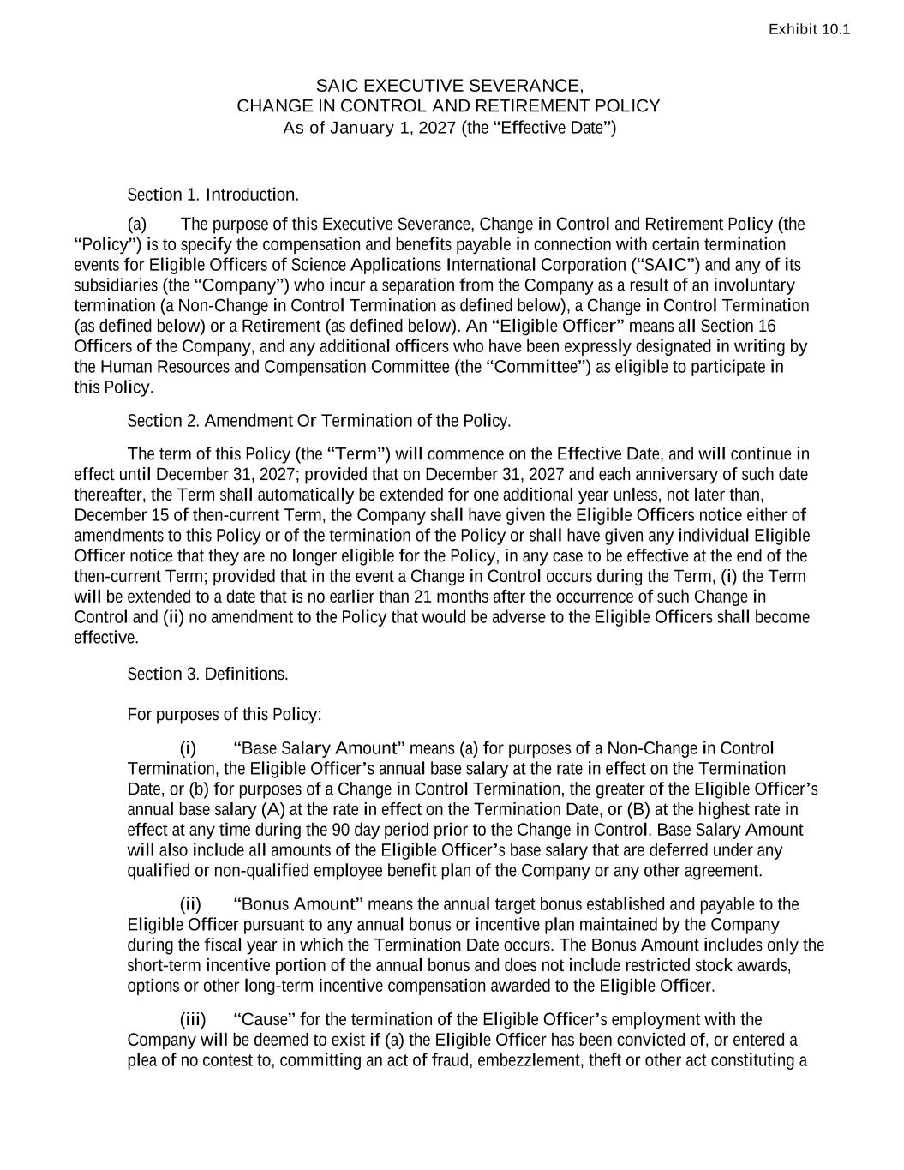
-34-
Exhibit 10.1 SAIC EXECUTIVE SEVERANCE, CHANGE IN CONTROL AND RETIREMENT POLICY As of January 1, 2027 (the “Effective Date”) Section 1. Introduction. (a) The purpose of this Executive Severance, Change in Control and Retirement Policy (the “Policy”) is to specify the compensation and benefits payable in connection with certain termination events for Eligible Officers of Science Applications International Corporation (“SAIC”) and any of its subsidiaries (the “Company”) who incur a separation from the Company as a result of an involuntary termination (a Non-Change in Control Termination as defined below), a Change in Control Termination (as defined below) or a Retirement (as defined below). An “Eligible Officer” means all Section 16 Officers of the Company, and any additional officers who have been expressly designated in writing by the Human Resources and Compensation Committee (the “Committee”) as eligible to participate in this Policy. Section 2. Amendment Or Termination of the Policy. The term of this Policy (the “Term”) will commence on the Effective Date, and will continue in effect until December 31, 2027; provided that on December 31, 2027 and each anniversary of such date thereafter, the Term shall automatically be extended for one additional year unless, not later than, December 15 of then-current Term, the Company shall have given the Eligible Officers notice either of amendments to this Policy or of the termination of the Policy or shall have given any individual Eligible Officer notice that they are no longer eligible for the Policy, in any case to be effective at the end of the then-current Term; provided that in the event a Change in Control occurs during the Term, (i) the Term will be extended to a date that is no earlier than 21 months after the occurrence of such Change in Control and (ii) no amendment to the Policy that would be adverse to the Eligible Officers shall become effective. Section 3. Definitions. For purposes of this Policy: (i) “Base Salary Amount” means (a) for purposes of a Non-Change in Control Termination, the Eligible Officer’s annual base salary at the rate in effect on the Termination Date, or (b) for purposes of a Change in Control Termination, the greater of the Eligible Officer’s annual base salary (A) at the rate in effect on the Termination Date, or (B) at the highest rate in effect at any time during the 90 day period prior to the Change in Control. Base Salary Amount will also include all amounts of the Eligible Officer’s base salary that are deferred under any qualified or non-qualified employee benefit plan of the Company or any other agreement. (ii) “Bonus Amount” means the annual target bonus established and payable to the Eligible Officer pursuant to any annual bonus or incentive plan maintained by the Company during the fiscal year in which the Termination Date occurs. The Bonus Amount includes only the short-term incentive portion of the annual bonus and does not include restricted stock awards, options or other long-term incentive compensation awarded to the Eligible Officer. (iii) “Cause” for the termination of the Eligible Officer’s employment with the Company will be deemed to exist if (a) the Eligible Officer has been convicted of, or entered a plea of no contest to, committing an act of fraud, embezzlement, theft or other act constituting a

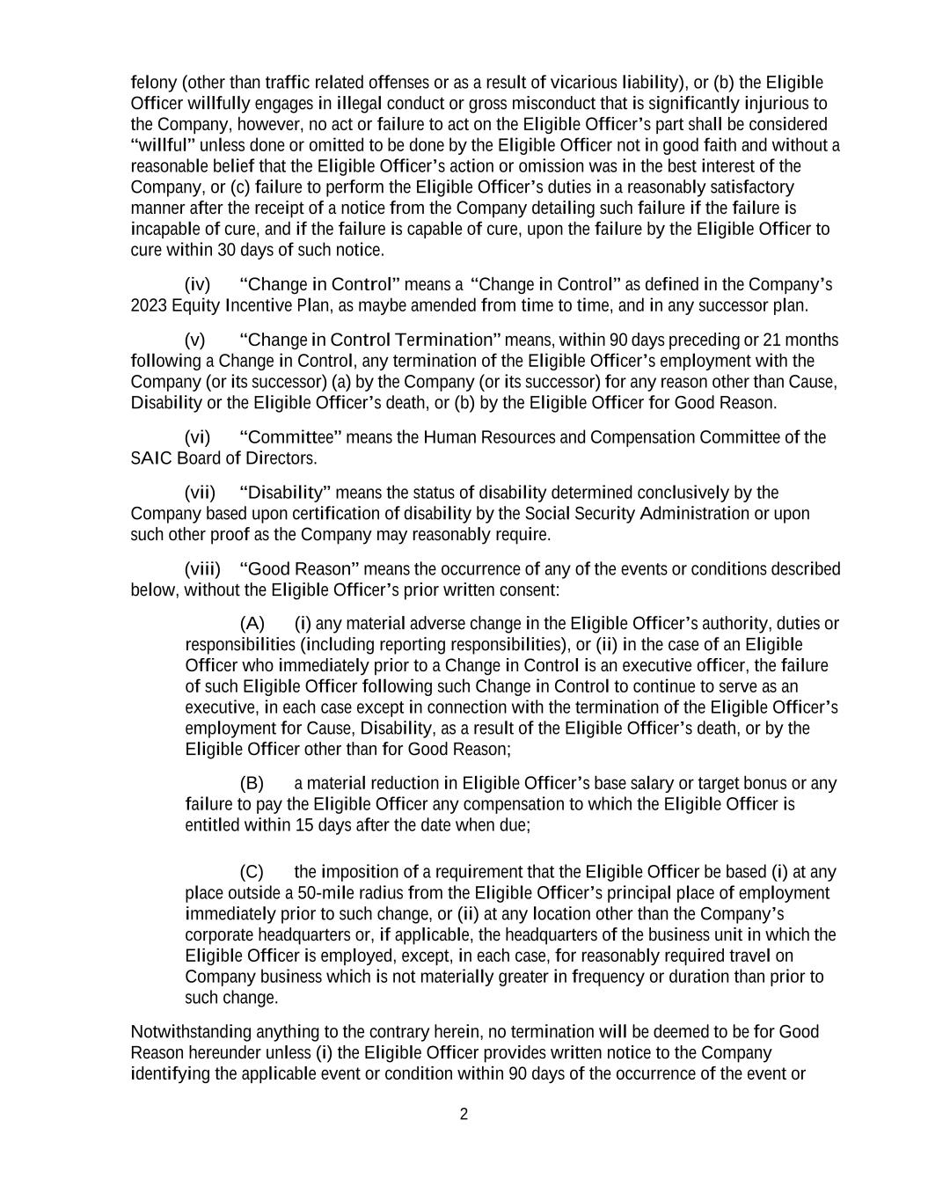
2 felony (other than traffic related offenses or as a result of vicarious liability), or (b) the Eligible Officer willfully engages in illegal conduct or gross misconduct that is significantly injurious to the Company, however, no act or failure to act on the Eligible Officer’s part shall be considered “willful” unless done or omitted to be done by the Eligible Officer not in good faith and without a reasonable belief that the Eligible Officer’s action or omission was in the best interest of the Company, or (c) failure to perform the Eligible Officer’s duties in a reasonably satisfactory manner after the receipt of a notice from the Company detailing such failure if the failure is incapable of cure, and if the failure is capable of cure, upon the failure by the Eligible Officer to cure within 30 days of such notice. (iv) “Change in Control” means a “Change in Control” as defined in the Company’s 2023 Equity Incentive Plan, as maybe amended from time to time, and in any successor plan. (v) “Change in Control Termination” means, within 90 days preceding or 21 months following a Change in Control, any termination of the Eligible Officer’s employment with the Company (or its successor) (a) by the Company (or its successor) for any reason other than Cause, Disability or the Eligible Officer’s death, or (b) by the Eligible Officer for Good Reason. (vi) “Committee” means the Human Resources and Compensation Committee of the SAIC Board of Directors. (vii) “Disability” means the status of disability determined conclusively by the Company based upon certification of disability by the Social Security Administration or upon such other proof as the Company may reasonably require. (viii) “Good Reason” means the occurrence of any of the events or conditions described below, without the Eligible Officer’s prior written consent: (A) (i) any material adverse change in the Eligible Officer’s authority, duties or responsibilities (including reporting responsibilities), or (ii) in the case of an Eligible Officer who immediately prior to a Change in Control is an executive officer, the failure of such Eligible Officer following such Change in Control to continue to serve as an executive, in each case except in connection with the termination of the Eligible Officer’s employment for Cause, Disability, as a result of the Eligible Officer’s death, or by the Eligible Officer other than for Good Reason; (B) a material reduction in Eligible Officer’s base salary or target bonus or any failure to pay the Eligible Officer any compensation to which the Eligible Officer is entitled within 15 days after the date when due; (C) the imposition of a requirement that the Eligible Officer be based (i) at any place outside a 50-mile radius from the Eligible Officer’s principal place of employment immediately prior to such change, or (ii) at any location other than the Company’s corporate headquarters or, if applicable, the headquarters of the business unit in which the Eligible Officer is employed, except, in each case, for reasonably required travel on Company business which is not materially greater in frequency or duration than prior to such change. Notwithstanding anything to the contrary herein, no termination will be deemed to be for Good Reason hereunder unless (i) the Eligible Officer provides written notice to the Company identifying the applicable event or condition within 90 days of the occurrence of the event or

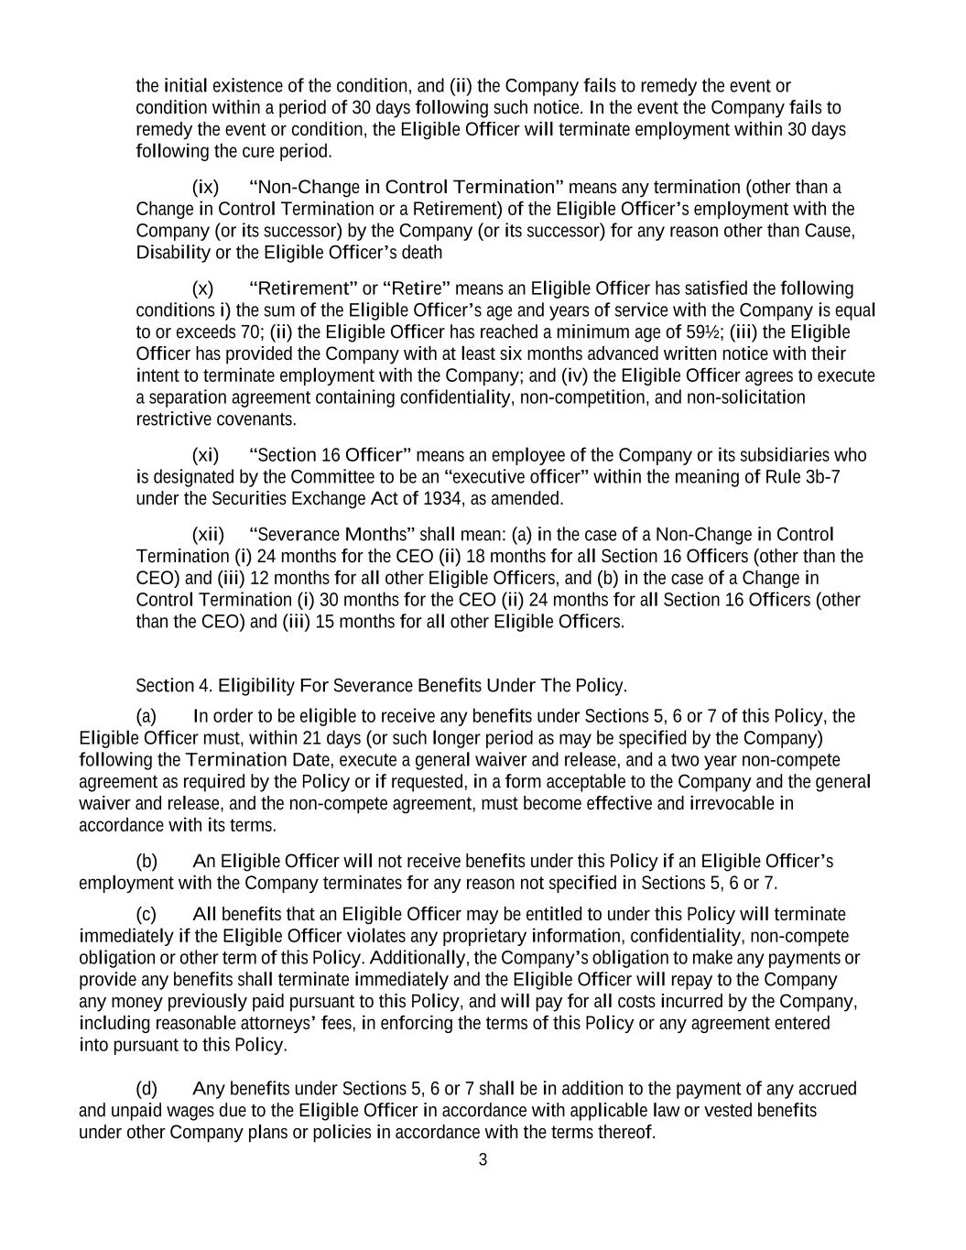
3 the initial existence of the condition, and (ii) the Company fails to remedy the event or condition within a period of 30 days following such notice. In the event the Company fails to remedy the event or condition, the Eligible Officer will terminate employment within 30 days following the cure period. (ix) “Non-Change in Control Termination” means any termination (other than a Change in Control Termination or a Retirement) of the Eligible Officer’s employment with the Company (or its successor) by the Company (or its successor) for any reason other than Cause, Disability or the Eligible Officer’s death (x) “Retirement” or “Retire” means an Eligible Officer has satisfied the following conditions i) the sum of the Eligible Officer’s age and years of service with the Company is equal to or exceeds 70; (ii) the Eligible Officer has reached a minimum age of 59½; (iii) the Eligible Officer has provided the Company with at least six months advanced written notice with their intent to terminate employment with the Company; and (iv) the Eligible Officer agrees to execute a separation agreement containing confidentiality, non-competition, and non-solicitation restrictive covenants. (xi) “Section 16 Officer” means an employee of the Company or its subsidiaries who is designated by the Committee to be an “executive officer” within the meaning of Rule 3b-7 under the Securities Exchange Act of 1934, as amended. (xii) “Severance Months” shall mean: (a) in the case of a Non-Change in Control Termination (i) 24 months for the CEO (ii) 18 months for all Section 16 Officers (other than the CEO) and (iii) 12 months for all other Eligible Officers, and (b) in the case of a Change in Control Termination (i) 30 months for the CEO (ii) 24 months for all Section 16 Officers (other than the CEO) and (iii) 15 months for all other Eligible Officers. Section 4. Eligibility For Severance Benefits Under The Policy. (a) In order to be eligible to receive any benefits under Sections 5, 6 or 7 of this Policy, the Eligible Officer must, within 21 days (or such longer period as may be specified by the Company) following the Termination Date, execute a general waiver and release, and a two year non-compete agreement as required by the Policy or if requested, in a form acceptable to the Company and the general waiver and release, and the non-compete agreement, must become effective and irrevocable in accordance with its terms. (b) An Eligible Officer will not receive benefits under this Policy if an Eligible Officer’s employment with the Company terminates for any reason not specified in Sections 5, 6 or 7. (c) All benefits that an Eligible Officer may be entitled to under this Policy will terminate immediately if the Eligible Officer violates any proprietary information, confidentiality, non-compete obligation or other term of this Policy. Additionally, the Company’s obligation to make any payments or provide any benefits shall terminate immediately and the Eligible Officer will repay to the Company any money previously paid pursuant to this Policy, and will pay for all costs incurred by the Company, including reasonable attorneys’ fees, in enforcing the terms of this Policy or any agreement entered into pursuant to this Policy. (d) Any benefits under Sections 5, 6 or 7 shall be in addition to the payment of any accrued and unpaid wages due to the Eligible Officer in accordance with applicable law or vested benefits under other Company plans or policies in accordance with the terms thereof.

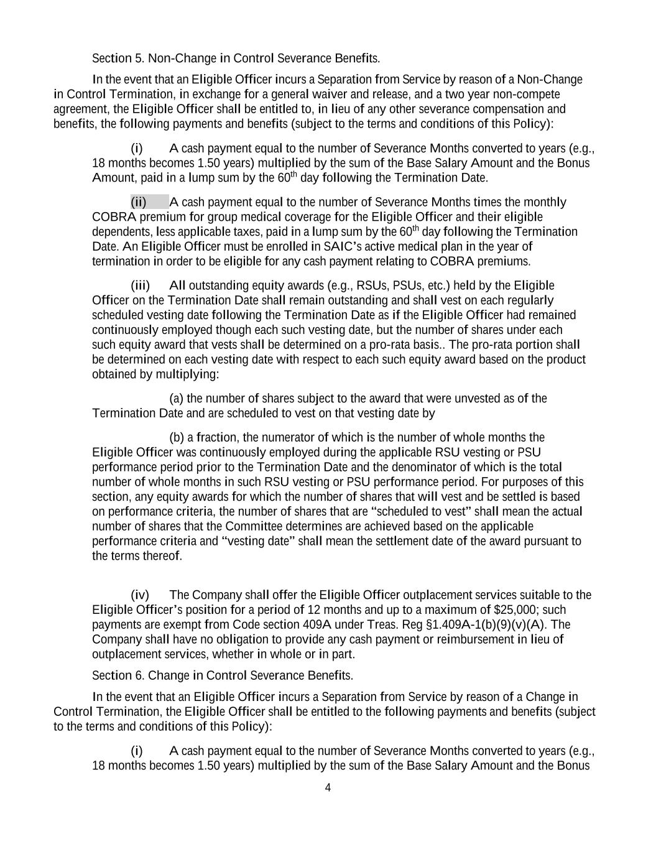
4 Section 5. Non-Change in Control Severance Benefits. In the event that an Eligible Officer incurs a Separation from Service by reason of a Non-Change in Control Termination, in exchange for a general waiver and release, and a two year non-compete agreement, the Eligible Officer shall be entitled to, in lieu of any other severance compensation and benefits, the following payments and benefits (subject to the terms and conditions of this Policy): (i) A cash payment equal to the number of Severance Months converted to years (e.g., 18 months becomes 1.50 years) multiplied by the sum of the Base Salary Amount and the Bonus Amount, paid in a lump sum by the 60th day following the Termination Date. (ii) A cash payment equal to the number of Severance Months times the monthly COBRA premium for group medical coverage for the Eligible Officer and their eligible dependents, less applicable taxes, paid in a lump sum by the 60th day following the Termination Date. An Eligible Officer must be enrolled in SAIC’s active medical plan in the year of termination in order to be eligible for any cash payment relating to COBRA premiums. (iii) All outstanding equity awards (e.g., RSUs, PSUs, etc.) held by the Eligible Officer on the Termination Date shall remain outstanding and shall vest on each regularly scheduled vesting date following the Termination Date as if the Eligible Officer had remained continuously employed though each such vesting date, but the number of shares under each such equity award that vests shall be determined on a pro-rata basis.. The pro-rata portion shall be determined on each vesting date with respect to each such equity award based on the product obtained by multiplying: (a) the number of shares subject to the award that were unvested as of the Termination Date and are scheduled to vest on that vesting date by (b) a fraction, the numerator of which is the number of whole months the Eligible Officer was continuously employed during the applicable RSU vesting or PSU performance period prior to the Termination Date and the denominator of which is the total number of whole months in such RSU vesting or PSU performance period. For purposes of this section, any equity awards for which the number of shares that will vest and be settled is based on performance criteria, the number of shares that are “scheduled to vest” shall mean the actual number of shares that the Committee determines are achieved based on the applicable performance criteria and “vesting date” shall mean the settlement date of the award pursuant to the terms thereof. (iv) The Company shall offer the Eligible Officer outplacement services suitable to the Eligible Officer’s position for a period of 12 months and up to a maximum of $25,000; such payments are exempt from Code section 409A under Treas. Reg §1.409A-1(b)(9)(v)(A). The Company shall have no obligation to provide any cash payment or reimbursement in lieu of outplacement services, whether in whole or in part. Section 6. Change in Control Severance Benefits. In the event that an Eligible Officer incurs a Separation from Service by reason of a Change in Control Termination, the Eligible Officer shall be entitled to the following payments and benefits (subject to the terms and conditions of this Policy): (i) A cash payment equal to the number of Severance Months converted to years (e.g., 18 months becomes 1.50 years) multiplied by the sum of the Base Salary Amount and the Bonus

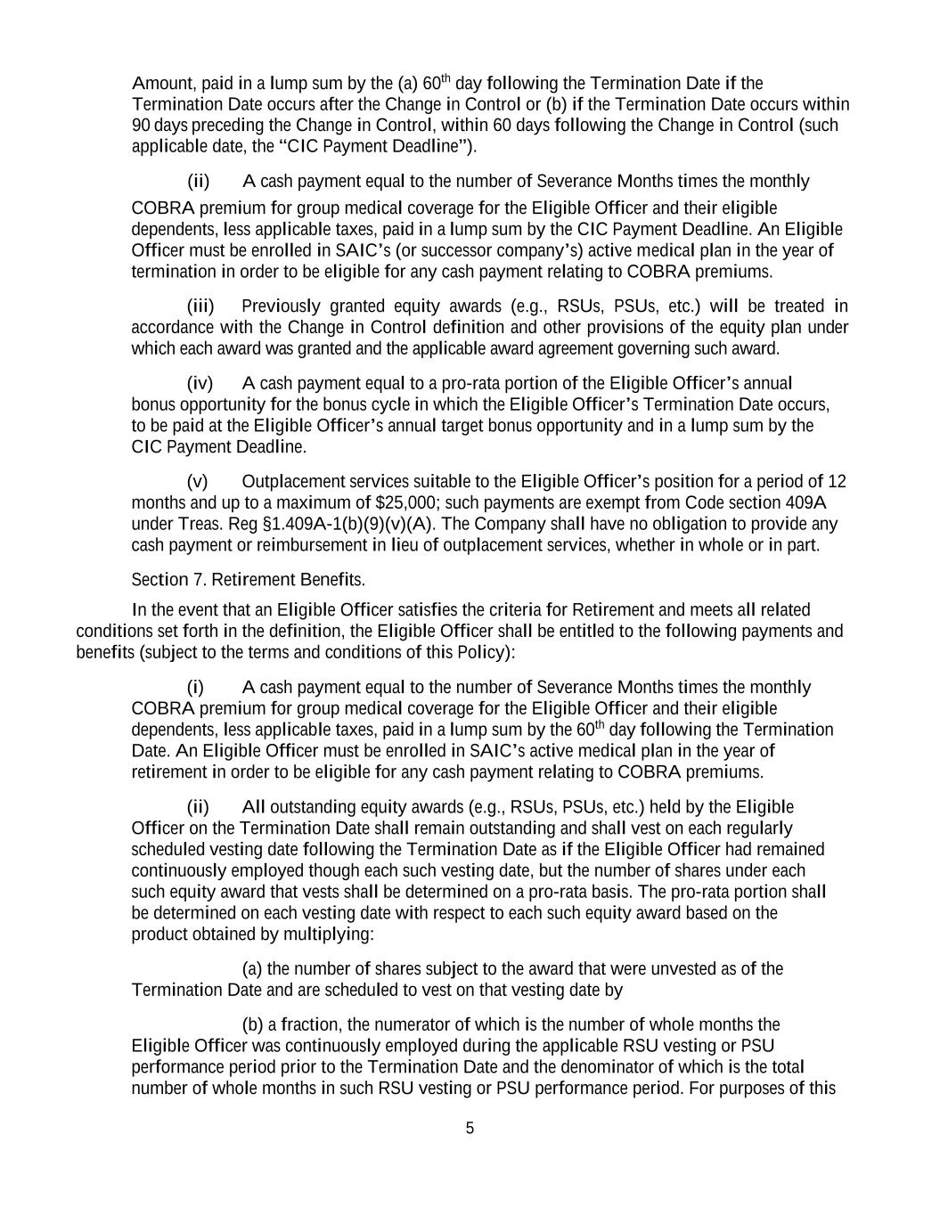
5 Amount, paid in a lump sum by the (a) 60th day following the Termination Date if the Termination Date occurs after the Change in Control or (b) if the Termination Date occurs within 90 days preceding the Change in Control, within 60 days following the Change in Control (such applicable date, the “CIC Payment Deadline”). (ii) A cash payment equal to the number of Severance Months times the monthly COBRA premium for group medical coverage for the Eligible Officer and their eligible dependents, less applicable taxes, paid in a lump sum by the CIC Payment Deadline. An Eligible Officer must be enrolled in SAIC’s (or successor company’s) active medical plan in the year of termination in order to be eligible for any cash payment relating to COBRA premiums. (iii) Previously granted equity awards (e.g., RSUs, PSUs, etc.) will be treated in accordance with the Change in Control definition and other provisions of the equity plan under which each award was granted and the applicable award agreement governing such award. (iv) A cash payment equal to a pro-rata portion of the Eligible Officer’s annual bonus opportunity for the bonus cycle in which the Eligible Officer’s Termination Date occurs, to be paid at the Eligible Officer’s annual target bonus opportunity and in a lump sum by the CIC Payment Deadline. (v) Outplacement services suitable to the Eligible Officer’s position for a period of 12 months and up to a maximum of $25,000; such payments are exempt from Code section 409A under Treas. Reg §1.409A-1(b)(9)(v)(A). The Company shall have no obligation to provide any cash payment or reimbursement in lieu of outplacement services, whether in whole or in part. Section 7. Retirement Benefits. In the event that an Eligible Officer satisfies the criteria for Retirement and meets all related conditions set forth in the definition, the Eligible Officer shall be entitled to the following payments and benefits (subject to the terms and conditions of this Policy): (i) A cash payment equal to the number of Severance Months times the monthly COBRA premium for group medical coverage for the Eligible Officer and their eligible dependents, less applicable taxes, paid in a lump sum by the 60th day following the Termination Date. An Eligible Officer must be enrolled in SAIC’s active medical plan in the year of retirement in order to be eligible for any cash payment relating to COBRA premiums. (ii) All outstanding equity awards (e.g., RSUs, PSUs, etc.) held by the Eligible Officer on the Termination Date shall remain outstanding and shall vest on each regularly scheduled vesting date following the Termination Date as if the Eligible Officer had remained continuously employed though each such vesting date, but the number of shares under each such equity award that vests shall be determined on a pro-rata basis. The pro-rata portion shall be determined on each vesting date with respect to each such equity award based on the product obtained by multiplying: (a) the number of shares subject to the award that were unvested as of the Termination Date and are scheduled to vest on that vesting date by (b) a fraction, the numerator of which is the number of whole months the Eligible Officer was continuously employed during the applicable RSU vesting or PSU performance period prior to the Termination Date and the denominator of which is the total number of whole months in such RSU vesting or PSU performance period. For purposes of this

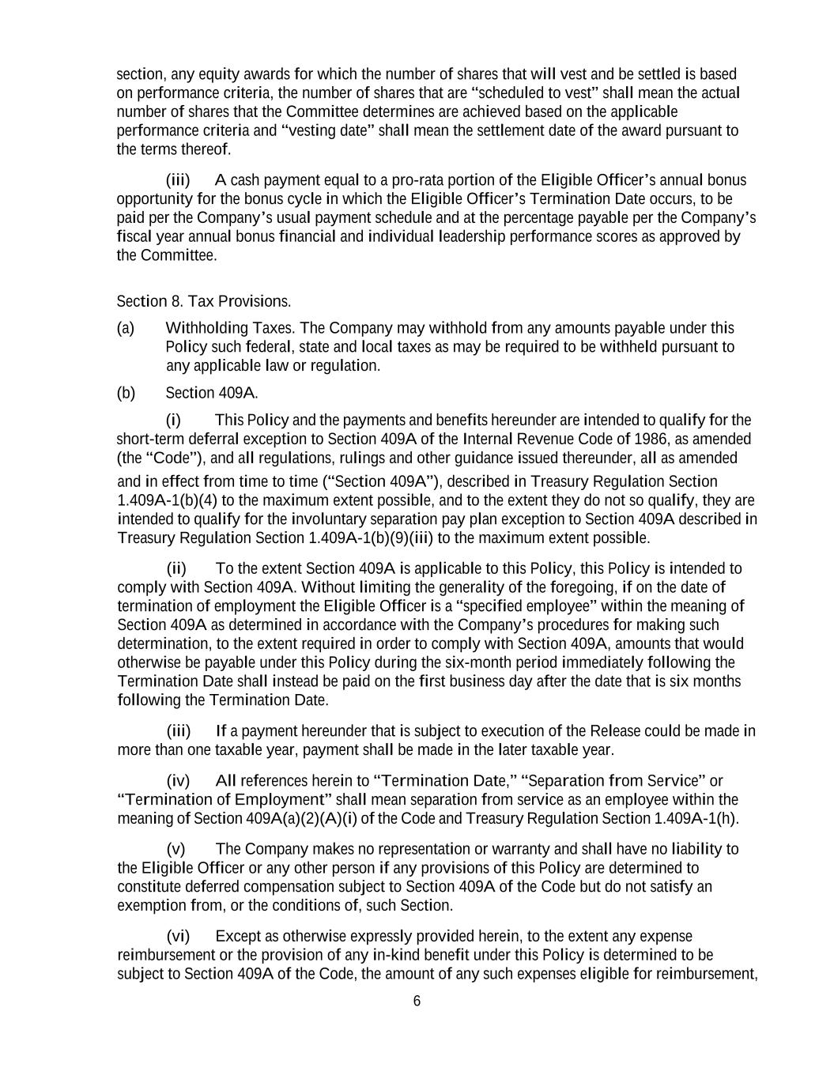
6 section, any equity awards for which the number of shares that will vest and be settled is based on performance criteria, the number of shares that are “scheduled to vest” shall mean the actual number of shares that the Committee determines are achieved based on the applicable performance criteria and “vesting date” shall mean the settlement date of the award pursuant to the terms thereof. (iii) A cash payment equal to a pro-rata portion of the Eligible Officer’s annual bonus opportunity for the bonus cycle in which the Eligible Officer’s Termination Date occurs, to be paid per the Company’s usual payment schedule and at the percentage payable per the Company’s fiscal year annual bonus financial and individual leadership performance scores as approved by the Committee. Section 8. Tax Provisions. (a) Withholding Taxes. The Company may withhold from any amounts payable under this Policy such federal, state and local taxes as may be required to be withheld pursuant to any applicable law or regulation. (b) Section 409A. (i) This Policy and the payments and benefits hereunder are intended to qualify for the short-term deferral exception to Section 409A of the Internal Revenue Code of 1986, as amended (the “Code”), and all regulations, rulings and other guidance issued thereunder, all as amended and in effect from time to time (“Section 409A”), described in Treasury Regulation Section 1.409A-1(b)(4) to the maximum extent possible, and to the extent they do not so qualify, they are intended to qualify for the involuntary separation pay plan exception to Section 409A described in Treasury Regulation Section 1.409A-1(b)(9)(iii) to the maximum extent possible. (ii) To the extent Section 409A is applicable to this Policy, this Policy is intended to comply with Section 409A. Without limiting the generality of the foregoing, if on the date of termination of employment the Eligible Officer is a “specified employee” within the meaning of Section 409A as determined in accordance with the Company’s procedures for making such determination, to the extent required in order to comply with Section 409A, amounts that would otherwise be payable under this Policy during the six-month period immediately following the Termination Date shall instead be paid on the first business day after the date that is six months following the Termination Date. (iii) If a payment hereunder that is subject to execution of the Release could be made in more than one taxable year, payment shall be made in the later taxable year. (iv) All references herein to “Termination Date,” “Separation from Service” or “Termination of Employment” shall mean separation from service as an employee within the meaning of Section 409A(a)(2)(A)(i) of the Code and Treasury Regulation Section 1.409A-1(h). (v) The Company makes no representation or warranty and shall have no liability to the Eligible Officer or any other person if any provisions of this Policy are determined to constitute deferred compensation subject to Section 409A of the Code but do not satisfy an exemption from, or the conditions of, such Section. (vi) Except as otherwise expressly provided herein, to the extent any expense reimbursement or the provision of any in-kind benefit under this Policy is determined to be subject to Section 409A of the Code, the amount of any such expenses eligible for reimbursement,

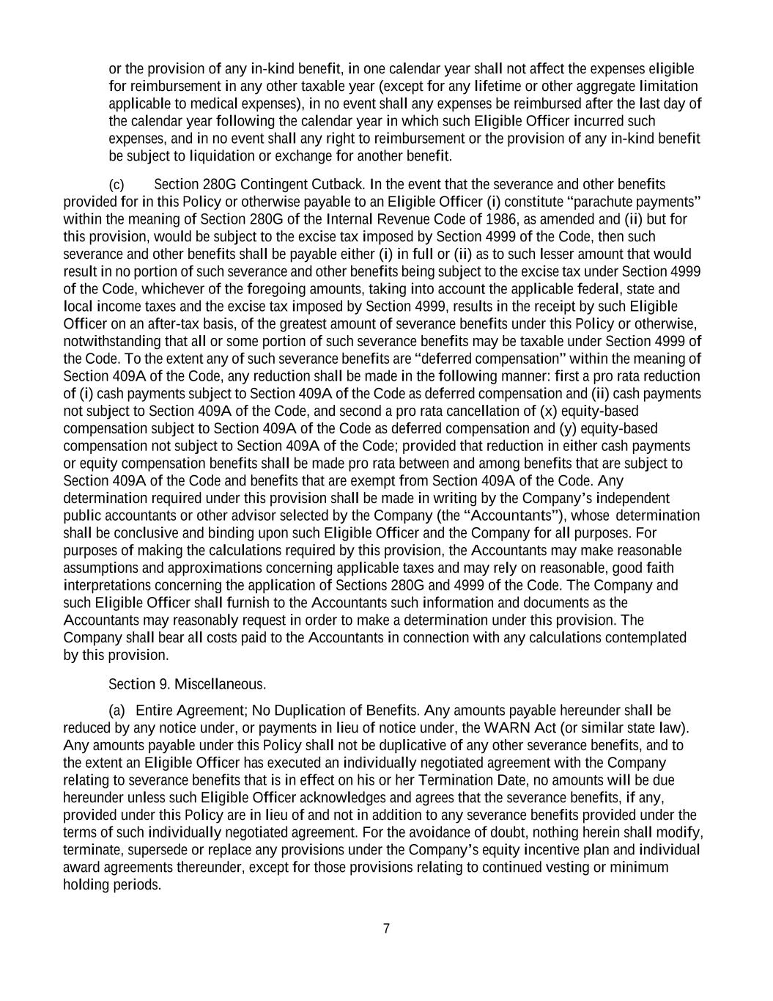
7 or the provision of any in-kind benefit, in one calendar year shall not affect the expenses eligible for reimbursement in any other taxable year (except for any lifetime or other aggregate limitation applicable to medical expenses), in no event shall any expenses be reimbursed after the last day of the calendar year following the calendar year in which such Eligible Officer incurred such expenses, and in no event shall any right to reimbursement or the provision of any in-kind benefit be subject to liquidation or exchange for another benefit. (c) Section 280G Contingent Cutback. In the event that the severance and other benefits provided for in this Policy or otherwise payable to an Eligible Officer (i) constitute “parachute payments” within the meaning of Section 280G of the Internal Revenue Code of 1986, as amended and (ii) but for this provision, would be subject to the excise tax imposed by Section 4999 of the Code, then such severance and other benefits shall be payable either (i) in full or (ii) as to such lesser amount that would result in no portion of such severance and other benefits being subject to the excise tax under Section 4999 of the Code, whichever of the foregoing amounts, taking into account the applicable federal, state and local income taxes and the excise tax imposed by Section 4999, results in the receipt by such Eligible Officer on an after-tax basis, of the greatest amount of severance benefits under this Policy or otherwise, notwithstanding that all or some portion of such severance benefits may be taxable under Section 4999 of the Code. To the extent any of such severance benefits are “deferred compensation” within the meaning of Section 409A of the Code, any reduction shall be made in the following manner: first a pro rata reduction of (i) cash payments subject to Section 409A of the Code as deferred compensation and (ii) cash payments not subject to Section 409A of the Code, and second a pro rata cancellation of (x) equity-based compensation subject to Section 409A of the Code as deferred compensation and (y) equity-based compensation not subject to Section 409A of the Code; provided that reduction in either cash payments or equity compensation benefits shall be made pro rata between and among benefits that are subject to Section 409A of the Code and benefits that are exempt from Section 409A of the Code. Any determination required under this provision shall be made in writing by the Company’s independent public accountants or other advisor selected by the Company (the “Accountants”), whose determination shall be conclusive and binding upon such Eligible Officer and the Company for all purposes. For purposes of making the calculations required by this provision, the Accountants may make reasonable assumptions and approximations concerning applicable taxes and may rely on reasonable, good faith interpretations concerning the application of Sections 280G and 4999 of the Code. The Company and such Eligible Officer shall furnish to the Accountants such information and documents as the Accountants may reasonably request in order to make a determination under this provision. The Company shall bear all costs paid to the Accountants in connection with any calculations contemplated by this provision. Section 9. Miscellaneous. (a) Entire Agreement; No Duplication of Benefits. Any amounts payable hereunder shall be reduced by any notice under, or payments in lieu of notice under, the WARN Act (or similar state law). Any amounts payable under this Policy shall not be duplicative of any other severance benefits, and to the extent an Eligible Officer has executed an individually negotiated agreement with the Company relating to severance benefits that is in effect on his or her Termination Date, no amounts will be due hereunder unless such Eligible Officer acknowledges and agrees that the severance benefits, if any, provided under this Policy are in lieu of and not in addition to any severance benefits provided under the terms of such individually negotiated agreement. For the avoidance of doubt, nothing herein shall modify, terminate, supersede or replace any provisions under the Company’s equity incentive plan and individual award agreements thereunder, except for those provisions relating to continued vesting or minimum holding periods.

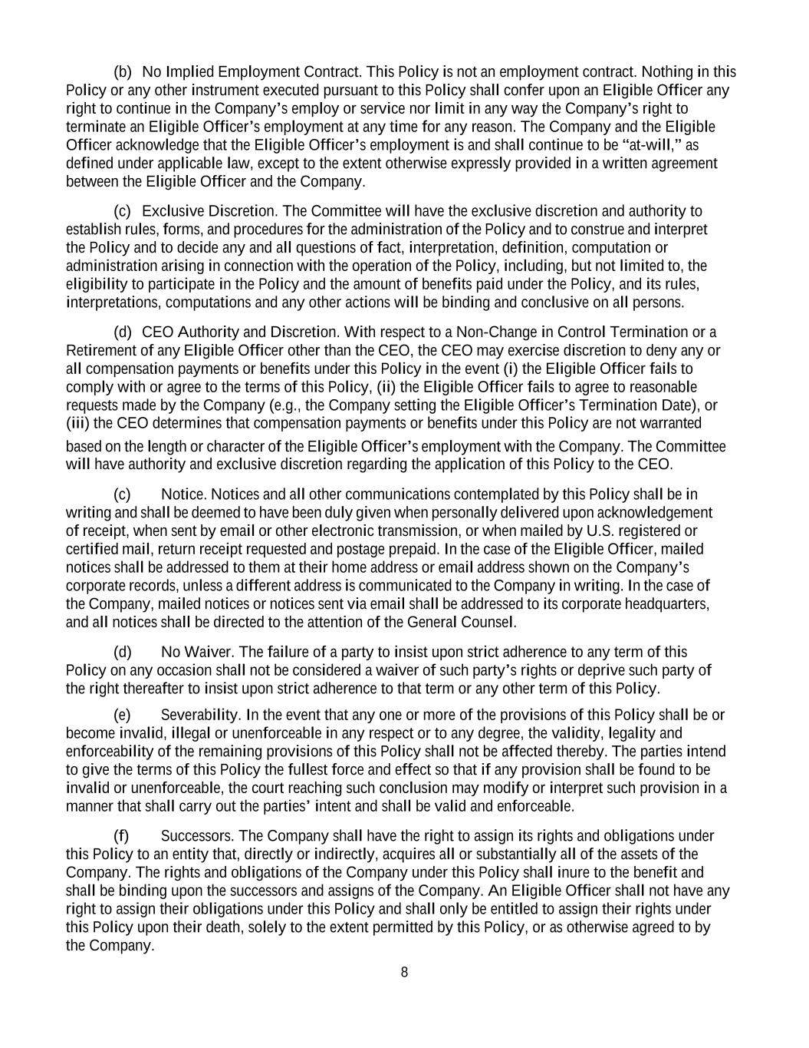
8 (b) No Implied Employment Contract. This Policy is not an employment contract. Nothing in this Policy or any other instrument executed pursuant to this Policy shall confer upon an Eligible Officer any right to continue in the Company’s employ or service nor limit in any way the Company’s right to terminate an Eligible Officer’s employment at any time for any reason. The Company and the Eligible Officer acknowledge that the Eligible Officer’s employment is and shall continue to be “at-will,” as defined under applicable law, except to the extent otherwise expressly provided in a written agreement between the Eligible Officer and the Company. (c) Exclusive Discretion. The Committee will have the exclusive discretion and authority to establish rules, forms, and procedures for the administration of the Policy and to construe and interpret the Policy and to decide any and all questions of fact, interpretation, definition, computation or administration arising in connection with the operation of the Policy, including, but not limited to, the eligibility to participate in the Policy and the amount of benefits paid under the Policy, and its rules, interpretations, computations and any other actions will be binding and conclusive on all persons. (d) CEO Authority and Discretion. With respect to a Non-Change in Control Termination or a Retirement of any Eligible Officer other than the CEO, the CEO may exercise discretion to deny any or all compensation payments or benefits under this Policy in the event (i) the Eligible Officer fails to comply with or agree to the terms of this Policy, (ii) the Eligible Officer fails to agree to reasonable requests made by the Company (e.g., the Company setting the Eligible Officer’s Termination Date), or (iii) the CEO determines that compensation payments or benefits under this Policy are not warranted based on the length or character of the Eligible Officer’s employment with the Company. The Committee will have authority and exclusive discretion regarding the application of this Policy to the CEO. (c) Notice. Notices and all other communications contemplated by this Policy shall be in writing and shall be deemed to have been duly given when personally delivered upon acknowledgement of receipt, when sent by email or other electronic transmission, or when mailed by U.S. registered or certified mail, return receipt requested and postage prepaid. In the case of the Eligible Officer, mailed notices shall be addressed to them at their home address or email address shown on the Company’s corporate records, unless a different address is communicated to the Company in writing. In the case of the Company, mailed notices or notices sent via email shall be addressed to its corporate headquarters, and all notices shall be directed to the attention of the General Counsel. (d) No Waiver. The failure of a party to insist upon strict adherence to any term of this Policy on any occasion shall not be considered a waiver of such party’s rights or deprive such party of the right thereafter to insist upon strict adherence to that term or any other term of this Policy. (e) Severability. In the event that any one or more of the provisions of this Policy shall be or become invalid, illegal or unenforceable in any respect or to any degree, the validity, legality and enforceability of the remaining provisions of this Policy shall not be affected thereby. The parties intend to give the terms of this Policy the fullest force and effect so that if any provision shall be found to be invalid or unenforceable, the court reaching such conclusion may modify or interpret such provision in a manner that shall carry out the parties’ intent and shall be valid and enforceable. (f) Successors. The Company shall have the right to assign its rights and obligations under this Policy to an entity that, directly or indirectly, acquires all or substantially all of the assets of the Company. The rights and obligations of the Company under this Policy shall inure to the benefit and shall be binding upon the successors and assigns of the Company. An Eligible Officer shall not have any right to assign their obligations under this Policy and shall only be entitled to assign their rights under this Policy upon their death, solely to the extent permitted by this Policy, or as otherwise agreed to by the Company.


9 (g) Creditor Status of Eligible Officers. In the event that any Eligible Officer acquires a right to receive payments from the Company under this Policy, such right shall be no greater than the right of any unsecured general creditor of the Company. (h) Governing Law. This Policy is intended to be governed by and will be construed in accordance with the laws of the Commonwealth of Virginia. (i) Supremacy Clause. To the extent that the defined terms and conditions in this Policy conflict with the award agreement, the definitions set forth in here shall prevail.

Exhibit 10.3

AMENDMENT NO. 2
TO THE
SCIENCE APPLICATIONS INTERNATIONAL CORPORATION
2023 EQUITY INCENTIVE PLAN
WHEREAS, Science Applications International Corporation (the “Company”) maintains the 2023 Equity Incentive Plan (the “Plan”), which was approved by the Company’s stockholders in 2023.
WHEREAS, the Human Resources and Compensation Committee (the “Committee”) has reviewed the projected needs of the Company’s compensation program, including anticipated equity usage, competitive practices, dilution levels, and the Company’s strategic and compensation objectives.
WHEREAS, the Committee has determined that it is in the best interests of the Company and its stockholders to amend the Plan to increase the number of shares authorized for awards granted under the Plan by up to an additional 1,194,000 shares.
RESOLVED, that the Committee hereby approves, and recommends to the Board of Directors that it approve and recommend to the stockholders for approval at the Company’s 2026 Annual Meeting of Stockholders, an amendment to the Plan to increase the number of shares authorized for awards granted under the Plan by up to an additional 1,194,000 shares.
Approved by the Human Resources and Compensation Committee on March 24, 2026.
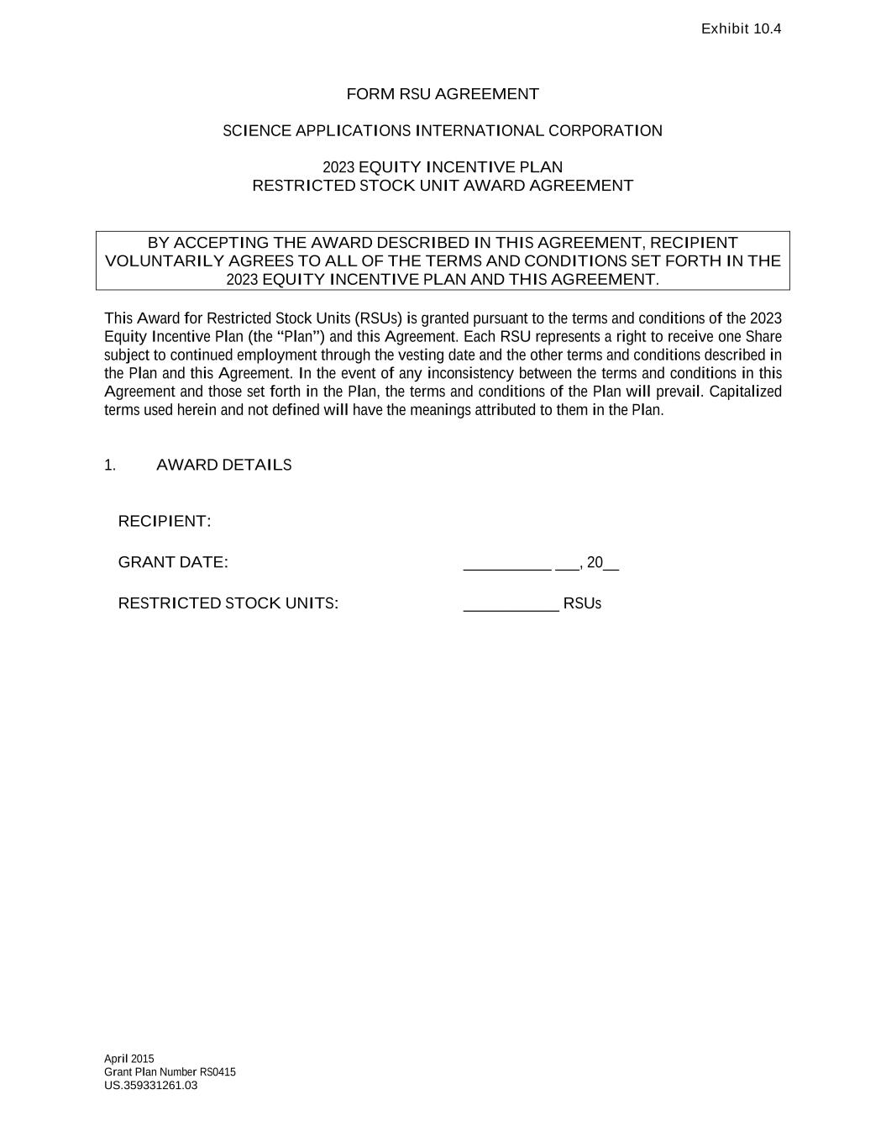

US.359331261.03 Exhibit 10.4 April 2015 Grant Plan Number RS0415 FORM RSU AGREEMENT SCIENCE APPLICATIONS INTERNATIONAL CORPORATION 2023 EQUITY INCENTIVE PLAN RESTRICTED STOCK UNIT AWARD AGREEMENT BY ACCEPTING THE AWARD DESCRIBED IN THIS AGREEMENT, RECIPIENT VOLUNTARILY AGREES TO ALL OF THE TERMS AND CONDITIONS SET FORTH IN THE 2023 EQUITY INCENTIVE PLAN AND THIS AGREEMENT. This Award for Restricted Stock Units (RSUs) is granted pursuant to the terms and conditions of the 2023 Equity Incentive Plan (the “Plan”) and this Agreement. Each RSU represents a right to receive one Share subject to continued employment through the vesting date and the other terms and conditions described in the Plan and this Agreement. In the event of any inconsistency between the terms and conditions in this Agreement and those set forth in the Plan, the terms and conditions of the Plan will prevail. Capitalized terms used herein and not defined will have the meanings attributed to them in the Plan. 1. AWARD DETAILS RECIPIENT: GRANT DATE: ___________ ___, 20__ RESTRICTED STOCK UNITS: ____________ RSUs

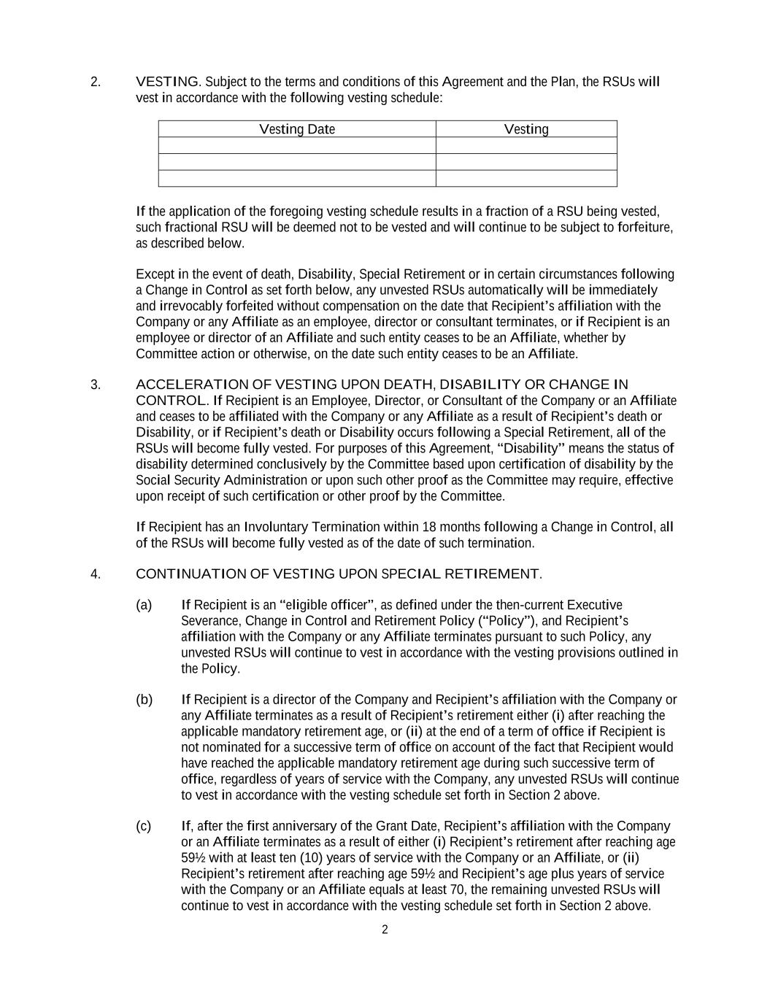
2 2. VESTING. Subject to the terms and conditions of this Agreement and the Plan, the RSUs will vest in accordance with the following vesting schedule: Vesting Date Vesting If the application of the foregoing vesting schedule results in a fraction of a RSU being vested, such fractional RSU will be deemed not to be vested and will continue to be subject to forfeiture, as described below. Except in the event of death, Disability, Special Retirement or in certain circumstances following a Change in Control as set forth below, any unvested RSUs automatically will be immediately and irrevocably forfeited without compensation on the date that Recipient’s affiliation with the Company or any Affiliate as an employee, director or consultant terminates, or if Recipient is an employee or director of an Affiliate and such entity ceases to be an Affiliate, whether by Committee action or otherwise, on the date such entity ceases to be an Affiliate. 3. ACCELERATION OF VESTING UPON DEATH, DISABILITY OR CHANGE IN CONTROL. If Recipient is an Employee, Director, or Consultant of the Company or an Affiliate and ceases to be affiliated with the Company or any Affiliate as a result of Recipient’s death or Disability, or if Recipient’s death or Disability occurs following a Special Retirement, all of the RSUs will become fully vested. For purposes of this Agreement, “Disability” means the status of disability determined conclusively by the Committee based upon certification of disability by the Social Security Administration or upon such other proof as the Committee may require, effective upon receipt of such certification or other proof by the Committee. If Recipient has an Involuntary Termination within 18 months following a Change in Control, all of the RSUs will become fully vested as of the date of such termination. 4. CONTINUATION OF VESTING UPON SPECIAL RETIREMENT. (a) If Recipient is an “eligible officer”, as defined under the then-current Executive Severance, Change in Control and Retirement Policy (“Policy”), and Recipient’s affiliation with the Company or any Affiliate terminates pursuant to such Policy, any unvested RSUs will continue to vest in accordance with the vesting provisions outlined in the Policy. (b) If Recipient is a director of the Company and Recipient’s affiliation with the Company or any Affiliate terminates as a result of Recipient’s retirement either (i) after reaching the applicable mandatory retirement age, or (ii) at the end of a term of office if Recipient is not nominated for a successive term of office on account of the fact that Recipient would have reached the applicable mandatory retirement age during such successive term of office, regardless of years of service with the Company, any unvested RSUs will continue to vest in accordance with the vesting schedule set forth in Section 2 above. (c) If, after the first anniversary of the Grant Date, Recipient’s affiliation with the Company or an Affiliate terminates as a result of either (i) Recipient’s retirement after reaching age 59½ with at least ten (10) years of service with the Company or an Affiliate, or (ii) Recipient’s retirement after reaching age 59½ and Recipient’s age plus years of service with the Company or an Affiliate equals at least 70, the remaining unvested RSUs will continue to vest in accordance with the vesting schedule set forth in Section 2 above.

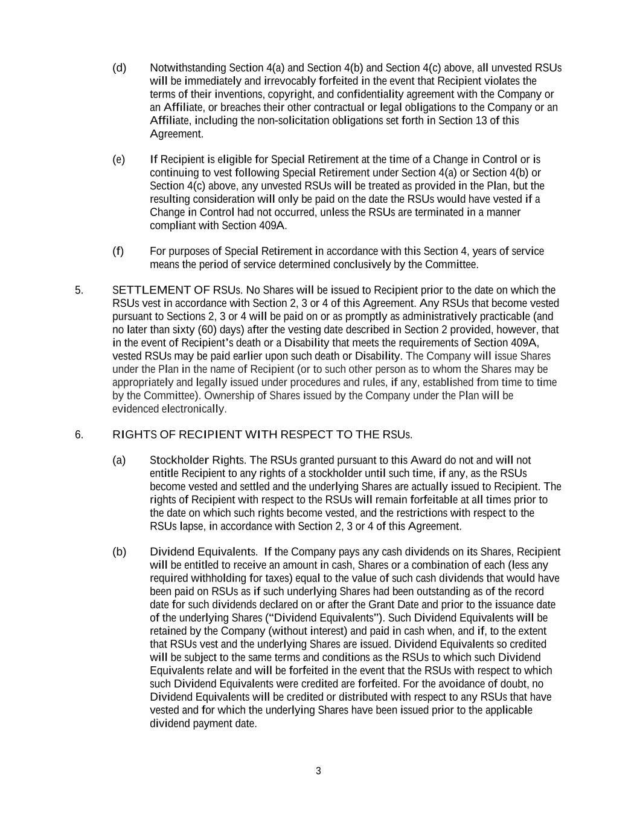
3 (d) Notwithstanding Section 4(a) and Section 4(b) and Section 4(c) above, all unvested RSUs will be immediately and irrevocably forfeited in the event that Recipient violates the terms of their inventions, copyright, and confidentiality agreement with the Company or an Affiliate, or breaches their other contractual or legal obligations to the Company or an Affiliate, including the non-solicitation obligations set forth in Section 13 of this Agreement. (e) If Recipient is eligible for Special Retirement at the time of a Change in Control or is continuing to vest following Special Retirement under Section 4(a) or Section 4(b) or Section 4(c) above, any unvested RSUs will be treated as provided in the Plan, but the resulting consideration will only be paid on the date the RSUs would have vested if a Change in Control had not occurred, unless the RSUs are terminated in a manner compliant with Section 409A. (f) For purposes of Special Retirement in accordance with this Section 4, years of service means the period of service determined conclusively by the Committee. 5. SETTLEMENT OF RSUs. No Shares will be issued to Recipient prior to the date on which the RSUs vest in accordance with Section 2, 3 or 4 of this Agreement. Any RSUs that become vested pursuant to Sections 2, 3 or 4 will be paid on or as promptly as administratively practicable (and no later than sixty (60) days) after the vesting date described in Section 2 provided, however, that in the event of Recipient’s death or a Disability that meets the requirements of Section 409A, vested RSUs may be paid earlier upon such death or Disability. The Company will issue Shares under the Plan in the name of Recipient (or to such other person as to whom the Shares may be appropriately and legally issued under procedures and rules, if any, established from time to time by the Committee). Ownership of Shares issued by the Company under the Plan will be evidenced electronically. 6. RIGHTS OF RECIPIENT WITH RESPECT TO THE RSUs. (a) Stockholder Rights. The RSUs granted pursuant to this Award do not and will not entitle Recipient to any rights of a stockholder until such time, if any, as the RSUs become vested and settled and the underlying Shares are actually issued to Recipient. The rights of Recipient with respect to the RSUs will remain forfeitable at all times prior to the date on which such rights become vested, and the restrictions with respect to the RSUs lapse, in accordance with Section 2, 3 or 4 of this Agreement. (b) Dividend Equivalents. If the Company pays any cash dividends on its Shares, Recipient will be entitled to receive an amount in cash, Shares or a combination of each (less any required withholding for taxes) equal to the value of such cash dividends that would have been paid on RSUs as if such underlying Shares had been outstanding as of the record date for such dividends declared on or after the Grant Date and prior to the issuance date of the underlying Shares (“Dividend Equivalents”). Such Dividend Equivalents will be retained by the Company (without interest) and paid in cash when, and if, to the extent that RSUs vest and the underlying Shares are issued. Dividend Equivalents so credited will be subject to the same terms and conditions as the RSUs to which such Dividend Equivalents relate and will be forfeited in the event that the RSUs with respect to which such Dividend Equivalents were credited are forfeited. For the avoidance of doubt, no Dividend Equivalents will be credited or distributed with respect to any RSUs that have vested and for which the underlying Shares have been issued prior to the applicable dividend payment date.

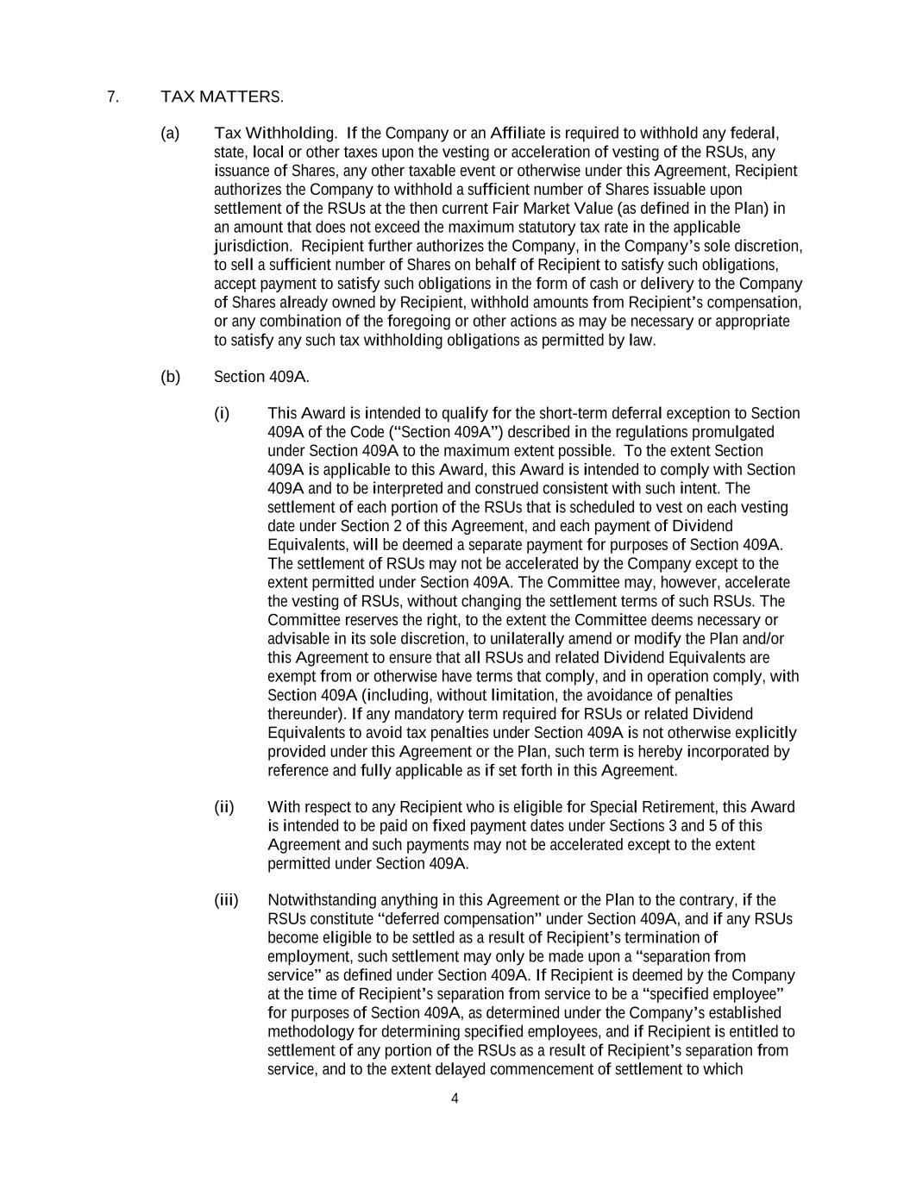
4 7. TAX MATTERS. (a) Tax Withholding. If the Company or an Affiliate is required to withhold any federal, state, local or other taxes upon the vesting or acceleration of vesting of the RSUs, any issuance of Shares, any other taxable event or otherwise under this Agreement, Recipient authorizes the Company to withhold a sufficient number of Shares issuable upon settlement of the RSUs at the then current Fair Market Value (as defined in the Plan) in an amount that does not exceed the maximum statutory tax rate in the applicable jurisdiction. Recipient further authorizes the Company, in the Company’s sole discretion, to sell a sufficient number of Shares on behalf of Recipient to satisfy such obligations, accept payment to satisfy such obligations in the form of cash or delivery to the Company of Shares already owned by Recipient, withhold amounts from Recipient’s compensation, or any combination of the foregoing or other actions as may be necessary or appropriate to satisfy any such tax withholding obligations as permitted by law. (b) Section 409A. (i) This Award is intended to qualify for the short-term deferral exception to Section 409A of the Code (“Section 409A”) described in the regulations promulgated under Section 409A to the maximum extent possible. To the extent Section 409A is applicable to this Award, this Award is intended to comply with Section 409A and to be interpreted and construed consistent with such intent. The settlement of each portion of the RSUs that is scheduled to vest on each vesting date under Section 2 of this Agreement, and each payment of Dividend Equivalents, will be deemed a separate payment for purposes of Section 409A. The settlement of RSUs may not be accelerated by the Company except to the extent permitted under Section 409A. The Committee may, however, accelerate the vesting of RSUs, without changing the settlement terms of such RSUs. The Committee reserves the right, to the extent the Committee deems necessary or advisable in its sole discretion, to unilaterally amend or modify the Plan and/or this Agreement to ensure that all RSUs and related Dividend Equivalents are exempt from or otherwise have terms that comply, and in operation comply, with Section 409A (including, without limitation, the avoidance of penalties thereunder). If any mandatory term required for RSUs or related Dividend Equivalents to avoid tax penalties under Section 409A is not otherwise explicitly provided under this Agreement or the Plan, such term is hereby incorporated by reference and fully applicable as if set forth in this Agreement. (ii) With respect to any Recipient who is eligible for Special Retirement, this Award is intended to be paid on fixed payment dates under Sections 3 and 5 of this Agreement and such payments may not be accelerated except to the extent permitted under Section 409A. (iii) Notwithstanding anything in this Agreement or the Plan to the contrary, if the RSUs constitute “deferred compensation” under Section 409A, and if any RSUs become eligible to be settled as a result of Recipient’s termination of employment, such settlement may only be made upon a “separation from service” as defined under Section 409A. If Recipient is deemed by the Company at the time of Recipient’s separation from service to be a “specified employee” for purposes of Section 409A, as determined under the Company’s established methodology for determining specified employees, and if Recipient is entitled to settlement of any portion of the RSUs as a result of Recipient’s separation from service, and to the extent delayed commencement of settlement to which

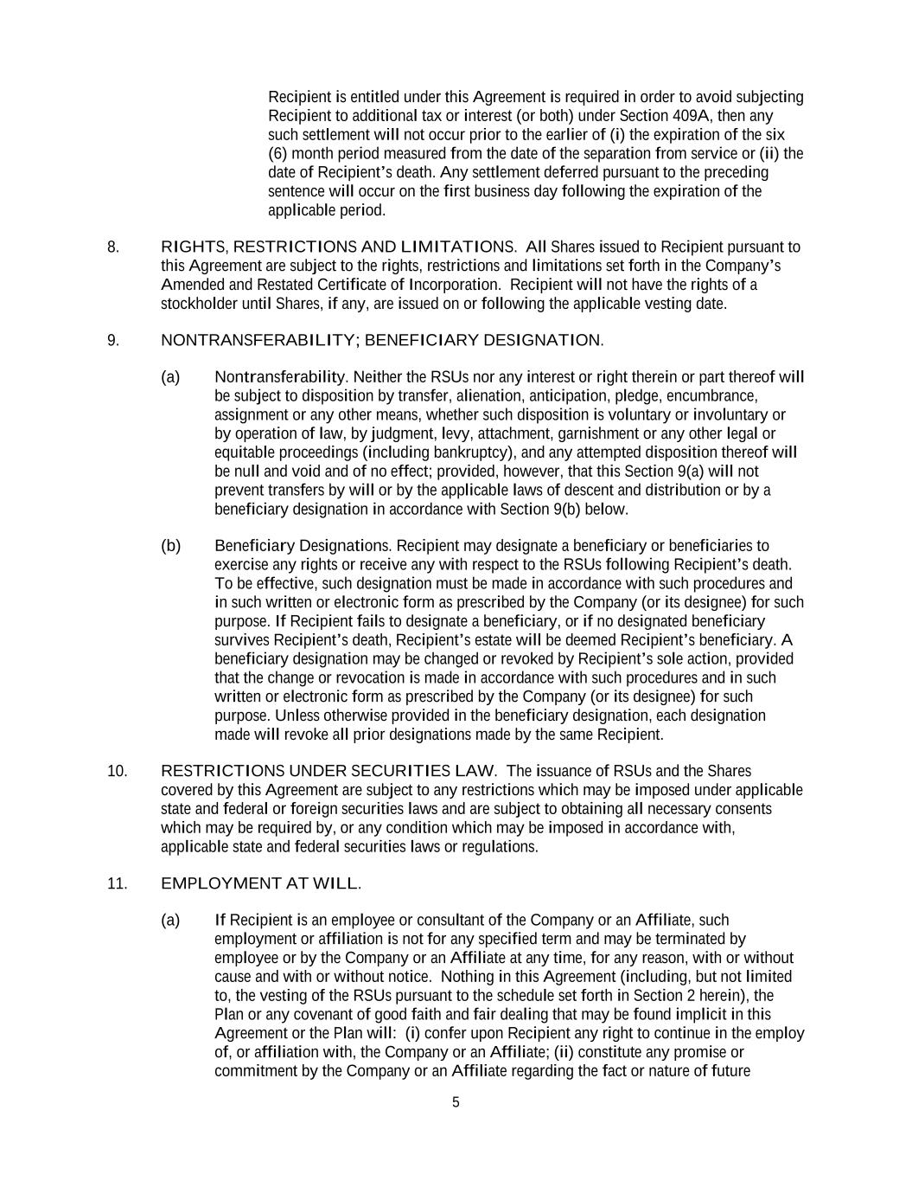
5 Recipient is entitled under this Agreement is required in order to avoid subjecting Recipient to additional tax or interest (or both) under Section 409A, then any such settlement will not occur prior to the earlier of (i) the expiration of the six (6) month period measured from the date of the separation from service or (ii) the date of Recipient’s death. Any settlement deferred pursuant to the preceding sentence will occur on the first business day following the expiration of the applicable period. 8. RIGHTS, RESTRICTIONS AND LIMITATIONS. All Shares issued to Recipient pursuant to this Agreement are subject to the rights, restrictions and limitations set forth in the Company’s Amended and Restated Certificate of Incorporation. Recipient will not have the rights of a stockholder until Shares, if any, are issued on or following the applicable vesting date. 9. NONTRANSFERABILITY; BENEFICIARY DESIGNATION. (a) Nontransferability. Neither the RSUs nor any interest or right therein or part thereof will be subject to disposition by transfer, alienation, anticipation, pledge, encumbrance, assignment or any other means, whether such disposition is voluntary or involuntary or by operation of law, by judgment, levy, attachment, garnishment or any other legal or equitable proceedings (including bankruptcy), and any attempted disposition thereof will be null and void and of no effect; provided, however, that this Section 9(a) will not prevent transfers by will or by the applicable laws of descent and distribution or by a beneficiary designation in accordance with Section 9(b) below. (b) Beneficiary Designations. Recipient may designate a beneficiary or beneficiaries to exercise any rights or receive any with respect to the RSUs following Recipient’s death. To be effective, such designation must be made in accordance with such procedures and in such written or electronic form as prescribed by the Company (or its designee) for such purpose. If Recipient fails to designate a beneficiary, or if no designated beneficiary survives Recipient’s death, Recipient’s estate will be deemed Recipient’s beneficiary. A beneficiary designation may be changed or revoked by Recipient’s sole action, provided that the change or revocation is made in accordance with such procedures and in such written or electronic form as prescribed by the Company (or its designee) for such purpose. Unless otherwise provided in the beneficiary designation, each designation made will revoke all prior designations made by the same Recipient. 10. RESTRICTIONS UNDER SECURITIES LAW. The issuance of RSUs and the Shares covered by this Agreement are subject to any restrictions which may be imposed under applicable state and federal or foreign securities laws and are subject to obtaining all necessary consents which may be required by, or any condition which may be imposed in accordance with, applicable state and federal securities laws or regulations. 11. EMPLOYMENT AT WILL. (a) If Recipient is an employee or consultant of the Company or an Affiliate, such employment or affiliation is not for any specified term and may be terminated by employee or by the Company or an Affiliate at any time, for any reason, with or without cause and with or without notice. Nothing in this Agreement (including, but not limited to, the vesting of the RSUs pursuant to the schedule set forth in Section 2 herein), the Plan or any covenant of good faith and fair dealing that may be found implicit in this Agreement or the Plan will: (i) confer upon Recipient any right to continue in the employ of, or affiliation with, the Company or an Affiliate; (ii) constitute any promise or commitment by the Company or an Affiliate regarding the fact or nature of future

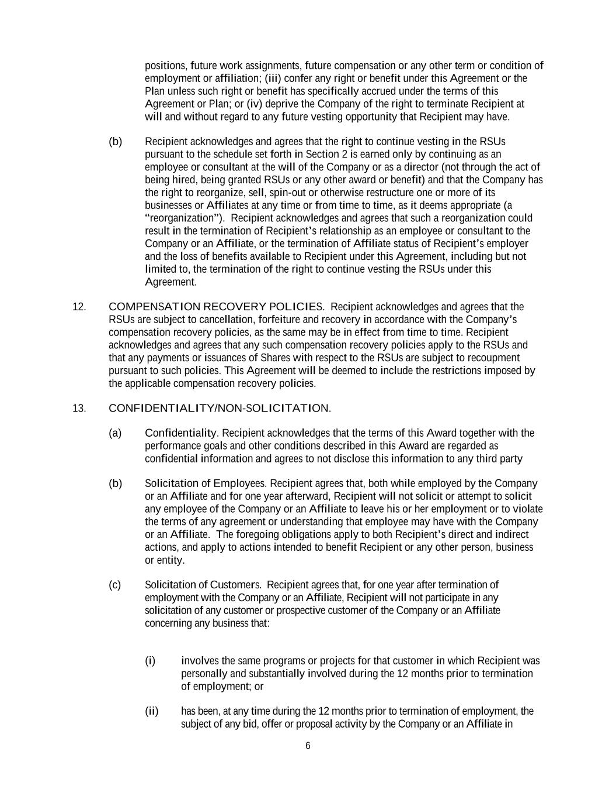
6 positions, future work assignments, future compensation or any other term or condition of employment or affiliation; (iii) confer any right or benefit under this Agreement or the Plan unless such right or benefit has specifically accrued under the terms of this Agreement or Plan; or (iv) deprive the Company of the right to terminate Recipient at will and without regard to any future vesting opportunity that Recipient may have. (b) Recipient acknowledges and agrees that the right to continue vesting in the RSUs pursuant to the schedule set forth in Section 2 is earned only by continuing as an employee or consultant at the will of the Company or as a director (not through the act of being hired, being granted RSUs or any other award or benefit) and that the Company has the right to reorganize, sell, spin-out or otherwise restructure one or more of its businesses or Affiliates at any time or from time to time, as it deems appropriate (a “reorganization”). Recipient acknowledges and agrees that such a reorganization could result in the termination of Recipient’s relationship as an employee or consultant to the Company or an Affiliate, or the termination of Affiliate status of Recipient’s employer and the loss of benefits available to Recipient under this Agreement, including but not limited to, the termination of the right to continue vesting the RSUs under this Agreement. 12. COMPENSATION RECOVERY POLICIES. Recipient acknowledges and agrees that the RSUs are subject to cancellation, forfeiture and recovery in accordance with the Company’s compensation recovery policies, as the same may be in effect from time to time. Recipient acknowledges and agrees that any such compensation recovery policies apply to the RSUs and that any payments or issuances of Shares with respect to the RSUs are subject to recoupment pursuant to such policies. This Agreement will be deemed to include the restrictions imposed by the applicable compensation recovery policies. 13. CONFIDENTIALITY/NON-SOLICITATION. (a) Confidentiality. Recipient acknowledges that the terms of this Award together with the performance goals and other conditions described in this Award are regarded as confidential information and agrees to not disclose this information to any third party (b) Solicitation of Employees. Recipient agrees that, both while employed by the Company or an Affiliate and for one year afterward, Recipient will not solicit or attempt to solicit any employee of the Company or an Affiliate to leave his or her employment or to violate the terms of any agreement or understanding that employee may have with the Company or an Affiliate. The foregoing obligations apply to both Recipient’s direct and indirect actions, and apply to actions intended to benefit Recipient or any other person, business or entity. (c) Solicitation of Customers. Recipient agrees that, for one year after termination of employment with the Company or an Affiliate, Recipient will not participate in any solicitation of any customer or prospective customer of the Company or an Affiliate concerning any business that: (i) involves the same programs or projects for that customer in which Recipient was personally and substantially involved during the 12 months prior to termination of employment; or (ii) has been, at any time during the 12 months prior to termination of employment, the subject of any bid, offer or proposal activity by the Company or an Affiliate in

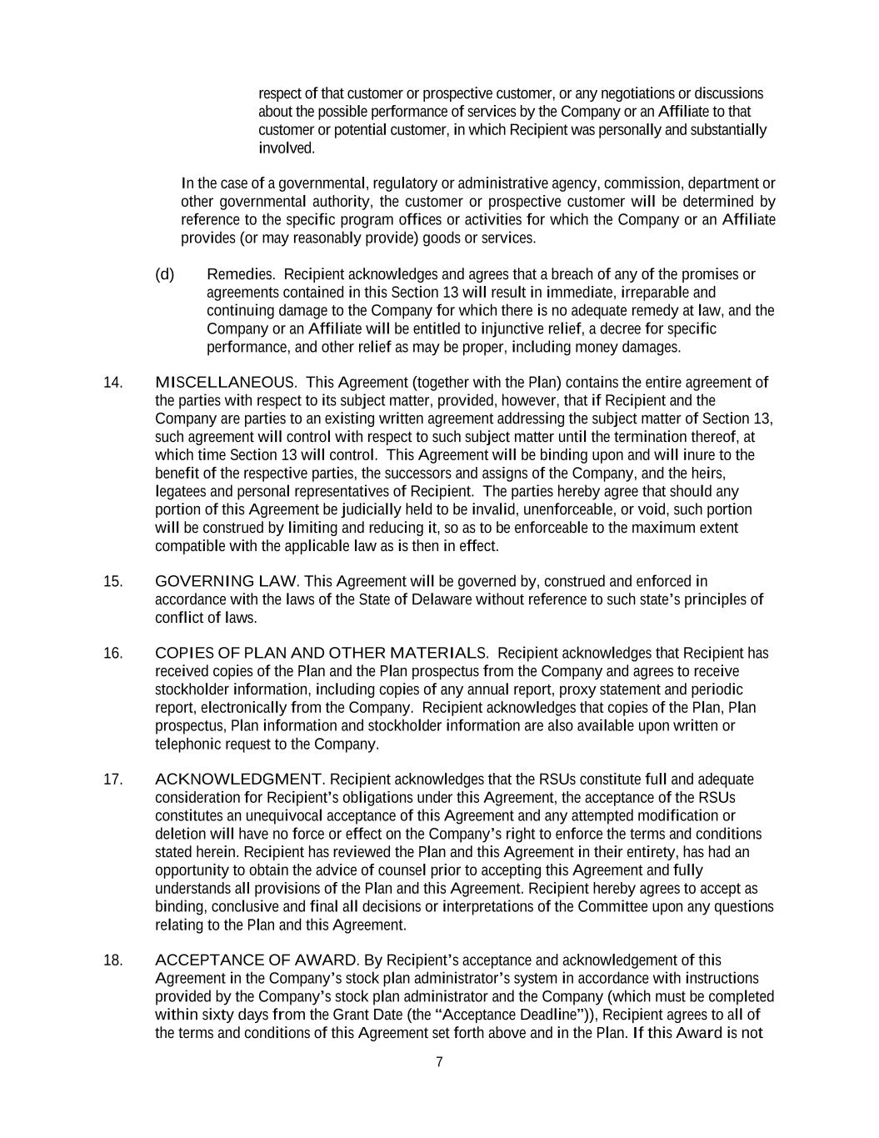
7 respect of that customer or prospective customer, or any negotiations or discussions about the possible performance of services by the Company or an Affiliate to that customer or potential customer, in which Recipient was personally and substantially involved. In the case of a governmental, regulatory or administrative agency, commission, department or other governmental authority, the customer or prospective customer will be determined by reference to the specific program offices or activities for which the Company or an Affiliate provides (or may reasonably provide) goods or services. (d) Remedies. Recipient acknowledges and agrees that a breach of any of the promises or agreements contained in this Section 13 will result in immediate, irreparable and continuing damage to the Company for which there is no adequate remedy at law, and the Company or an Affiliate will be entitled to injunctive relief, a decree for specific performance, and other relief as may be proper, including money damages. 14. MISCELLANEOUS. This Agreement (together with the Plan) contains the entire agreement of the parties with respect to its subject matter, provided, however, that if Recipient and the Company are parties to an existing written agreement addressing the subject matter of Section 13, such agreement will control with respect to such subject matter until the termination thereof, at which time Section 13 will control. This Agreement will be binding upon and will inure to the benefit of the respective parties, the successors and assigns of the Company, and the heirs, legatees and personal representatives of Recipient. The parties hereby agree that should any portion of this Agreement be judicially held to be invalid, unenforceable, or void, such portion will be construed by limiting and reducing it, so as to be enforceable to the maximum extent compatible with the applicable law as is then in effect. 15. GOVERNING LAW. This Agreement will be governed by, construed and enforced in accordance with the laws of the State of Delaware without reference to such state’s principles of conflict of laws. 16. COPIES OF PLAN AND OTHER MATERIALS. Recipient acknowledges that Recipient has received copies of the Plan and the Plan prospectus from the Company and agrees to receive stockholder information, including copies of any annual report, proxy statement and periodic report, electronically from the Company. Recipient acknowledges that copies of the Plan, Plan prospectus, Plan information and stockholder information are also available upon written or telephonic request to the Company. 17. ACKNOWLEDGMENT. Recipient acknowledges that the RSUs constitute full and adequate consideration for Recipient’s obligations under this Agreement, the acceptance of the RSUs constitutes an unequivocal acceptance of this Agreement and any attempted modification or deletion will have no force or effect on the Company’s right to enforce the terms and conditions stated herein. Recipient has reviewed the Plan and this Agreement in their entirety, has had an opportunity to obtain the advice of counsel prior to accepting this Agreement and fully understands all provisions of the Plan and this Agreement. Recipient hereby agrees to accept as binding, conclusive and final all decisions or interpretations of the Committee upon any questions relating to the Plan and this Agreement. 18. ACCEPTANCE OF AWARD. By Recipient’s acceptance and acknowledgement of this Agreement in the Company’s stock plan administrator’s system in accordance with instructions provided by the Company’s stock plan administrator and the Company (which must be completed within sixty days from the Grant Date (the “Acceptance Deadline”)), Recipient agrees to all of the terms and conditions of this Agreement set forth above and in the Plan. If this Award is not


8 accepted by the Acceptance Deadline as described in the preceding sentence, it will be immediately canceled and forfeited in its entirety at no cost to the Company and no benefits from the RSUs nor any compensation or benefits in lieu of the RSUs will be provided to Recipient. The Administrator or its designee shall have the right to grant an exception to this requirement under limited circumstances at its sole discretion.

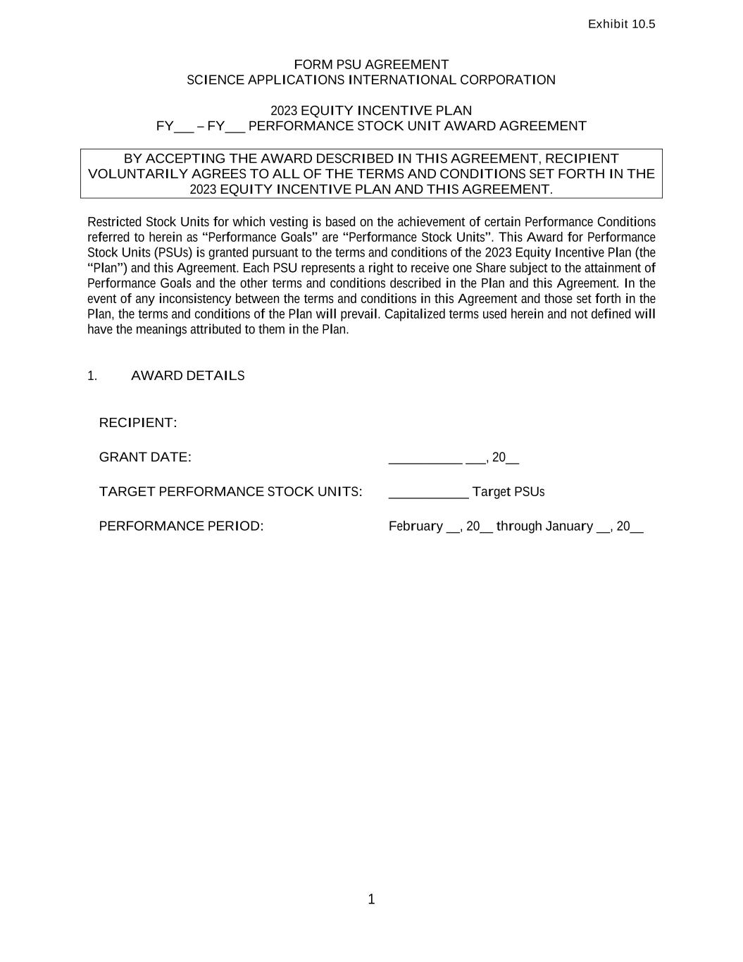
Exhibit 10.5 1 FORM PSU AGREEMENT SCIENCE APPLICATIONS INTERNATIONAL CORPORATION 2023 EQUITY INCENTIVE PLAN FY___ – FY___ PERFORMANCE STOCK UNIT AWARD AGREEMENT BY ACCEPTING THE AWARD DESCRIBED IN THIS AGREEMENT, RECIPIENT VOLUNTARILY AGREES TO ALL OF THE TERMS AND CONDITIONS SET FORTH IN THE 2023 EQUITY INCENTIVE PLAN AND THIS AGREEMENT. Restricted Stock Units for which vesting is based on the achievement of certain Performance Conditions referred to herein as “Performance Goals” are “Performance Stock Units”. This Award for Performance Stock Units (PSUs) is granted pursuant to the terms and conditions of the 2023 Equity Incentive Plan (the “Plan”) and this Agreement. Each PSU represents a right to receive one Share subject to the attainment of Performance Goals and the other terms and conditions described in the Plan and this Agreement. In the event of any inconsistency between the terms and conditions in this Agreement and those set forth in the Plan, the terms and conditions of the Plan will prevail. Capitalized terms used herein and not defined will have the meanings attributed to them in the Plan. 1. AWARD DETAILS RECIPIENT: GRANT DATE: ___________ ___, 20__ TARGET PERFORMANCE STOCK UNITS: ____________ Target PSUs PERFORMANCE PERIOD: February __, 20__ through January __, 20__

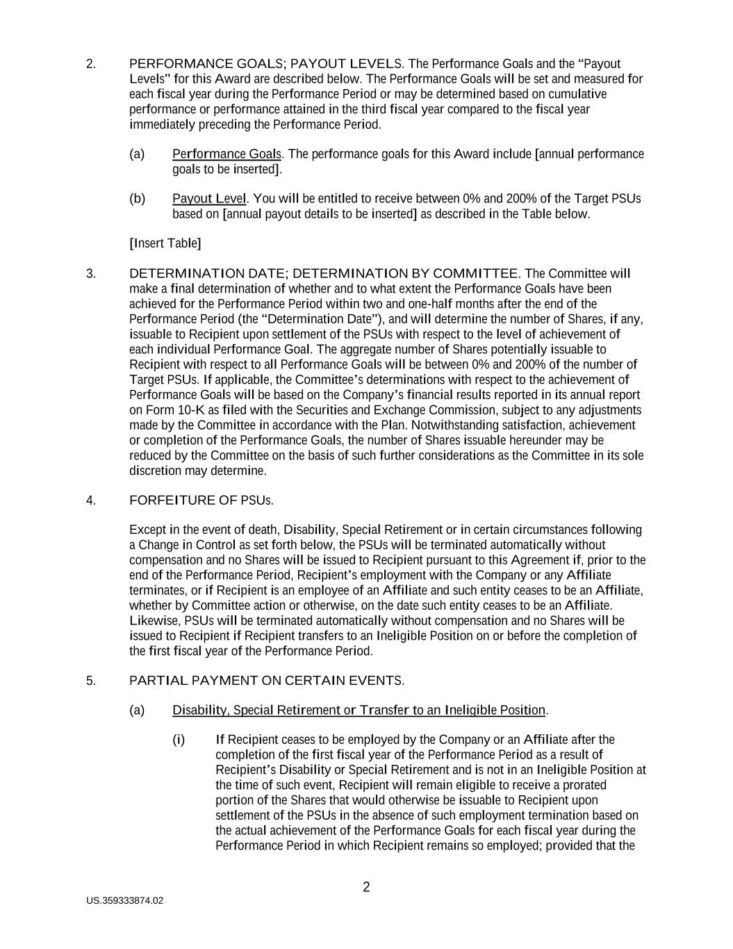
US.359333874.02 2 2. PERFORMANCE GOALS; PAYOUT LEVELS. The Performance Goals and the “Payout Levels” for this Award are described below. The Performance Goals will be set and measured for each fiscal year during the Performance Period or may be determined based on cumulative performance or performance attained in the third fiscal year compared to the fiscal year immediately preceding the Performance Period. (a) Performance Goals. The performance goals for this Award include [annual performance goals to be inserted]. (b) Payout Level. You will be entitled to receive between 0% and 200% of the Target PSUs based on [annual payout details to be inserted] as described in the Table below. [Insert Table] 3. DETERMINATION DATE; DETERMINATION BY COMMITTEE. The Committee will make a final determination of whether and to what extent the Performance Goals have been achieved for the Performance Period within two and one-half months after the end of the Performance Period (the “Determination Date”), and will determine the number of Shares, if any, issuable to Recipient upon settlement of the PSUs with respect to the level of achievement of each individual Performance Goal. The aggregate number of Shares potentially issuable to Recipient with respect to all Performance Goals will be between 0% and 200% of the number of Target PSUs. If applicable, the Committee’s determinations with respect to the achievement of Performance Goals will be based on the Company’s financial results reported in its annual report on Form 10-K as filed with the Securities and Exchange Commission, subject to any adjustments made by the Committee in accordance with the Plan. Notwithstanding satisfaction, achievement or completion of the Performance Goals, the number of Shares issuable hereunder may be reduced by the Committee on the basis of such further considerations as the Committee in its sole discretion may determine. 4. FORFEITURE OF PSUs. Except in the event of death, Disability, Special Retirement or in certain circumstances following a Change in Control as set forth below, the PSUs will be terminated automatically without compensation and no Shares will be issued to Recipient pursuant to this Agreement if, prior to the end of the Performance Period, Recipient’s employment with the Company or any Affiliate terminates, or if Recipient is an employee of an Affiliate and such entity ceases to be an Affiliate, whether by Committee action or otherwise, on the date such entity ceases to be an Affiliate. Likewise, PSUs will be terminated automatically without compensation and no Shares will be issued to Recipient if Recipient transfers to an Ineligible Position on or before the completion of the first fiscal year of the Performance Period. 5. PARTIAL PAYMENT ON CERTAIN EVENTS. (a) Disability, Special Retirement or Transfer to an Ineligible Position. (i) If Recipient ceases to be employed by the Company or an Affiliate after the completion of the first fiscal year of the Performance Period as a result of Recipient’s Disability or Special Retirement and is not in an Ineligible Position at the time of such event, Recipient will remain eligible to receive a prorated portion of the Shares that would otherwise be issuable to Recipient upon settlement of the PSUs in the absence of such employment termination based on the actual achievement of the Performance Goals for each fiscal year during the Performance Period in which Recipient remains so employed; provided that the

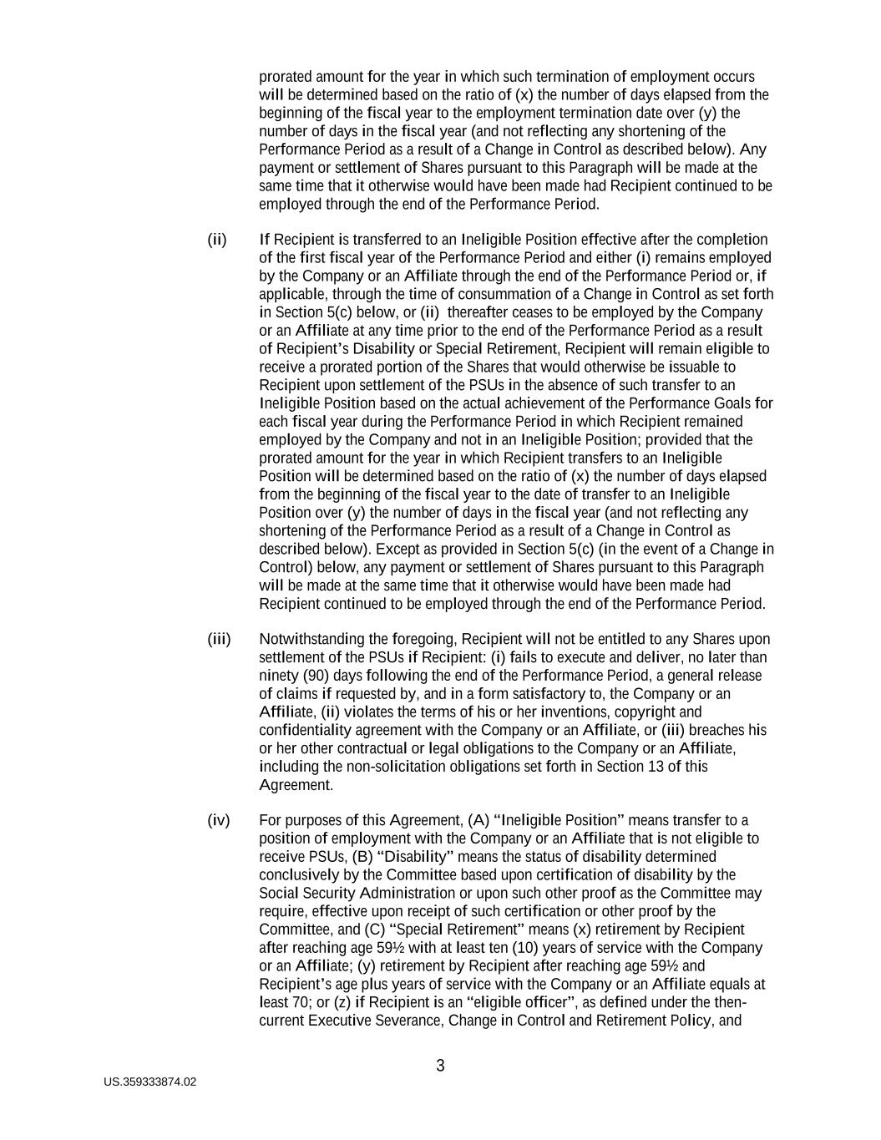
US.359333874.02 3 prorated amount for the year in which such termination of employment occurs will be determined based on the ratio of (x) the number of days elapsed from the beginning of the fiscal year to the employment termination date over (y) the number of days in the fiscal year (and not reflecting any shortening of the Performance Period as a result of a Change in Control as described below). Any payment or settlement of Shares pursuant to this Paragraph will be made at the same time that it otherwise would have been made had Recipient continued to be employed through the end of the Performance Period. (ii) If Recipient is transferred to an Ineligible Position effective after the completion of the first fiscal year of the Performance Period and either (i) remains employed by the Company or an Affiliate through the end of the Performance Period or, if applicable, through the time of consummation of a Change in Control as set forth in Section 5(c) below, or (ii) thereafter ceases to be employed by the Company or an Affiliate at any time prior to the end of the Performance Period as a result of Recipient’s Disability or Special Retirement, Recipient will remain eligible to receive a prorated portion of the Shares that would otherwise be issuable to Recipient upon settlement of the PSUs in the absence of such transfer to an Ineligible Position based on the actual achievement of the Performance Goals for each fiscal year during the Performance Period in which Recipient remained employed by the Company and not in an Ineligible Position; provided that the prorated amount for the year in which Recipient transfers to an Ineligible Position will be determined based on the ratio of (x) the number of days elapsed from the beginning of the fiscal year to the date of transfer to an Ineligible Position over (y) the number of days in the fiscal year (and not reflecting any shortening of the Performance Period as a result of a Change in Control as described below). Except as provided in Section 5(c) (in the event of a Change in Control) below, any payment or settlement of Shares pursuant to this Paragraph will be made at the same time that it otherwise would have been made had Recipient continued to be employed through the end of the Performance Period. (iii) Notwithstanding the foregoing, Recipient will not be entitled to any Shares upon settlement of the PSUs if Recipient: (i) fails to execute and deliver, no later than ninety (90) days following the end of the Performance Period, a general release of claims if requested by, and in a form satisfactory to, the Company or an Affiliate, (ii) violates the terms of his or her inventions, copyright and confidentiality agreement with the Company or an Affiliate, or (iii) breaches his or her other contractual or legal obligations to the Company or an Affiliate, including the non-solicitation obligations set forth in Section 13 of this Agreement. (iv) For purposes of this Agreement, (A) “Ineligible Position” means transfer to a position of employment with the Company or an Affiliate that is not eligible to receive PSUs, (B) “Disability” means the status of disability determined conclusively by the Committee based upon certification of disability by the Social Security Administration or upon such other proof as the Committee may require, effective upon receipt of such certification or other proof by the Committee, and (C) “Special Retirement” means (x) retirement by Recipient after reaching age 59½ with at least ten (10) years of service with the Company or an Affiliate; (y) retirement by Recipient after reaching age 59½ and Recipient’s age plus years of service with the Company or an Affiliate equals at least 70; or (z) if Recipient is an “eligible officer”, as defined under the then- current Executive Severance, Change in Control and Retirement Policy, and

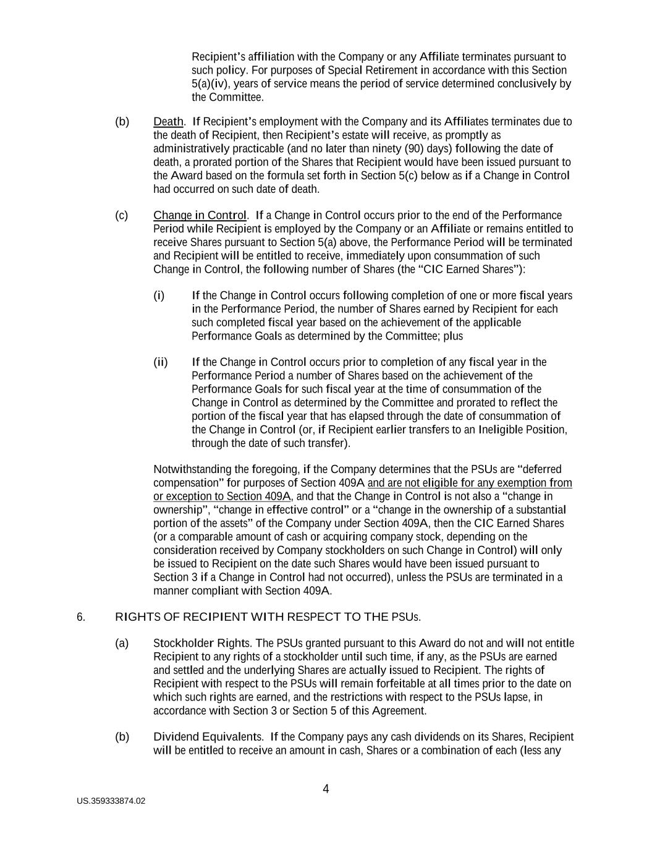
US.359333874.02 4 Recipient’s affiliation with the Company or any Affiliate terminates pursuant to such policy. For purposes of Special Retirement in accordance with this Section 5(a)(iv), years of service means the period of service determined conclusively by the Committee. (b) Death. If Recipient’s employment with the Company and its Affiliates terminates due to the death of Recipient, then Recipient’s estate will receive, as promptly as administratively practicable (and no later than ninety (90) days) following the date of death, a prorated portion of the Shares that Recipient would have been issued pursuant to the Award based on the formula set forth in Section 5(c) below as if a Change in Control had occurred on such date of death. (c) Change in Control. If a Change in Control occurs prior to the end of the Performance Period while Recipient is employed by the Company or an Affiliate or remains entitled to receive Shares pursuant to Section 5(a) above, the Performance Period will be terminated and Recipient will be entitled to receive, immediately upon consummation of such Change in Control, the following number of Shares (the “CIC Earned Shares”): (i) If the Change in Control occurs following completion of one or more fiscal years in the Performance Period, the number of Shares earned by Recipient for each such completed fiscal year based on the achievement of the applicable Performance Goals as determined by the Committee; plus (ii) If the Change in Control occurs prior to completion of any fiscal year in the Performance Period a number of Shares based on the achievement of the Performance Goals for such fiscal year at the time of consummation of the Change in Control as determined by the Committee and prorated to reflect the portion of the fiscal year that has elapsed through the date of consummation of the Change in Control (or, if Recipient earlier transfers to an Ineligible Position, through the date of such transfer). Notwithstanding the foregoing, if the Company determines that the PSUs are “deferred compensation” for purposes of Section 409A and are not eligible for any exemption from or exception to Section 409A, and that the Change in Control is not also a “change in ownership”, “change in effective control” or a “change in the ownership of a substantial portion of the assets” of the Company under Section 409A, then the CIC Earned Shares (or a comparable amount of cash or acquiring company stock, depending on the consideration received by Company stockholders on such Change in Control) will only be issued to Recipient on the date such Shares would have been issued pursuant to Section 3 if a Change in Control had not occurred), unless the PSUs are terminated in a manner compliant with Section 409A. 6. RIGHTS OF RECIPIENT WITH RESPECT TO THE PSUs. (a) Stockholder Rights. The PSUs granted pursuant to this Award do not and will not entitle Recipient to any rights of a stockholder until such time, if any, as the PSUs are earned and settled and the underlying Shares are actually issued to Recipient. The rights of Recipient with respect to the PSUs will remain forfeitable at all times prior to the date on which such rights are earned, and the restrictions with respect to the PSUs lapse, in accordance with Section 3 or Section 5 of this Agreement. (b) Dividend Equivalents. If the Company pays any cash dividends on its Shares, Recipient will be entitled to receive an amount in cash, Shares or a combination of each (less any

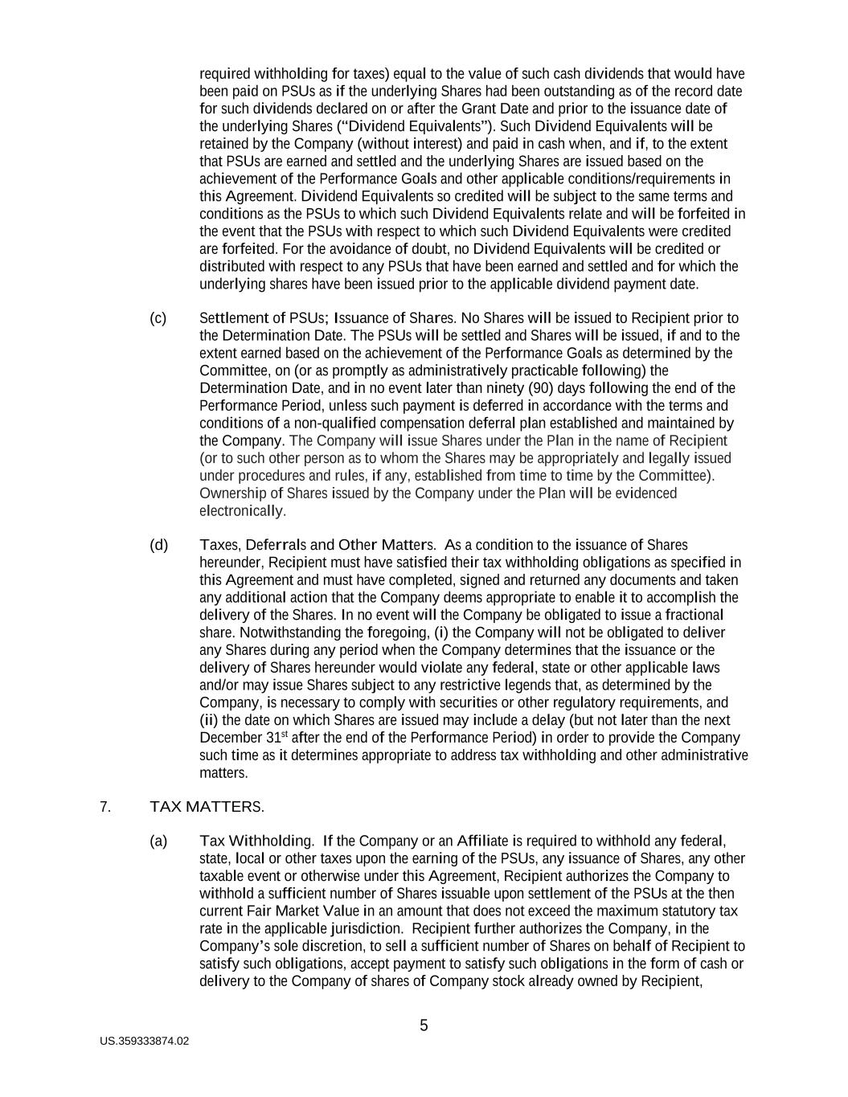
US.359333874.02 5 required withholding for taxes) equal to the value of such cash dividends that would have been paid on PSUs as if the underlying Shares had been outstanding as of the record date for such dividends declared on or after the Grant Date and prior to the issuance date of the underlying Shares (“Dividend Equivalents”). Such Dividend Equivalents will be retained by the Company (without interest) and paid in cash when, and if, to the extent that PSUs are earned and settled and the underlying Shares are issued based on the achievement of the Performance Goals and other applicable conditions/requirements in this Agreement. Dividend Equivalents so credited will be subject to the same terms and conditions as the PSUs to which such Dividend Equivalents relate and will be forfeited in the event that the PSUs with respect to which such Dividend Equivalents were credited are forfeited. For the avoidance of doubt, no Dividend Equivalents will be credited or distributed with respect to any PSUs that have been earned and settled and for which the underlying shares have been issued prior to the applicable dividend payment date. (c) Settlement of PSUs; Issuance of Shares. No Shares will be issued to Recipient prior to the Determination Date. The PSUs will be settled and Shares will be issued, if and to the extent earned based on the achievement of the Performance Goals as determined by the Committee, on (or as promptly as administratively practicable following) the Determination Date, and in no event later than ninety (90) days following the end of the Performance Period, unless such payment is deferred in accordance with the terms and conditions of a non-qualified compensation deferral plan established and maintained by the Company. The Company will issue Shares under the Plan in the name of Recipient (or to such other person as to whom the Shares may be appropriately and legally issued under procedures and rules, if any, established from time to time by the Committee). Ownership of Shares issued by the Company under the Plan will be evidenced electronically. (d) Taxes, Deferrals and Other Matters. As a condition to the issuance of Shares hereunder, Recipient must have satisfied their tax withholding obligations as specified in this Agreement and must have completed, signed and returned any documents and taken any additional action that the Company deems appropriate to enable it to accomplish the delivery of the Shares. In no event will the Company be obligated to issue a fractional share. Notwithstanding the foregoing, (i) the Company will not be obligated to deliver any Shares during any period when the Company determines that the issuance or the delivery of Shares hereunder would violate any federal, state or other applicable laws and/or may issue Shares subject to any restrictive legends that, as determined by the Company, is necessary to comply with securities or other regulatory requirements, and (ii) the date on which Shares are issued may include a delay (but not later than the next December 31st after the end of the Performance Period) in order to provide the Company such time as it determines appropriate to address tax withholding and other administrative matters. 7. TAX MATTERS. (a) Tax Withholding. If the Company or an Affiliate is required to withhold any federal, state, local or other taxes upon the earning of the PSUs, any issuance of Shares, any other taxable event or otherwise under this Agreement, Recipient authorizes the Company to withhold a sufficient number of Shares issuable upon settlement of the PSUs at the then current Fair Market Value in an amount that does not exceed the maximum statutory tax rate in the applicable jurisdiction. Recipient further authorizes the Company, in the Company’s sole discretion, to sell a sufficient number of Shares on behalf of Recipient to satisfy such obligations, accept payment to satisfy such obligations in the form of cash or delivery to the Company of shares of Company stock already owned by Recipient,

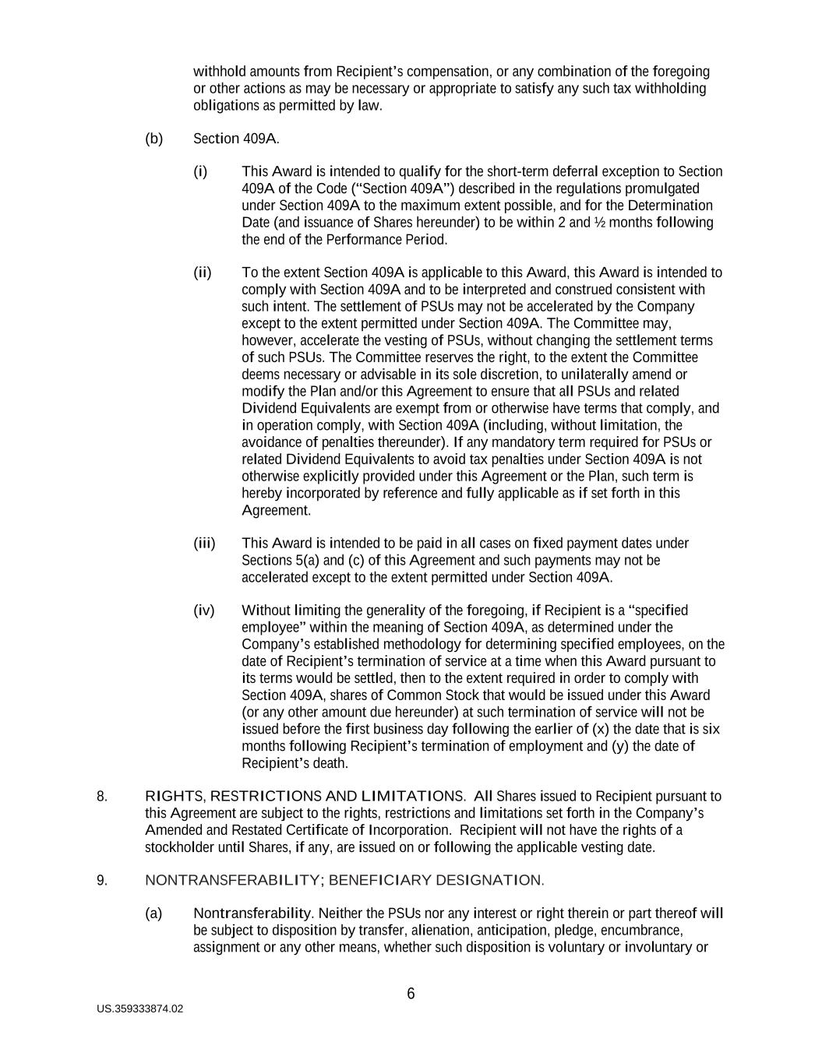
US.359333874.02 6 withhold amounts from Recipient’s compensation, or any combination of the foregoing or other actions as may be necessary or appropriate to satisfy any such tax withholding obligations as permitted by law. (b) Section 409A. (i) This Award is intended to qualify for the short-term deferral exception to Section 409A of the Code (“Section 409A”) described in the regulations promulgated under Section 409A to the maximum extent possible, and for the Determination Date (and issuance of Shares hereunder) to be within 2 and ½ months following the end of the Performance Period. (ii) To the extent Section 409A is applicable to this Award, this Award is intended to comply with Section 409A and to be interpreted and construed consistent with such intent. The settlement of PSUs may not be accelerated by the Company except to the extent permitted under Section 409A. The Committee may, however, accelerate the vesting of PSUs, without changing the settlement terms of such PSUs. The Committee reserves the right, to the extent the Committee deems necessary or advisable in its sole discretion, to unilaterally amend or modify the Plan and/or this Agreement to ensure that all PSUs and related Dividend Equivalents are exempt from or otherwise have terms that comply, and in operation comply, with Section 409A (including, without limitation, the avoidance of penalties thereunder). If any mandatory term required for PSUs or related Dividend Equivalents to avoid tax penalties under Section 409A is not otherwise explicitly provided under this Agreement or the Plan, such term is hereby incorporated by reference and fully applicable as if set forth in this Agreement. (iii) This Award is intended to be paid in all cases on fixed payment dates under Sections 5(a) and (c) of this Agreement and such payments may not be accelerated except to the extent permitted under Section 409A. (iv) Without limiting the generality of the foregoing, if Recipient is a “specified employee” within the meaning of Section 409A, as determined under the Company’s established methodology for determining specified employees, on the date of Recipient’s termination of service at a time when this Award pursuant to its terms would be settled, then to the extent required in order to comply with Section 409A, shares of Common Stock that would be issued under this Award (or any other amount due hereunder) at such termination of service will not be issued before the first business day following the earlier of (x) the date that is six months following Recipient’s termination of employment and (y) the date of Recipient’s death. 8. RIGHTS, RESTRICTIONS AND LIMITATIONS. All Shares issued to Recipient pursuant to this Agreement are subject to the rights, restrictions and limitations set forth in the Company’s Amended and Restated Certificate of Incorporation. Recipient will not have the rights of a stockholder until Shares, if any, are issued on or following the applicable vesting date. 9. NONTRANSFERABILITY; BENEFICIARY DESIGNATION. (a) Nontransferability. Neither the PSUs nor any interest or right therein or part thereof will be subject to disposition by transfer, alienation, anticipation, pledge, encumbrance, assignment or any other means, whether such disposition is voluntary or involuntary or

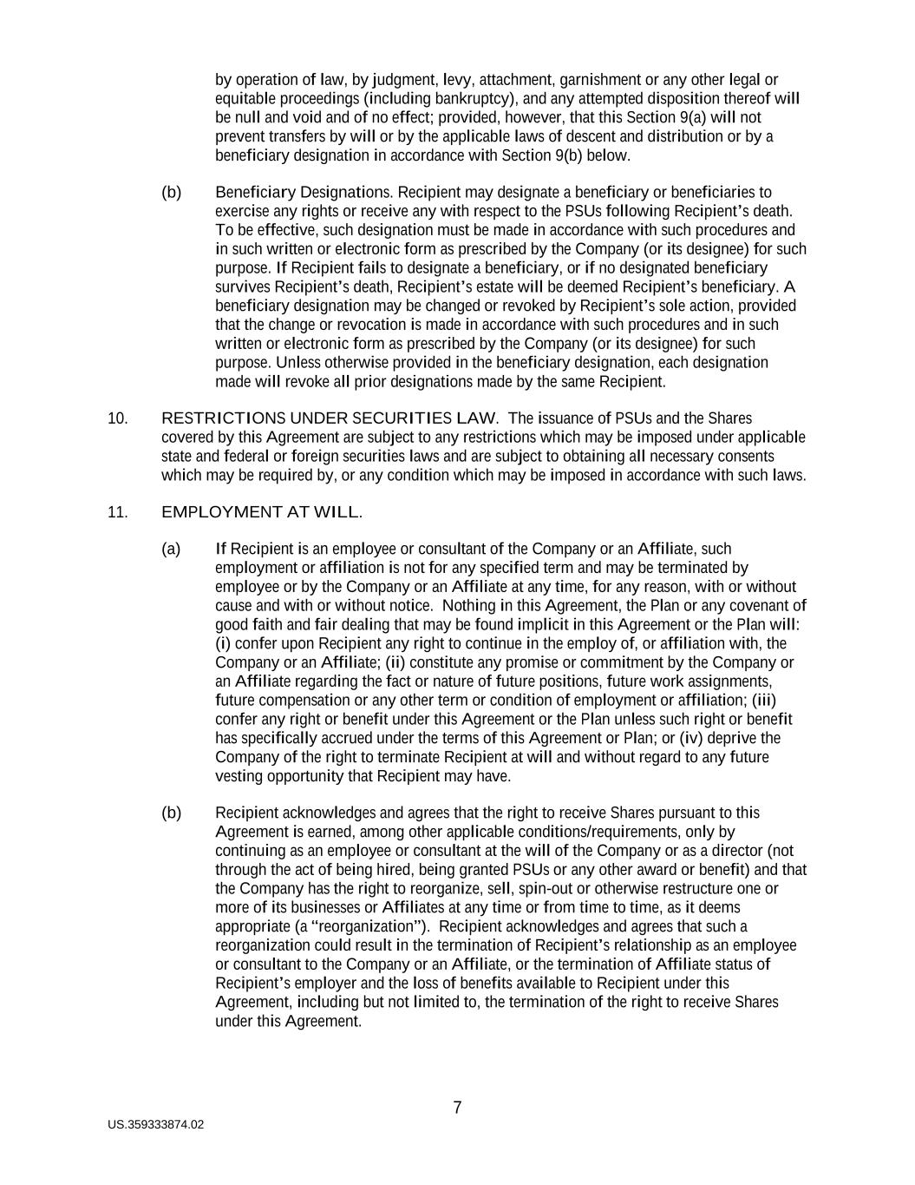
US.359333874.02 7 by operation of law, by judgment, levy, attachment, garnishment or any other legal or equitable proceedings (including bankruptcy), and any attempted disposition thereof will be null and void and of no effect; provided, however, that this Section 9(a) will not prevent transfers by will or by the applicable laws of descent and distribution or by a beneficiary designation in accordance with Section 9(b) below. (b) Beneficiary Designations. Recipient may designate a beneficiary or beneficiaries to exercise any rights or receive any with respect to the PSUs following Recipient’s death. To be effective, such designation must be made in accordance with such procedures and in such written or electronic form as prescribed by the Company (or its designee) for such purpose. If Recipient fails to designate a beneficiary, or if no designated beneficiary survives Recipient’s death, Recipient’s estate will be deemed Recipient’s beneficiary. A beneficiary designation may be changed or revoked by Recipient’s sole action, provided that the change or revocation is made in accordance with such procedures and in such written or electronic form as prescribed by the Company (or its designee) for such purpose. Unless otherwise provided in the beneficiary designation, each designation made will revoke all prior designations made by the same Recipient. 10. RESTRICTIONS UNDER SECURITIES LAW. The issuance of PSUs and the Shares covered by this Agreement are subject to any restrictions which may be imposed under applicable state and federal or foreign securities laws and are subject to obtaining all necessary consents which may be required by, or any condition which may be imposed in accordance with such laws. 11. EMPLOYMENT AT WILL. (a) If Recipient is an employee or consultant of the Company or an Affiliate, such employment or affiliation is not for any specified term and may be terminated by employee or by the Company or an Affiliate at any time, for any reason, with or without cause and with or without notice. Nothing in this Agreement, the Plan or any covenant of good faith and fair dealing that may be found implicit in this Agreement or the Plan will: (i) confer upon Recipient any right to continue in the employ of, or affiliation with, the Company or an Affiliate; (ii) constitute any promise or commitment by the Company or an Affiliate regarding the fact or nature of future positions, future work assignments, future compensation or any other term or condition of employment or affiliation; (iii) confer any right or benefit under this Agreement or the Plan unless such right or benefit has specifically accrued under the terms of this Agreement or Plan; or (iv) deprive the Company of the right to terminate Recipient at will and without regard to any future vesting opportunity that Recipient may have. (b) Recipient acknowledges and agrees that the right to receive Shares pursuant to this Agreement is earned, among other applicable conditions/requirements, only by continuing as an employee or consultant at the will of the Company or as a director (not through the act of being hired, being granted PSUs or any other award or benefit) and that the Company has the right to reorganize, sell, spin-out or otherwise restructure one or more of its businesses or Affiliates at any time or from time to time, as it deems appropriate (a “reorganization”). Recipient acknowledges and agrees that such a reorganization could result in the termination of Recipient’s relationship as an employee or consultant to the Company or an Affiliate, or the termination of Affiliate status of Recipient’s employer and the loss of benefits available to Recipient under this Agreement, including but not limited to, the termination of the right to receive Shares under this Agreement.

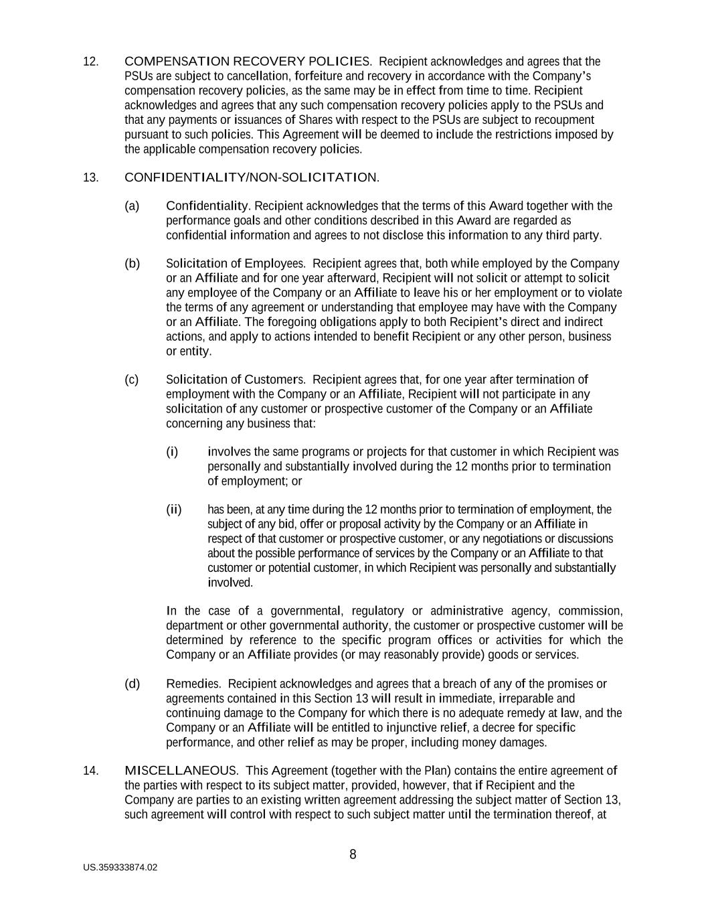
US.359333874.02 8 12. COMPENSATION RECOVERY POLICIES. Recipient acknowledges and agrees that the PSUs are subject to cancellation, forfeiture and recovery in accordance with the Company’s compensation recovery policies, as the same may be in effect from time to time. Recipient acknowledges and agrees that any such compensation recovery policies apply to the PSUs and that any payments or issuances of Shares with respect to the PSUs are subject to recoupment pursuant to such policies. This Agreement will be deemed to include the restrictions imposed by the applicable compensation recovery policies. 13. CONFIDENTIALITY/NON-SOLICITATION. (a) Confidentiality. Recipient acknowledges that the terms of this Award together with the performance goals and other conditions described in this Award are regarded as confidential information and agrees to not disclose this information to any third party. (b) Solicitation of Employees. Recipient agrees that, both while employed by the Company or an Affiliate and for one year afterward, Recipient will not solicit or attempt to solicit any employee of the Company or an Affiliate to leave his or her employment or to violate the terms of any agreement or understanding that employee may have with the Company or an Affiliate. The foregoing obligations apply to both Recipient’s direct and indirect actions, and apply to actions intended to benefit Recipient or any other person, business or entity. (c) Solicitation of Customers. Recipient agrees that, for one year after termination of employment with the Company or an Affiliate, Recipient will not participate in any solicitation of any customer or prospective customer of the Company or an Affiliate concerning any business that: (i) involves the same programs or projects for that customer in which Recipient was personally and substantially involved during the 12 months prior to termination of employment; or (ii) has been, at any time during the 12 months prior to termination of employment, the subject of any bid, offer or proposal activity by the Company or an Affiliate in respect of that customer or prospective customer, or any negotiations or discussions about the possible performance of services by the Company or an Affiliate to that customer or potential customer, in which Recipient was personally and substantially involved. In the case of a governmental, regulatory or administrative agency, commission, department or other governmental authority, the customer or prospective customer will be determined by reference to the specific program offices or activities for which the Company or an Affiliate provides (or may reasonably provide) goods or services. (d) Remedies. Recipient acknowledges and agrees that a breach of any of the promises or agreements contained in this Section 13 will result in immediate, irreparable and continuing damage to the Company for which there is no adequate remedy at law, and the Company or an Affiliate will be entitled to injunctive relief, a decree for specific performance, and other relief as may be proper, including money damages. 14. MISCELLANEOUS. This Agreement (together with the Plan) contains the entire agreement of the parties with respect to its subject matter, provided, however, that if Recipient and the Company are parties to an existing written agreement addressing the subject matter of Section 13, such agreement will control with respect to such subject matter until the termination thereof, at

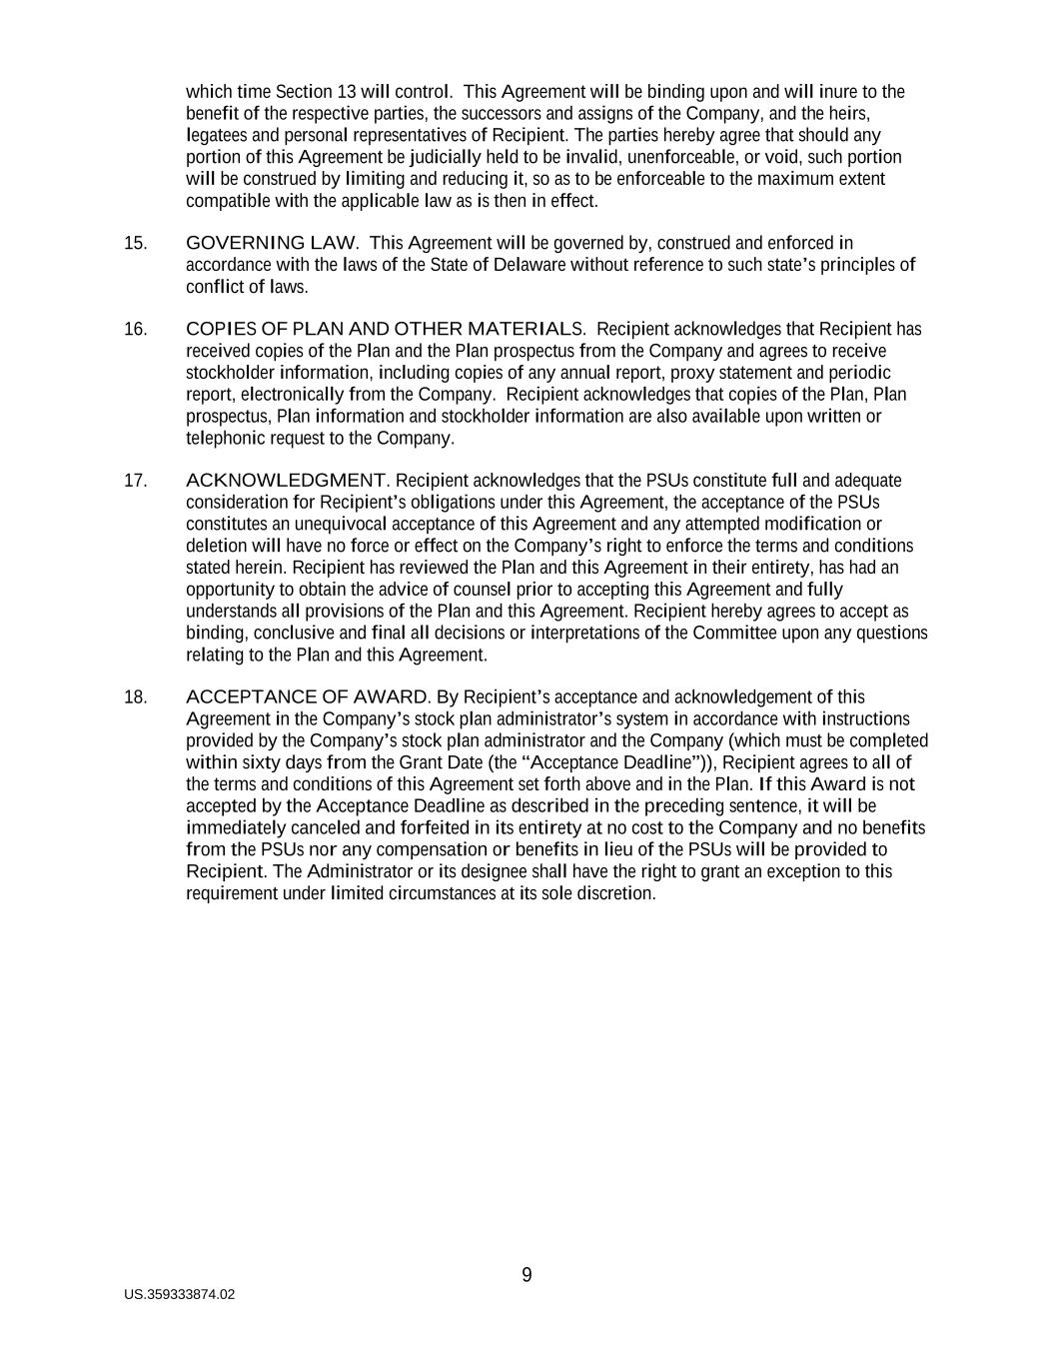
US.359333874.02 9 which time Section 13 will control. This Agreement will be binding upon and will inure to the benefit of the respective parties, the successors and assigns of the Company, and the heirs, legatees and personal representatives of Recipient. The parties hereby agree that should any portion of this Agreement be judicially held to be invalid, unenforceable, or void, such portion will be construed by limiting and reducing it, so as to be enforceable to the maximum extent compatible with the applicable law as is then in effect. 15. GOVERNING LAW. This Agreement will be governed by, construed and enforced in accordance with the laws of the State of Delaware without reference to such state’s principles of conflict of laws. 16. COPIES OF PLAN AND OTHER MATERIALS. Recipient acknowledges that Recipient has received copies of the Plan and the Plan prospectus from the Company and agrees to receive stockholder information, including copies of any annual report, proxy statement and periodic report, electronically from the Company. Recipient acknowledges that copies of the Plan, Plan prospectus, Plan information and stockholder information are also available upon written or telephonic request to the Company. 17. ACKNOWLEDGMENT. Recipient acknowledges that the PSUs constitute full and adequate consideration for Recipient’s obligations under this Agreement, the acceptance of the PSUs constitutes an unequivocal acceptance of this Agreement and any attempted modification or deletion will have no force or effect on the Company’s right to enforce the terms and conditions stated herein. Recipient has reviewed the Plan and this Agreement in their entirety, has had an opportunity to obtain the advice of counsel prior to accepting this Agreement and fully understands all provisions of the Plan and this Agreement. Recipient hereby agrees to accept as binding, conclusive and final all decisions or interpretations of the Committee upon any questions relating to the Plan and this Agreement. 18. ACCEPTANCE OF AWARD. By Recipient’s acceptance and acknowledgement of this Agreement in the Company’s stock plan administrator’s system in accordance with instructions provided by the Company’s stock plan administrator and the Company (which must be completed within sixty days from the Grant Date (the “Acceptance Deadline”)), Recipient agrees to all of the terms and conditions of this Agreement set forth above and in the Plan. If this Award is not accepted by the Acceptance Deadline as described in the preceding sentence, it will be immediately canceled and forfeited in its entirety at no cost to the Company and no benefits from the PSUs nor any compensation or benefits in lieu of the PSUs will be provided to Recipient. The Administrator or its designee shall have the right to grant an exception to this requirement under limited circumstances at its sole discretion.

Exhibit 31.1
SCIENCE APPLICATIONS INTERNATIONAL CORPORATION
CERTIFICATION OF CHIEF EXECUTIVE OFFICER PURSUANT TO
SECTION 302 OF THE SARBANES-OXLEY ACT OF 2002
I, James C. Reagan, certify that:
1.I have reviewed this Quarterly Report on Form 10-Q for the period ended July 31, 2026 of Science Applications International Corporation;
2.Based on my knowledge, this report does not contain any untrue statement of a material fact or omit to state a material fact necessary to make the statements made, in light of the circumstances under which such statements were made, not misleading with respect to the period covered by this report;
3.Based on my knowledge, the financial statements, and other financial information included in this report, fairly present in all material respects the financial condition, results of operations and cash flows of the registrant as of, and for, the periods presented in this report;
4.The registrant’s other certifying officer and I are responsible for establishing and maintaining disclosure controls and procedures (as defined in Exchange Act Rules 13a-15(e) and 15d-15(e)) and internal control over financial reporting (as defined in Exchange Act Rules 13a-15(f) and 15d-15(f)) for the registrant and have:
a)Designed such disclosure controls and procedures, or caused such disclosure controls and procedures to be designed under our supervision, to ensure that material information relating to the registrant, including its consolidated subsidiaries, is made known to us by others within those entities, particularly during the period in which this report is being prepared;
b)Designed such internal control over financial reporting, or caused such internal control over financial reporting to be designed under our supervision, to provide reasonable assurance regarding the reliability of financial reporting and the preparation of financial statements for external purposes in accordance with generally accepted accounting principles;
c)Evaluated the effectiveness of the registrant’s disclosure controls and procedures and presented in this report our conclusions about the effectiveness of the disclosure controls and procedures, as of the end of the period covered by this report based on such evaluation; and
d)Disclosed in this report any change in the registrant’s internal control over financial reporting that occurred during the registrant’s most recent fiscal quarter (the registrant’s fourth fiscal quarter in the case of an annual report) that has materially affected, or is reasonably likely to materially affect, the registrant’s internal control over financial reporting; and
5.The registrant’s other certifying officer and I have disclosed, based on our most recent evaluation of internal control over financial reporting, to the registrant’s auditors and the audit committee of the registrant’s board of directors (or persons performing the equivalent functions):
a)All significant deficiencies and material weaknesses in the design or operation of internal control over financial reporting which are reasonably likely to adversely affect the registrant’s ability to record, process, summarize and report financial information; and
b)Any fraud, whether or not material, that involves management or other employees who have a significant role in the registrant’s internal control over financial reporting.
Date: August 31, 2026

/s/ James C. Reagan
James C. Reagan
Chief Executive Officer

Exhibit 31.2
SCIENCE APPLICATIONS INTERNATIONAL CORPORATION
CERTIFICATION OF CHIEF FINANCIAL OFFICER PURSUANT TO
SECTION 302 OF THE SARBANES-OXLEY ACT OF 2002
I, Prabu Natarajan, certify that:
1.I have reviewed this Quarterly Report on Form 10-Q for the period ended July 31, 2026 of Science Applications International Corporation;
2.Based on my knowledge, this report does not contain any untrue statement of a material fact or omit to state a material fact necessary to make the statements made, in light of the circumstances under which such statements were made, not misleading with respect to the period covered by this report;
3.Based on my knowledge, the financial statements, and other financial information included in this report, fairly present in all material respects the financial condition, results of operations and cash flows of the registrant as of, and for, the periods presented in this report;
4.The registrant’s other certifying officer and I are responsible for establishing and maintaining disclosure controls and procedures (as defined in Exchange Act Rules 13a-15(e) and 15d-15(e)) and internal control over financial reporting (as defined in Exchange Act Rules 13a-15(f) and 15d-15(f)) for the registrant and have:
a)Designed such disclosure controls and procedures, or caused such disclosure controls and procedures to be designed under our supervision, to ensure that material information relating to the registrant, including its consolidated subsidiaries, is made known to us by others within those entities, particularly during the period in which this report is being prepared;
b)Designed such internal control over financial reporting, or caused such internal control over financial reporting to be designed under our supervision, to provide reasonable assurance regarding the reliability of financial reporting and the preparation of financial statements for external purposes in accordance with generally accepted accounting principles;
c)Evaluated the effectiveness of the registrant’s disclosure controls and procedures and presented in this report our conclusions about the effectiveness of the disclosure controls and procedures, as of the end of the period covered by this report based on such evaluation; and
d)Disclosed in this report any change in the registrant’s internal control over financial reporting that occurred during the registrant’s most recent fiscal quarter (the registrant’s fourth fiscal quarter in the case of an annual report) that has materially affected, or is reasonably likely to materially affect, the registrant’s internal control over financial reporting; and
5.The registrant’s other certifying officer and I have disclosed, based on our most recent evaluation of internal control over financial reporting, to the registrant’s auditors and the audit committee of the registrant’s board of directors (or persons performing the equivalent functions):
a)All significant deficiencies and material weaknesses in the design or operation of internal control over financial reporting which are reasonably likely to adversely affect the registrant’s ability to record, process, summarize and report financial information; and
b)Any fraud, whether or not material, that involves management or other employees who have a significant role in the registrant’s internal control over financial reporting.
Date: August 31, 2026

/S/ Prabu Natarajan
Prabu Natarajan
Chief Financial Officer

Exhibit 32.1
SCIENCE APPLICATIONS INTERNATIONAL CORPORATION
CERTIFICATION OF CHIEF EXECUTIVE OFFICER PURSUANT TO
18 U.S.C SECTION 1350,
AS ADOPTED PURSUANT TO
SECTION 906 OF THE SARBANES-OXLEY ACT OF 2002
In connection with the Quarterly Report of Science Applications International Corporation (the “Company”) on Form 10-Q for the period ended July 31, 2026 as filed with the Securities and Exchange Commission on the date hereof (the “Report”), I, James C. Reagan, Chief Executive Officer of the Company, certify, pursuant to 18 U.S.C. § 1350, as adopted pursuant to § 906 of the Sarbanes-Oxley Act of 2002, that to the best of my knowledge:
1.The Report fully complies with the requirements of Section 13(a) or 15(d) of the Securities Exchange Act of 1934; and
2.The information contained in the Report fairly presents, in all material respects, the financial condition and results of operations of the Company.
Date: August 31, 2026

/s/ James C. Reagan
James C. Reagan
Chief Executive Officer

Exhibit 32.2
SCIENCE APPLICATIONS INTERNATIONAL CORPORATION
CERTIFICATION OF CHIEF FINANCIAL OFFICER PURSUANT TO
18 U.S.C SECTION 1350,
AS ADOPTED PURSUANT TO
SECTION 906 OF THE SARBANES-OXLEY ACT OF 2002
In connection with the Quarterly Report of Science Applications International Corporation (the “Company”) on Form 10-Q for the period ended July 31, 2026 as filed with the Securities and Exchange Commission on the date hereof (the “Report”), I, Prabu Natarajan, Chief Financial Officer of the Company, certify, pursuant to 18 U.S.C. § 1350, as adopted pursuant to § 906 of the Sarbanes-Oxley Act of 2002, that to the best of my knowledge:
1.The Report fully complies with the requirements of Section 13(a) or 15(d) of the Securities Exchange Act of 1934; and
2.The information contained in the Report fairly presents, in all material respects, the financial condition and results of operations of the Company.
Date: August 31, 2026

/S/ Prabu Natarajan
Prabu Natarajan
Chief Financial Officer

